 | COMMONWEALTH OF PENNSYLVANIA  PENNSYLVANIA PUBLIC UTILITY COMMISSION  400 NORTH STREET, HARRISBURG, PA 17120 | IN REPLY PLEASE REFER TO OUR FILE
January 9, 2020
Docket No. A-2016-2569746
Entity Code 9919244
HAROLD WALKER MANAGER FINANCIAL STUDIES
GANNETT FLEMING VALUATION AND RATE CONSULTANTS LLC
1010 ADAMS AVENUE
AUDUBON PA 19403-3402

Re: Application of Gannett Fleming Valuation and Rate Consultants, LLC to Renew Registration as a Utility Valuation Expert at Docket No. A-2016-2569746

Dear Mr. Walker:

On December 10, 2019, Gannett Fleming Valuation and Rate Consultants, LLC (Applicant) filed an application to renew registration as a utility valuation expert (UVE) with the Pennsylvania Public Utility Commission (Commission). UVEs are retained by entities for the valuation of municipal water and wastewater systems under Section 1329 of the Public Utility Code, 66 Pa C.S. § 1329, whereupon UVEs shall determine fair market value in compliance with the Uniform Standards of Professional Appraisal Practice, employing the cost, market and income approaches.

Upon review of the amended renewal application, it appears the Applicant continues to meet the Commission’s minimum qualifications to maintain its UVE registration. Therefore, the Applicant shall remain registered as a UVE on the Commission’s Registry of UVEs. This registration is valid until December 31, 2020. UVEs must re-register by January 1 of each year thereafter to remain on the registry. In addition, the Applicant is advised that if any information in the application changes, it must provide a written notice of said change to the Commission within 45 days of the change. This approval is not meant to constitute a license, certification or warranty of any kind by the Commission.

Questions concerning this letter may be directed to Janelle Eckman of the Bureau of Technical Utility Services, Water/Wastewater Division, at telephone number (717) 772-0613 or by email at jaeckman@pa.gov.

Sincerely,

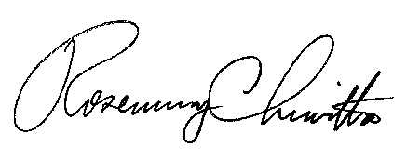

Rosemary Chiavetta
Secretary

cc: Office of Administration

