BEFORE THE
PENNSYLVANIA PUBLIC UTILITY COMMISSION

Alisa Stroud :
:
v. : C-2019-3011476
:
Peoples Natural Gas Company LLC ̶ Equitable :
Division :

INTERIM ORDER
CLOSING THE RECORD

AND NOW, the transcript of the December 17, 2019, hearing in this case having been filed with the Commission’s Secretary’s Bureau in Harrisburg on January 7, 2020; and a copy of the transcript having been received by the under signed on January 15, 2020; and no further hearings in this matter are to be scheduled or held,

THEREFORE,

IT IS ORDERED:

- That the record at Docket No. C-2019-3011476 is closed.

2. That the Initial Decision in this case shall be prepared and issued.

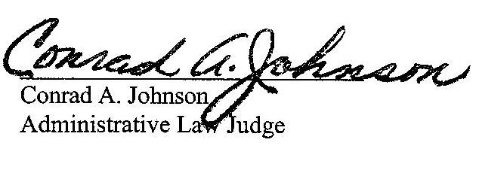
Dated: January 16, 2020

C-2019-3011476 - ALISA STROUD v. PEOPLES NATURAL GAS CO LLC - EQUITABLE DIVISION
ALISA STROUD
112 PALACE CT
BALDWIN VILLAGE
PITTSBURGH PA 15227
412.339.7566
JENNIFER PETRISEK ESQUIRE
PEOPLES NATURAL GAS COMPANY LLC - EQUITABLE DIVISION
375 NORTH SHORE DRIVE
PITTSBURGH PA 15212
412.208.6834
ACCEPTS E-SERVICE

