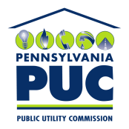 |  | COMMONWEALTH OF PENNSYLVANIA  PENNSYLVANIA PUBLIC UTILITY COMMISSION  400 NORTH STREET, HARRISBURG, PA 17120
January 24, 2020 May 30, 2017

IN REPLY PLEASE
REFER TO OUR FILE NUMBER

A-2011-2229050
LEAH GIBBONS, DIRECTOR, REGULATORY AFFAIRS
NRG RETAIL NORTHEAST
3711 MARKET ST. SUITE 1000
PHILADELPHIA, PA 19104

Dear Sir/ Madam:

We are returning your check, numbered 0107204160 for $350, received with your Annual Compliance Filing of Green Mountain Energy Company. A filing fee is not required with Financial Security Reduction Annual Compliance Filing.

Thank you for your attention to this matter.

Very truly yours,
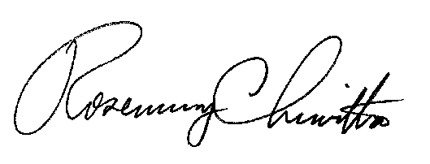

Rosemary Chiavetta
Secretary

Enclosure: Check No. 0107204160

Jbs

