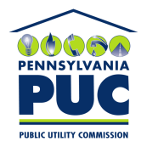 | COMMONWEALTH OF PENNSYLVANIA  PENNSYLVANIA PUBLIC UTILITY COMMISSION  400 NORTH STREET, HARRISBURG, PA 17120 | IN REPLY PLEASE REFER TO OUR FILE

Date of Service: January 31, 2020 Docket Number: C-2020-3017229

MARTHA LOPEZ
VERDE ENERGY USA, INC.
12140 WICKCHESTER LANE, SUITE 100
HOUSTON, TX 77079

Bureau of Investigation and Enforcement
v.
VERDE ENERGY USA, INC.

Dear Sir/Madam:

The Pennsylvania Public Utility Commission has delegated its authority to initiate prosecutory proceedings to several of its Commission bureaus with enforcement responsibilities. Pursuant to this delegated authority and Section 701 of the Public Utility Code, 66 Pa. C.S. § 701, Bureau of Investigation and Enforcement staff has filed the attached Complaint in the above docketed proceeding.

Very truly yours,
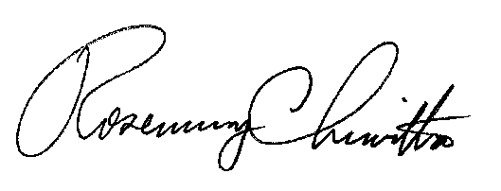

Rosemary Chiavetta
Secretary

RC:AEL

