BEFORE THE
PENNSYLVANIA PUBLIC UTILITY COMMISSION

Albert P. Carson :
:
v. : C-2019-3013885
:
West Penn Power Company :

INTERIM ORDER
HOLDING RESPONDENT’S PRELIMINARY OBJECTIONS IN ABEYANCE

On October 28, 2019, Albert P. Carson (Complainant) filed a Formal Complaint against West Penn Power Company (West Penn). Complainant alleges damages to his household appliances. As relief, Complainant requests monetary damages in the amount of $1,065.96.

West Penn filed an Answer and New Matter on November 18, 2019, 1) admitting that the Company is responsible for the alleged damage to Complainant’s personal property; 2) denying the Company provided unreasonable or inadequate service in handling Complainant’s concerns/issues; and 3) arguing that the Commission cannot grant Complainant’s request or monetary damages. West Penn also filed Preliminary Objections on November 18, 2019, which included a Notice to Plead. The basis for the Preliminary Objections is that the Commission does not have jurisdiction to award monetary damages. Therefore, West Penn requested that the Complaint be dismissed with prejudice or denied in its entirety for lack of subject matter jurisdiction.

Complainant did not file a response to the Preliminary Objections.

This matter was assigned to me by Telephone Hearing Notice dated January 23,
2020. A telephonic hearing on the Complaint is scheduled for March 4, 2020, at 10:00 a.m.
Complainant is currently self-represented. A ruling on West Penn’s Preliminary Objections will be held in abeyance pending a hearing on the Complaint. In Carlock v. The United Telephone Company of Pennsylvania, Docket No. F-00163617 (Order entered July 14, 1993), the Commission held that, in the normal course, the Commission would not dismiss a complaint of a self-represented person without first providing a hearing during which self-represented complainants could further explain their position and the factual basis for their complaint. The concern was expressed that, in general, complainants may find it difficult to navigate through pre-hearing motions and should be given the chance to orally describe their basic issue and supporting facts. The preliminary objections do not raise a novel issue of law. Holding a ruling on the preliminary objections in abeyance will not prejudice West Penn.

Complainant is cautioned that holding West Penn’s preliminary motion for dismissal of the Complaint in its entirety is held in abeyance to afford Complainant an opportunity to present his case. Holding a ruling on West Penn’s preliminary motion in abeyance does not, in any way, give credence to either the substance of the Complaint or to the likelihood of Complainant’s success on the merits.

A complainant has the burden of showing that the named utility is responsible or accountable for the problem described in the complaint in order to prevail. Patterson v. Bell Telephone Company of Pennsylvania, 72 Pa. PUC 196 (1990); Feinstein v. Philadelphia Suburban Water Company, 50 Pa. PUC 300 (1976). This must be shown by a preponderance of the evidence. Samuel J. Lansberry, Inc. v. Pa. Pub. Util. Comm’n, 578 A.2d 600 (1990), alloc. den., 602 A.2d 863 (1992). That is, by presenting evidence more convincing, by even the smallest amount, than that presented by the other party. Se-Ling Hosiery v. Marqulies, 70 A.2d 854 (1950).

The utility company’s offense must be a violation of the Public Utility Code, the Commission’s regulations, or an outstanding order of the Commission. 66 Pa.C.S. § 701. Complainant is responsible for proving that the utility has acted improperly, by providing testimony and documentary evidence, such as expert reports, photographs and any other relevant materials necessary to support that finding, and that the Commission has the jurisdiction to provide the remedy requested by Complainant.

The parties are encouraged to talk with each other to resolve this matter or some
portion thereof. It is the Commission’s policy to encourage settlements. 52 Pa.Code § 5.231.

ORDER

THEREFORE,

IT IS ORDERED:

1. That a ruling on the Preliminary Objections of West Penn Power Company filed at Docket No. C-2019-3013885 requesting dismissal of the Formal Complaint of Albert Carson will be held in abeyance pending a telephonic evidentiary hearing.

2. That this case shall proceed as scheduled to an evidentiary hearing by telephone on Wednesday, March 4, 2020, at 10:00 a.m.

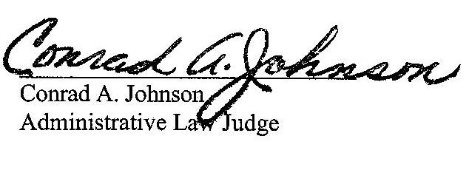
Date: February 5, 2020

C-2019-3013885 - ALBERT CARSON V. WEST PENN POWER COMPANY
ALBERT CARSON
200 RIVERVIEW AVENUE
CHARLEROI PA 15022
412.664.0752
MARGARET MORRIS ESQUIRE
REGER RIZZO & DARNALL
CIRA CENTRE 13TH FL
2929 ARCH STREET
PHILADELPHIA PA 19104
215.495.6524
ACCEPTS E-SERVICE

See also Richmond v. PECO Energy Company, Docket No. F-2010-2187305 (Opinion and Order entered December 7, 2011).

