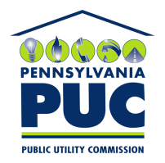 | COMMONWEALTH OF PENNSYLVANIA  PENNSYLVANIA PUBLIC UTILITY COMMISSION  400 NORTH STREET, KEYSTONE BUILDING, SECOND FLOOR  HARRISBURG, PENNSYLVANIA 17120 | IN REPLY PLEASE REFER TO OUR FILE
February 7, 2020

Via Certified Mail

ALEX MORALES, ENERGY PROCUREMENT ANALYST
FS ENERGY LLC
622 3RD AVENUE, 16TH FLOOR
NEW YORK, NY 10017

RE: Bond Invoice
FS Energy LLC
A-2015-2507077

Dear Sir/ Madam:

Please find under cover of this letter the Bond Invoice filed on behalf of FS Energy LLC. We believe this was sent to the Pennsylvania Public Utility Commission in error. Therefore, we are sending the document back to you for appropriate action.

Thank you for your attention to this matter.

Sincerely,

Rosemary Chiavetta
Secretary of the Commission

Enclosures
RC:jbs

