 |  | COMMONWEALTH OF PENNSYLVANIA  PENNSYLVANIA PUBLIC UTILITY COMMISSION  400 North Street, HARRISBURG, PA 17120 |  | IN REPLY PLEASE REFER TO OUR FILE  Phone: 717-772-7777
Formal Complaint Docket #: C-2020-3018501

Date Served: February 14, 2020

CARL YASTREMSKI
FRONTIER COMMUNICATIONS COMMONWEALTH TELEPHONE COMPANY
100 CTE DRIVE
DALLAS, PA 18612

RE: PSI/SPI Docket-R-2020-3016152

Dear Mr. Yastremski:

A Formal Complaint has been filed against you in the above-captioned matter before the Pennsylvania Public Utility Commission by the Office of Consumer Advocate.

This true and correct copy of the complaint has been filed of record with the Pennsylvania Public Utility Commission. Both the Pennsylvania Public Utility Code, 66 Pa. C.S. and the Commission’s regulations at 52 Pa. Code Section 1.53, requires the Commission to serve on each party named in a Formal Complaint a copy of the complaint.

Within twenty (20) days from the above date of service, you may either satisfy or answer this complaint in accordance with the provisions of 52 Pa Code, §5.61(a).

When filing your answer to the Formal Complaint, please reference the “Formal Complaint Docket Number” located in the upper-right hand corner of this Notice.

Very Truly Yours,
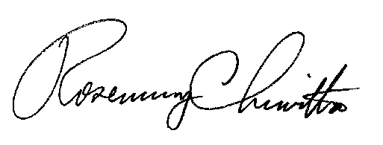

Rosemary Chiavetta
Secretary

(SEAL)

RC: AEL

Certified Mail
Return Receipt Requested

