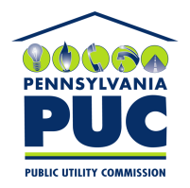 | COMMONWEALTH OF PENNSYLVANIA  PENNSYLVANIA PUBLIC UTILITY COMMISSION  400 NORTH STREET, HARRISBURG, PA 17120 | IN REPLY PLEASE REFER TO OUR FILE
January 29, 2020

OPEN MARKET ENERGY LLC
7625 WISCONSIN AVENUE, SUITE 200
BETHESDA, MD 20814

C. BRIAN CARLIN, ESQUIRE
OPPENHEIMER, FLEISCHER & QUIGGLE, P.C.
4419 EAST-WEST HIGHWAY
BETHESDA, MD 20814

Dear Sir/Madam:

On January 14, 2020, the Commission received the Application of Open Market Energy LLC for approval to supply natural gas services to the public in the Commonwealth of PA. Upon initial review, the Application has been determined to be missing information for the following reasons:

- No Business Entity and/or Department of State filings for the Commonwealth of Pennsylvania

- No Bonding Letters

Pursuant to 52 Pa. Code §1.4, you are being advised of this missing information and are required to file corrections. Failure to correct the foregoing missing information within 20 days of the date of this letter will result in the Application being returned unfiled.
Please return your items to the above listed address and address to the attention of the Office of the Secretary.
If you have any question in regards to this letter, please contact our bureau at (717) 772-7777. Thank you
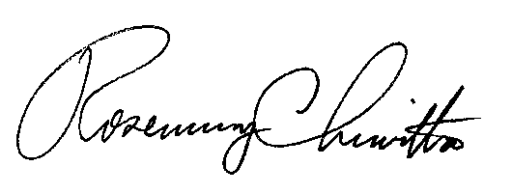
Sincerely,

Rosemary Chiavetta
Secretary

RC:AEL

