BEFORE THE
PENNSYLVANIA PUBLIC UTILITY COMMISSION

Darnell D. Jones :
:
v. : C-2019-3014574
:
Duquesne Light Company :

SECOND INTERIM ORDER
GRANTING RESPONDENT’S MOTION FOR CONTINUANCE

By Notice dated February 12, 2020, the Parties were informed that an initial telephonic hearing was scheduled before me for this proceeding on Friday, March 6, 2020, at 10:00 a.m. On February 20, 2020, Respondent Duquesne Light Company (Duquesne Light) filed a Motion for Continuance of the scheduled hearing asserting that the Company’s counsel was unavailable for the hearing due to a scheduled vacation. The motion further stated, “Attempts to contact the Complainant, using the telephone number listed on the Complaint, on February 18, 2020 and February 19, 2020, were unsuccessful.”

After due consideration, Duquesne Light’s Motion for Continuance of the telephonic hearing scheduled for Friday, March 6, 2020, will be granted in the ordering paragraphs below.

The Parties are encouraged to talk with each other to resolve this matter or some portion thereof. It is the Commission’s policy to encourage settlements. 52 Pa.Code § 5.231.

THEREFORE,

IT IS ORDERED:

- That Duquesne Light Company’s Motion for Continuance of the Initial Telephonic Hearing scheduled in this matter for Friday, March 6, 2020, in the matter of Darnell D. Jones at Docket No. C-2019-3014574 is granted.

- That the Scheduling Staff of the Office of Administrative Law Judge shall reschedule this matter for the next available hearing date after April 15, 2020, and so notify the Parties in writing.

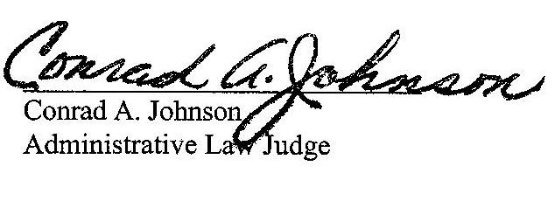
Date: February 27, 2020

C-2019-3014574 - DARNELL JONES v. DUQUESNE LIGHT COMPANY
DARNELL D JONES
1210 HOLMES STREET
APARTMENT 1
MCKEES ROCKS PA 15136
412.587.3496
EMILY M FARAH COUNSEL
DUQUESNE LIGHT COMPANY
411 SEVENTH AVENUE
PITTSBURGH PA 15219
412.393.6431
ACCEPTS eSERVICE

