PENNSYLVANIA
PUBLIC UTILITY COMMISSION
Harrisburg, PA 17120

Public Meeting held March 26, 2020

Commissioners Present:

Gladys Brown Dutrieuille, Chairman
David W. Sweet, Vice Chairman
Andrew G. Place
John F. Coleman, Jr.
Ralph V. Yanora

Pennsylvania Public Utility Commission  Office of Consumer Advocate  Irene Blanchard  Jeffrey Shatt  Ciro Matrecano  Neil and Kathleen Joyce  Lisa Celenza  Tami DeFrancesco  Virginia Pfeiffer  Charles Dellert  James Gelardi  Frank and Shuko Kashimba  v.  Twin Lakes Utilities, Inc. | R-2019-3010958  C-2019-3011845  C-2019-3011969  C-2019-3012087  C-2019-3012169  C-2019-3012221  C-2019-3012272  C-2019-3012332  C-2019-3012399  C-2019-3012487  C-2019-3012659  C-2019-3012667

OPINION AND ORDER

Table of Contents

I. Background 4
II. History of Proceeding 5
III. Legal Standards 8
IV. The Parties’ Joint Stipulations and the ALJ’s Uncontested Recommendations….12
A. Joint Stipulation of the Parties 12
B. The ALJ’s Uncontested Recommendations 13
1. Rate Base: 1) Utility Plant in Service; 2) Depreciation Reserve; and 3) Cash Working Capital 13
a. Utility Plant in Service 13
b. Depreciation Reserve 14
c. Cash Working Capital 14
C. Expenses: 1) Rate Case Expense; 2) Maintenance Supplies; 3) Purchased Power and Chemical Expenses; 4) Bad Debt Expense 15
1. Rate Case Expense 15
2. Maintenance Supplies 16
3. Purchased Power and Chemical Expenses 17
4. Bad Debt Expense 18
D. Capital Structure 19
E. Rate Structure and Rate Design 21
F. Disposition 21
V. Review of Exceptions and Replies 23
A. Rate Base Acquisition Adjustment 24
1. Position of the Parties 24
2. Recommended Decision 27
3. Exceptions and Replies 29
4. Disposition 30
B. Revenues and Revenue Requirement 32
1. Position of the Parties 32
2. Recommended Decision 33
3. Disposition 33
C. Taxes 34
1. Position of the Parties 34
2. Recommended Decision 35
3. Exceptions and Replies 36
4. Disposition 36
D. Rate of Return 39
1. Position of the Parties 39
2. Recommended Decision 41
3. Exceptions and Replies 44
4. Disposition 45
E. Quality of Services 48
1. Position of the Parties 48
2. Recommended Decision 54
3. Exceptions and Replies 55
a. Twin Lakes Exception No. 1 and Replies 55
b. Twin Lakes Exception No. 3 and Replies 60
c. OCA Exception No. 4 62
4. Disposition 63
F. Affordability of Rates 66
1. Position of the Parties 66
2. Recommended Decision 73
3. Exceptions and Replies 74
a. Twin Lakes Exception No. 2 and Replies 74
b. OCA Exception No. 5 79
4. Disposition 79
VI. Conclusion 80
BY THE COMMISSION:

Before the Pennsylvania Public Utility Commission (Commission) for consideration and disposition is the Recommended Decision (R.D.) of Administrative Law Judge (ALJ) Marta Guhl, issued on February 19, 2020, relative to the above-captioned general rate increase proceeding. Also, before the Commission are the Exceptions and the Replies to Exceptions filed with respect thereto.

Exceptions to the Recommended Decision were filed on March 2, 2020, by the following Parties: Twin Lakes Utilities, Inc. (Twin Lakes or Company), the Commission’s Bureau of Investigation and Enforcement (I&E), and the Office of Consumer Advocate (OCA). On March 9, 2020, the OCA and I&E filed Replies to Exceptions.

Also, before the Commission is the Joint Stipulation of the active Parties to the proceeding, Twin Lakes, I&E and the OCA (Joint Stipulation), filed on December 18, 2019, where, in support of the Parties’ Joint Motion to Admit Testimony and Exhibits into the Record (Joint Motion), the Parties also requested that the ALJ cancel the scheduled evidentiary hearings based upon the Parties’ stipulation to the contents of two Appendices attached to the Joint Motion: (1) Appendix A (Stipulation for Admission of Testimony and Exhibits), specifying the Parties’ witnesses’ testimony and exhibits, and waiving the right to cross examination of witnesses sponsoring their respective testimony; and, (2) Appendix B (Stipulation of the Parties) stipulating to certain contested facts regarding lead and copper monitoring by the Company. See attached, Appendix B (Joint Stipulation).

For the reasons stated, infra, we shall adopt the Parties’ Joint Stipulation, as in the public interest. Additionally, we shall: (1) grant, in part, and deny, in part, the Exception of I&E: (2) grant, in part, and deny, in part, the Exceptions of the OCA; (3) deny the Exceptions of Twin Lakes; and, (4) adopt the ALJ’s Recommended Decision, as modified, consistent with this Opinion and Order.

As discussed infra, Twin Lakes’ proposed increase to its rate base would have increased its annual revenues by $211,793, or 158.63%, based on the historic test year (HTY) ending March 31, 2019. While the Company requested approval of an overall rate of return of 9.0%, with a cost of common equity (COE) of 11.0%, by this Opinion and Order, we shall approve an overall rate of return of 8.12% with a COE of 9.23%. Therefore, by our Order, we shall approve an annual revenue increase for the Company in the amount of $117, 374, or 87.91%. Because we adopt a rate increase which is less than the full amount requested by the Company, this Opinion and Order directs Twin Lakes to scale back its fixed and volumetric rates to correspond proportionally with the percent increase originally requested. By this Order we shall also direct that the Company report to the Commission regarding the affirmative steps taken by the Company to obtain low-cost debt to reduce the approved cost of debt rate of 7.0%. Finally, we shall direct that the Company report to the Commission on its progress in implementing the planned capital investments for repair and improvement of critical infrastructure necessary to ensure safe, reliable, and reasonable water service to its customers.

Background

Twin Lakes provides jurisdictional water distribution services to approximately 114 residential customers in the service territory of Pike County, in the Commonwealth of Pennsylvania. Twin Lakes maintains a water distribution system consisting of: one functional well (Well No. 2); one non-functional well (Well No. 1); a small treatment/pumping station with an integral atmospheric 20,000 gallon storage tank; approximately 3.7 miles of water main of various diameters; and, an approximate combined 120 active and inactive services. The Company is a public utility and jurisdictional water distribution company as those terms are defined in the Pennsylvania Public Utility Code (Code), 66 Pa. C.S. § 102.

As noted previously, Twin Lakes seeks approval of an increase in its annual jurisdictional operating revenues of $211,793, or 158.63% above present revenues. The Company’s requested increase is based on an HTY ending March 31, 2019 and is designed to provide the Company with an opportunity to earn a 9% overall rate of return, including an 11% return on equity, on a claimed rate base of $1,307,710.

Twin Lakes asserts that the requested rate increase reflects the business challenges the Company currently faces, including, required investments in the repair/replacement or improvement of the distribution system; and the high costs associated with maintaining a distribution system while serving a small customer base. Twin Lakes further asserts that continued growth in operating and capital costs, along with the inability to obtain low-cost credit as a stand-alone entity, prevent it from earning a fair rate of return on its investment, at current rates.

- History of Proceeding

On July 23, 2019, Twin Lakes filed Supplement No. 8 to Tariff Water-Pa. P.U.C. No. 4 (Supplement No. 8), to become effective September 19, 2019. In Supplement No. 8, Twin Lakes proposed changes to its base retail distribution rates designed to produce an increase in revenues of approximately $211,793, based upon data for the HTY ending March 31, 2019.

By Order entered August 29, 2019, Supplement No. 8 was suspended by operation of law, for up to nine months, or until April 19, 2020, unless permitted by Commission Order to become effective at an earlier date, pursuant to Section 1308(d) of the Code, 66 Pa. C.S. § 1308(d). The Commission also referred the matter to the Commission’s Office of Administrative Law Judge (OALJ) for evidentiary hearing and a Recommended Decision regarding Twin Lakes’ proposed general rate increase. The matter was assigned to ALJ Guhl.

On July 29, 2019, I&E filed a Notice of Appearance.

On July 30, 2019, the OCA filed a Formal Complaint and Public Statement.

Ten Twin Lakes’ residential customers filed Formal Complaints in which they asserted that Twin Lakes’ proposed rate increase was too high, and, if approved, would render water service unaffordable. Those ten customers included the following individuals:(1) Irene Blanchard on August 5, 2019; (2) Jeffrey Shatt on August 7, 2019; (3) Ciro Matrecano on August 12, 2019; (4) Neil and Kathleen Joyce on August 15, 2019; (5) Lisa Celenza on August 19, 2019; (6) Tami DeFrancesco on August 21, 2019; (7) Virginia Pfeiffer on August 21, 2019; (8) Charles Dellert on August 26, 2019; (9) James Gelardi on September 3, 2019; and, (10) Frank and Shuko Kashimba on September 3, 2019.

On September 13, 2019, Twin Lakes filed Supplement No. 9 to Tariff Water-Pa. P.U.C. No. 4 (Supplement No. 9), to suspend the rates proposed in Supplement No. 8 until April 19, 2020.

A pre-hearing conference was held on September 23, 2019, at which Counsel was in attendance and appeared on behalf of Twin Lakes, I&E and the OCA. Also present were pro se Complainants Irene Blanchard, Lisa Celenza and Charles Dellert, who each elected to be inactive participants in this proceeding. R.D. at 4-5.

On September 27, 2019, Twin Lakes filed the Direct Testimony of three witnesses: A. Bruce O’Conner, TLU Statements No. 1; Michele L. Tilley, TLU Statement No. 2; and Robert Fullager, TLU Statement NO. 3. R.D. at 5

Two public input hearings were held on October 17, 2019, at which nine of Twin Lakes’ customers presented on the record testimony. R.D. at 5.

On November 1, the OCA served the Direct Testimony of its three witnesses: Aaron L. Rothschild, OCA Statement No. 1; Stacy L. Sherwood, OCA Statement No. 2; and, Terry L. Fought, OCA Statement No. 3.

On November 4, 2019, I&E served the Direct Testimony of its three witnesses: John Zalesky, I&E Statement No. 1; Christopher M. Henkel, I&E Statement No. 2; and, Esyan A. Sakaya, I&E Statement No. 3.

On November 20, 2019, Twin Lakes served the following Rebuttal Testimony and Exhibits: Michele L. Tilley, TLU Statement No. MLT-2R, and Exhibits MLT-A-G; and Robert K. Fullager, TLU Statement No. RFK-2R.

I&E and the OCA served Surrebuttal Testimony and Exhibits on December 10, 2019, including: Surrebuttal Testimony of John Zalesky, I&E Statement No. 1-SR; Surrebuttal Testimony of Christopher M. Henkel, I&E Statement No. 2-SR; Surrebuttal Testimony of Esyan A. Sakaya, I&E Statement No. 3-SR.; Surrebuttal Testimony and Exhibits of Stacy L. Sherwood, OCA Statement No. 1-SR; Surrebuttal Testimony of John Zalesky, I&E Statement No. 1-SR

On December 18, 2019, the active Parties to the proceeding, Twin Lakes, I&E and the OCA, filed the Joint Motion and the Joint Stipulation. As earlier indicated, the Joint Stipulation was comprised of two attached Appendices: Appendix A (Stipulation for Admission of Testimony and Exhibits); and, Appendix B (Stipulation of the Parties) (stipulating to the certain contested facts regarding, inter alia, lead and copper monitoring by the Company).

By Order entered on December 18, 2019, the ALJ: (1) granted the Joint Motion filed by Twin Lakes, I&E and the OCA; (2) adopted the Joint Stipulation; (3) admitted the stipulation of facts and testimony, exhibits into the record; and (4) cancelled the evidentiary hearings scheduled in the proceeding.

Twin Lakes, I&E, and the OCA filed Main Briefs on January 7, 2020, and Reply Briefs on January 15, 2020. Upon the filing of the Parties’ Reply Briefs on January 15, 2020, the record was closed.

In the Recommended Decision issued on February 19, 2020, the ALJ recommended that the Company be permitted to file tariffs or tariff supplements containing rates designed to produce an increase in the amount of $111,776 over the Company’s present annual operating revenues. R.D. at 91. As previously noted, Twin Lakes, I&E, and the OCA filed Exceptions on March 2, 2020. I&E and the OCA filed Replies to Exceptions on March 9, 2020.

- Legal Standards

In deciding this or any other general rate increase case brought under Section 1308(d) of the Code, 66 Pa. C.S. § 1308(d), certain general principles always apply. A public utility is entitled to an opportunity to earn a fair rate of return on the value of the property dedicated to public service. Pa. PUC v. Pennsylvania Gas and Water Co., 341 A.2d 239, 251 (Pa. Cmwlth. 1975). In determining a fair rate of return, the Commission is guided by the criteria provided by the United States Supreme Court in the landmark cases of Bluefield Water Works and Improvement Co. v. Public Service Comm’n of West Virginia, 262 U.S. 679 (1923) and Federal Power Comm’n v. Hope Natural Gas Co., 320 U.S. 591 (1944). In Bluefield, the Court stated:

A public utility is entitled to such rates as will permit it to earn a return on the value of the property which it employs for the convenience of the public equal to that generally being made at the same time and in the same general part of the country on investments in other business undertakings which are attended by corresponding risks and uncertainties; but it has no constitutional right to profits such as are realized or anticipated in highly profitable enterprises or speculative ventures. The return should be reasonably sufficient to assure confidence in the financial soundness of the utility and should be adequate, under efficient and economical management, to maintain and support its credit and enable it to raise the money necessary for the proper discharge of its public duties. A rate of return may be too high or too low by changes affecting opportunities for investment, the money market and business conditions generally.

Bluefield, 262 U.S. at 692-693.

The burden of proof to establish the justness and reasonableness of every element of a public utility’s rate increase request rests solely upon the public utility in all proceedings filed under Section 1308(d) of the Code. The standard to be met by the public utility is set forth in Section 315(a) of the Code, 66 Pa. C.S. § 315(a), as follows:

Reasonableness of rates. – In any proceeding upon the motion of the commission, involving any proposed or existing rate of any public utility, or in any proceedings upon complaint involving any proposed increase in rates, the burden of proof to show that the rate involved is just and reasonable shall be upon the public utility.

In reviewing Section 315(a) of the Code, the Pennsylvania Commonwealth Court interpreted a public utility’s burden of proof in a rate proceeding as follows:
Section 315(a) of the Public Utility Code, 66 Pa. C.S. § 315(a), places the burden of proving the justness and reasonableness of a proposed rate hike squarely on the public utility. It is well-established that the evidence adduced by a utility to meet this burden must be substantial.

Lower Frederick Twp. Water Co. v. Pa. PUC, 409 A.2d 505, 507 (Pa. Cmwlth. 1980) (emphasis added). See also, Brockway Glass Co. v. Pa. PUC, 437 A.2d 1067 (Pa. Cmwlth. 1981).

In general rate increase proceedings, it is well established that the burden of proof does not shift to parties challenging a requested rate increase. Rather, the utility’s burden of establishing the justness and reasonableness of every component of its rate request is an affirmative one, and that burden remains with the public utility throughout the course of the rate proceeding. There is no similar burden placed on parties to justify a proposed adjustment to the Company’s filing. The Pennsylvania Supreme Court has held:

[T]he appellants did not have the burden of proving that the plant additions were improper, unnecessary or too costly; on the contrary, that burden is, by statute, on the utility to
demonstrate the reasonable necessity and cost of the installations, and that is the burden which the utility patently failed to carry.

Berner v. Pa. PUC, 116 A.2d 738, 744 (Pa. 1955).

This does not mean, however, that in proving that its proposed rates are just and reasonable, a public utility must affirmatively defend every claim it has made in its filing, even those which no other party has questioned. As the Pennsylvania Commonwealth Court has held:

While it is axiomatic that a utility has the burden of proving the justness and reasonableness of its proposed rates, it cannot be called upon to account for every action absent prior notice that such action is to be challenged.

Allegheny Center Assocs. v. Pa. PUC, 570 A.2d 149, 153 (Pa. Cmwlth. 1990) (citation omitted). See also, Pa. PUC v. Equitable Gas Co., 73 Pa. P.U.C. 310, 359-360 (1990).

Additionally, Section 315(a) of the Code, 66 Pa. C.S. § 315(a), cannot reasonably be read to place the burden of proof on the utility with respect to an issue the utility did not include in its general rate case filing and which, frequently, the utility would oppose. Inasmuch as the Legislature is not presumed to intend an absurd result in interpretation of its enactments, the burden of proof must be on the party who proposes a rate increase beyond that sought by the utility. The mere rejection of evidence contrary to that adduced by the public utility is not an impermissible shifting of the evidentiary burden. United States Steel Corp. v. Pa. PUC, 456 A.2d 686 (Pa. Cmwlth. 1983).

In analyzing a proposed general rate increase, the Commission determines a rate of return to be applied to a rate base measured by the aggregate value of all the utility’s property used and useful in the public service. The Commission determines a proper rate of return by calculating the utility’s capital structure and the cost of the different types of capital during the period in issue. The Commission is granted wide discretion, because of its administrative expertise, in determining the cost of capital. Equitable Gas Co. v. Pa. PUC, 405 A.2d 1055, 1059 (Pa. Cmwlth. 1979) (determination of cost of capital is basically a matter of judgment which should be left to the regulatory agency and not disturbed absent an abuse of discretion).

As we proceed in our review of the various positions of the Parties in this proceeding, we note that any issue or Exception that we do not specifically address shall be deemed to have been duly considered and denied without further discussion. The Commission is not required to consider expressly or at length each contention or argument raised by the parties. Consolidated Rail Corp. v. Pa. PUC, 625 A.2d 741 (Pa. Cmwlth. 1993); also see, generally, University of Pennsylvania v. Pa. PUC, 485 A.2d 1217 (Pa. Cmwlth. 1984).

- The Parties’ Joint Stipulations and the ALJ’s Uncontested Recommendations

- Joint Stipulation of the Parties

By Order entered on December 18, 2019, the ALJ granted the Joint Motion filed by Twin Lakes, I&E and the OCA, moving that the ALJ approve and admit the attached Joint Stipulation for Admission of Testimony and Exhibits (Joint Stipulation) into the record of this proceeding.

The Joint Stipulation was comprised of two attached Appendices: Appendix A (Stipulation for Admission of Testimony and Exhibits), specifying each parties’ witnesses’ testimony and exhibits, and waiving the right to cross examination of witnesses sponsoring their respective testimony; and, Appendix B (Stipulation of the Parties) stipulating to the certain contested facts regarding, inter alia, the Company’s duties to conduct lead and copper monitoring. See, Attached Appendix B (Joint Stipulation).

The ALJ recognized that the Parties’ agreement on certain evidentiary matters and stipulation to certain contested facts was beneficial for all parties, and in the public interest, as it operated to streamline the proceeding by resolving certain evidentiary and factual matters in dispute, and eliminate the litigation expense otherwise required by the scheduled evidentiary hearings. R.D. at 6.

- The ALJ’s Uncontested Recommendations

Our review of the ALJ’s uncontested recommendations pertains to all matters which were neither raised nor implicated by the Exceptions and Replies thereto filed by Twin Lakes, I&E, and the OCA. Therefore, our review of the ALJ’s uncontested recommendations includes: (1) Rate Base pertaining to utility plant in service, depreciation reserve, and cash working capital; (2) Expenses pertaining to rate case expense, maintenance supplies, purchased power and chemical expenses, and bad debt expense; (3) Capital Structure; and, (4) Rate Structure. In addition, the ALJ adopted the Joint Stipulation of the Parties, resolving certain evidentiary matters and potential facts in dispute. As discussed below, the ALJ recommended that the Commission adopt the findings on each issue as being in the public interest. See, R.D. at 6-12, 89-90.

- Rate Base: a) Utility Plant in Service; b) Depreciation Reserve; and c) Cash Working Capital

a. Utility Plant in Service

With respect to the utility plant in service component of Rate Base, the ALJ accepted the agreement among the Parties to the calculation of utility plant in service, including the pro forma adjustment, in the amount of $1,481,061.

Based on the Company’s HTY ending March 31, 2019, Twin Lakes claimed a depreciated original cost in this proceeding of $1,443,561. Twin Lakes further claimed projected plant in service additions from April 1, 2019 to September 30, 2019, of $37,500. This resulted in a total plant in service balance of $1,481,061.

Because both I&E and the OCA witnesses accepted the Company's proposal to reflect the post-test year pro forma plant in service additions and accumulated depreciation from April l, 2019 to September 30, 2019, the ALJ recommended adoption of the Company’s utility plant in service claimed as reasonable and in the public interest. R.D. at 14 (citing TLU M.B. at 5; I&E M.B. at 5; OCA M.B. at 7; Twin Lakes’ Short Form Filing Exhibit E).

- Depreciation Reserve

With respect to Depreciation Reserve, the ALJ accepted Twin Lakes’ claim for $219,884, based upon no opposition to the claim raised by either I&E or the OCA. The ALJ noted that neither I&E nor the OCA had proposed a depreciation reserve adjustment. Therefore, the ALJ recommended adoption of the Company’s claim for depreciation reserve as reasonable and in the public interest. RD at 15 (citing I&E MB at 6; OCA MB at 7; Twin Lakes’ Short Form Filing Exhibit E).

- Cash Working Capital

The ALJ recommended that I&E’s proposed calculation of the claim for Cash Working Capital (CWC) of $12,423, or a reduction of $4,752 to the Company’s claim, be adopted in this matter.

The ALJ noted that the Parties agreed that the one-eighth method is the proper method to calculate the CWC. However, the Parties disagreed on what should be included in the CWC calculation. The ALJ excluded non-cash items, such as depreciation and uncollectibles claimed in the amount of $4,752, as not appropriate in the determination of cash working capital requirements. R.D. at 25 (citing Pa. Pub. Util. Comm’n. v. Philadelphia Suburban Water Co., 58 Pa. P.U.C. 668, 674 (1984)). On that basis, the ALJ recommended adoption of I&E’s calculation of CWC which reduced Twin Lakes’ claimed CWC in the amount of $17,175, by $4,752, for a total claim of CWC in the amount of $12, 423, as reasonable and in the public interest. R.D. at 25 (citing I&E MB at 40 and OCA MB at 9).

- Expenses: 1) Rate Case Expense; 2) Maintenance Supplies; 3) Purchased Power and Chemical Expenses; 4) Bad Debt Expense

- Rate Case Expense

The ALJ recommended that the Company’s reasonable rate case expense in the present proceeding was $26,462, to be normalized over a period of 39 months, reflecting a reduction of $30,871, from the Company’s claimed annual rate case expense calculated to be $57,333, based on estimated costs of $86,000 amortized over 18 months.

The ALJ rejected the Company’s claimed rate case expense amount, as well as the Company’s proposed amortization of 18 months. In considering the OCA’s and I&E’s positions on the issue, the ALJ applied the rule that normalization, as opposed to amortization, is the appropriate means by which to allow recovery of the rate case expense, because normalization specifically addresses the prospective recovery of an ongoing expense that recurs sporadically. The ALJ also considered that the recovery of the rate case expense through normalization is not exact.

Therefore, the ALJ reasoned that the normalization of the expense should be for a fixed period which is neither too short (i.e., to preclude the Company from over recovery) nor too long (i.e., to ensure the Company does not under recover). On that basis, the ALJ determined the OCA’s proposed normalization period of 48 months as too long, and unreasonably increasing the risk of under recovery. Conversely, the Company’s proposed recovery period of 18 months was too short, as it would result in an over recovery. R.D. 27-31.

The ALJ recommended that, in this circumstance, I&E’s calculation of the rate case expense, normalized over a period of 39 months, which results in a rate case expense of $26,462, thereby reducing the Company’s claim by $30,871, was the most reasonable calculation of the allowable rate case expense, and is in the public interest. R.D. at 31.

- Maintenance Supplies

The ALJ recommended an allowance of $4,499 in the Company’s claimed maintenance supplies, reducing the Company’s claim of $9,509 by $5,010.

The ALJ accepted I&E’s position that it was not reasonable to calculate the expense based on the Company’s HTY, since the Company had experienced two water mains breaks during the HTY. I&E argued that a calculation based on a year in which the Company incurred extraordinary expenses would not result in an accurate projected expense. I&E asserted that, in order to calculate the expense to reflect a reliable estimate of future projected expense, the expense should be based on a three-year historic average. The ALJ agreed, noting that I&E’s calculation would normalize any extraordinary expense incurred during the HTY, therefore reflecting a more accurate projection of normal expenses.

Therefore, the ALJ recommended adoption of I&E’s calculation of maintenance supplies for an allowance of $4,499, or a reduction of $5,010, from the Company’s original claim of $9,509 as reasonable and in the public interest.

- Purchased Power and Chemical Expense

The ALJ recommended that Twin Lakes’ claimed Purchased Power and Chemical Expense of $13,527, be reduced by $9,392, for an allowable claim of $4,135. R.D. at 42.

The ALJ’s analysis turned on the rule that, while a Company is entitled to recover all reasonable and normal operating expenses, it is not entitled to recover expenses that are not incurred, imprudently incurred, or abnormally overstated. To the extent a Company’s claimed expenses are found to be imprudent, or abnormally overstated, the expenses should be disallowed. R.D. at 41.

The ALJ agreed with I&E’s position that certain expenses should be disallowed, as they were incurred by the Company’s own imprudent conduct. Specifically, to the extent the Company claimed expenses for purchased power and unaccounted- for -water or UFW, I&E maintained that the Company’s claim should be reduced, as unreasonable. I&E noted that the Company’s electric generation and transmission expenses were inflated by $3,000 over a 39-month period due to the Company paying more than the electric supplier’s applicable Price to Compare. Clearly, if a lower electric rate is readily available, I&E argued it is imprudent for the Company to pay the higher rate. Similarly, to the extent the Company claimed expenses associated with unaccounted- for -water, I&E argued that the Company was solely responsible for the excessive levels of unaccounted for water and therefore, should not be allowed to claim associated expenses which were unreasonable. R.D. at 33-42.

The ALJ accepted I&E’s position that the Company’s claim for purchased power and chemical expenses should be reduced by $9,392 to reflect the extent to which the expenses were attributable to the Company’s imprudent conduct. Therefore, the ALJ recommended a reduction of $9,392 from the Company’s claim, resulting in an allowable claim of $4,135, as reasonable and in the public interest. R.D. at 42.

- Bad Debt Expense

The ALJ recommended adoption of I&E’s proposed calculation of the claim for Bad Debt Expenses of $3,062, or a reduction of $16,033, from the Company’s claim of Bad Debt Expenses in the amount of $19,095. R.D. at 45.

The ALJ noted that the Company’s calculation is based on its amount of bad debt expense for the twelve months ending March 31, 2019, of $7,384, increased by the proposed rate increase of 158.6% (i.e., $7,384 x [1 + 1.586] = $19,095). The ALJ noted that the Company’s calculation factored in the assumption that bad debt will increase due to the proposed rate increase. The ALJ rejected the Company’s calculation on the basis of the assumption of a projected abnormal rise in bad debt. Id.

The ALJ concluded that I&E’s calculation, based on an average percentage of the net write-offs to gross revenues for the three historic twelve-month periods (ending March 31, 2017, 2018, and 2019) of increased bad debt, was a more reasonable basis to calculate the bad debt expense. The ALJ noted that I&E’s calculation was more reasonable, as it relied upon the Company’s actual historic experience of bad debt write-offs, rather than the hypothetical and abnormal future projection relied upon by the Company. Id.

On that basis, the ALJ recommended adoption of I&E’s calculation of bad debt expense which reduced Twin Lakes’ claimed expenses in the amount of $19,095, by $16,033, for a total claim of expenses in the amount of $3,062, as reasonable and in the public interest. R.D. at 42-45 (citing I&E M.B. at 29-3; OCA M.B. at 15-17).

- Capital Structure

The ALJ recommended adoption of the Parties’ position that Twin Lakes’ proposed Capital Structure based on 50% debt and 50% equity is appropriate. The ALJ further recommended that the cost of debt be fixed at 7.0% in recognition of the Company’s inability to obtain credit as a stand-alone entity. R.D. at 76-77.

The ALJ considered that the Company proposed a capital structure of 50% long term debt and 50% common equity based on the assertion that it is the current commonly accepted water industry practice. Twin Lakes’ proposal to use an embedded long-term debt cost rate of 7.0% at March 31, 2019, is based on the Company’s inability to obtain long term credit as a stand-alone entity, apart from its parent entity, Middlesex Water Company (Middlesex). R.D. at 75 (citing TLU M.B. 11-12).

The ALJ noted that I&E and the OCA agreed that the Company’s proposed capital structure is reasonable. I&E agreed based on I&E’s expert’s comparison of the range of capital structure employed by the proxy group of similarly situated water utilities. I&E noted that the use of data exclusively from one company may be less reliable than using data from a proxy group of companies. The OCA agreed that the proposed capital structure is reasonable based on an analysis of the proxy group, and further concurred on the basis that it is consistent with the capital structure ratios used by the Company’s parent, Middlesex. R.D. at 75 (citing I&E M.B. at 40; OCA M.B. at 22-23).

The ALJ considered that both I&E and the OCA disagreed with the Company’s basis for asserting a fixed cost of debt at 7.0%. I&E disagreed on the basis that the figure of 7.0% exceeds the cost of debt range for the proxy group by 74 basis points. I&E maintained that the Company should continue to pursue lower-cost debt from other entities including through channels available to the parent entity, Middlesex. While the OCA did not argue to adjust the Company’s claimed 7.0% cost of debt, the OCA noted its concerns that the cost is too high. R.D. at 75-76 (citing I&E M.B. at 40; I&E St. 2 at 11).

Further, the OCA asserted that, while the 7.0% cost of debt is presently justified by the Company’s demonstrated inability to obtain low-cost debt, the Company’s cost of debt should be adjusted in the future to reflect a significant change in the Company’s ability to obtain low-cost debt. Specifically, the OCA asserted that because Twin Lakes was presently in the process of applying for a Pennsylvania Infrastructure Investment Authority (PENNVEST) loan which is expected to significantly reduce its cost of debt in the future, the Company’s cost of debt should be adjusted to reflect the change. R.D. at 76 (citing OCA MB at 23).

Based on the agreement of I&E and the OCA to the Company’s proposed Capital Structure of 50% debt and 50% equity, the ALJ recommended adoption of the Company’s proposed Capital Structure as reasonable and in the public interest. With respect to the Company’s proposed cost of debt at the rate of 7.0%, the ALJ recommended adoption of the Company’s proposal, notwithstanding I&E’s and the OCA’s qualified opposition, in recognition of the Company’s demonstrated inability to obtain low-cost credit as a stand-alone entity. R.D. at 75-77.

- Rate Structure and Rate Design

The ALJ recommended that the rates approved by this proceeding be scaled back proportionally to ensure that the customer charge is not increased disproportionally as compared to the usage rate. R.D. at 89.

Because the ALJ’s recommendation for the approved rate increase is less than the original requested increase, the ALJ adopted I&E’s position that the rate increase should be applied proportionally to the Company’s fixed and volumetric rates, so that each rate receives the same rate increase. The Company did not oppose I&E’s position, based on a rate increase less than the Company requested. R.D. at 88-89.

Accordingly, the ALJ recommended that the rates should be scaled back proportionally in this matter, as reasonable and in the public interest. R.D. at 89.

- Disposition

Upon review of the ALJ’s uncontested recommendations, including the ALJ’s adoption of the Parties’ Joint Stipulation, we conclude that the ALJ’s uncontested recommendations and the underlying Findings of Fact and Conclusions of Law are supported by substantial evidence and in the public interest.

The ALJ’s uncontested recommendations, including the adoption of the Parties’ Joint Stipulation, resolve a variety of the issues necessary for the ultimate resolution of this rate proceeding. As such, the ALJ’s uncontested findings reflect the Parties’ ultimate agreement to abide by those findings. As a general matter, the ALJ’s uncontested findings, including the adoption of the Joint Stipulation, achieve the same practical benefit as a settlement of those issues. As we have previously acknowledged, a settlement of any aspect of a case, whether whole or partial, benefits not only the named parties directly, but, indirectly, all customers of the public utility involved in the case. Pa. PUC, et al. v. Columbia Gas of Pennsylvania, Inc., Docket Nos. R-2015-2468056, et al. (Order entered December 3, 2015) at 6-7. Our adoption of the ALJ’s uncontested recommendations and the Parties’ Joint Stipulation is based on our conclusion that both are supported by substantial evidence, and are reasonable and in the public interest. See, Pa. PUC v. York Water Co., Docket No. R-00049165 (Order entered October 4, 2004); Pa. PUC v. C. S. Water and Sewer Assoc., 74 Pa. P.U.C. 767 (1991) (requirement for a Commission finding that stipulations in rate proceedings be in the public interest).

Accordingly, we shall adopt and approve, without modification, the Joint Stipulation of the Parties and the ALJ’s uncontested recommendations, as set forth and discussed above, regarding: (1) Rate Base, (2) Expenses, (3) Capital Structure, and (4) Rate Structure as just and reasonable and in the public interest.

While we adopt the ALJ’s uncontested recommendations without modification, we will require future reporting by the Company regarding the Company’s Capital Structure, as it pertains to a cost of debt of 7.0%. We do so because, while we acknowledge the Company’s present inability to obtain lower-cost debt, we also conclude, as argued by I&E and the OCA, that the Company should actively pursue means to reduce the 7.0% cost of debt.

As the ALJ noted, I&E and the OCA offered persuasive evidence that Twin Lakes’ cost of debt is extremely high viewed in comparison to the proxy group. R.D. at 42-45. The ALJ concluded that, despite proof that the Company’s cost of debt is high, the Company’s demonstrated inability to obtain low-cost debt justifies the cost of debt rate of 7.0%. However, as noted by I&E, the Company should be accountable to take affirmative steps to obtain lower cost debt. Further, as the OCA observed, the Company’s future ability to obtain low-cost debt may improve due to external factors which may justify a future reduction to the Company’s cost of debt, including, inter alia, a PENNVEST loan approval. We agree.

Our approval of the Company’s proposed cost of debt of 7.0% reflects the Company’s present inability to otherwise obtain lower-cost debt. However, it does not relieve the Company from the duty to take active and prudent measures to obtain lower-cost debt during the interim until the Company’s next rate filing. We expect that the Company will continue to actively pursue possible sources of lower-cost debt. We further intend that the Company be responsible to advise the Commission annually of the affirmative steps it has taken toward securing lower cost debt, until such time as the Company’s cost of debt is commensurate with either the Company’s parent entity or the proxy group.

Therefore, we shall direct that Twin Lakes shall annually file a report, directed to the Secretary of the Commission, with a copy to the Commission’s Bureau of Technical Utility Services (TUS), on the affirmative steps taken by the Company toward reduction of the Company’s approved cost of debt rate of 7.0%, to continue until the Company’s cost of debt is reduced to a rate commensurate with either the Company’s parent entity or proxy group.

V. Review of Exceptions and Replies

We now turn to our consideration and disposition on the merits of those matters raised or implicated by the Exceptions filed by the Parties and Replies filed in response thereto. Matters raised or implicated by the Parties’ Exceptions and Replies filed in response thereto, include: (1) Rate Base Acquisition Adjustment; (2) Revenues and Revenue Requirements; (3) Taxes; (4) Rate of Return; (5) Quality of Service; and, (6) Affordability of Rates.

- Rate Base Acquisition Adjustment

- Position of the Parties

Twin Lakes claimed an Acquisition Adjustment of $54,406 to increase the rate base, as the residual portion of the $71,440 Acquisition Adjustment it had originally claimed pursuant to 66 Pa. C.S. §1327 (pertaining to Acquisition of Water and Sewer Facilities).

Twin Lakes argued that the ALJ should reject I&E’s and the OCA’s positions on the calculation of the Acquisition Adjustment, because they are in conflict with standard rate making principles. Specifically, Twin Lakes argued that the OCA’s position is based upon an incorrect reading of Section 1327 of the Code to require that a utility must obtain an approval for an Acquisition Adjustment in the first rate proceeding following the acquisition of water facilities or be forever barred from raising the claim. Twin Lakes noted that the OCA’s position would preclude the use of “black box” settlements, which do not specify the basis for calculation of the terms of the settlement, to resolve rate proceedings. The Company further notes that there is no language in the statute or regulations to support the OCA’s interpretation. R.D. at 15-16 (citing TLU M.B. at 5-6).

With respect to I&E’s position, Twin Lakes asserted that I&E’s calculation is unreasonable and in conflict with basic ratemaking principles. The Company asserted that I&E’s calculation would deprive the Company of the ability to recover the full adjusted increase to rate base (i.e., the difference between the purchase price of the acquired system and the value of the depreciated original cost of the system being acquired.) The Company also asserted that I&E failed to propose a corresponding adjustment to the operations and maintenance (O&M) expense to account for the annual amortization of the acquisition adjustment. Acquisition Adjustment. R.D. at 6 (citing TLU M.B. at 6-7).

The OCA argued that the Company’s claim for an Acquisition Adjustment in the present case should be denied. The OCA maintained that Section 1327 of the Code required that a claim for an Acquisition Adjustment must be raised by the Company and approved by the Commission in the first rate proceeding following the approved acquisition or be forever barred. The OCA contended that the Company had already claimed the Acquisition Adjustment in its 2011 rate proceeding, however, conceded that the Commission’s order in that proceeding did not address the Acquisition Adjustment. Nevertheless, the OCA argued that because the claim should have been brought in the first rate proceeding following the acquisition, and was not addressed, the Company is now barred from raising the claim. The OCA maintained that allowing the Company to claim an Acquisition Adjustment eight years after the first rate proceeding would violate Section 1327 of the Code and Commission Regulations. Alternatively, the OCA argued that if the Acquisition Adjustment claim is allowed it should be amortized over time. R.D. at 18-19 (citing OCA M.B. at 7-8).

I&E conceded that the Company was entitled to claim an Acquisition Adjustment to increase its rate base. However, I&E disagreed with the Company’s calculation of the appropriate amount of the Acquisition Adjustment. I&E explained that, under Section 1327 of the Code, a claim for a “positive acquisition adjustment” (i.e., an increase in rate base to recover an overpayment for an approved acquisition of water facilities) is authorized where the depreciated original cost of the acquired facilities is less than the purchase price of the facilities. In this case, I&E concedes that the depreciated original cost of the facilities acquired by Twin Lakes was less than the purchase price paid by Twin Lakes. Therefore, I&E concedes Twin Lakes is entitled to claim a positive Acquisition Adjustment for the difference. R.D. at 16-17 (citing I&E M.B. at 7-9; I&E R.B. at 4-5).

However, I&E maintains that pursuant to Section 1327, a claim for a positive Acquisition Adjustment (i.e., an increase to rate base), once claimed in a rate proceeding, is to be amortized over a fixed period of years. Therefore, I&E disputed Twin Lakes’ claimed amount of $54,406, which is the same amount the Company claimed as its Acquisition Adjustment in the Company’s 2015 rate proceeding. I&E maintained that the Company’s present Acquisition Adjustment claim fails to properly account for the reduction due to the accrued annual amortization since the Company last sought a rate increase in 2015. R.D. at 17-18.

I&E noted that in the Company’s 2011 rate proceeding, the Company claimed a positive Acquisition Adjustment of $71,440. Then, in its next base rate proceeding in 2015, Twin Lakes claimed a residual positive Acquisition Adjustment amount of $54,406. Therefore, the Company’s claim in 2015 accounted for accrued annual amortization of the claim of $71,440 in 2011, to a residual amount of $54,406 in 2015. Yet, I&E noted, the Company’s present claim seeks the same amount claimed in 2015, therefore accounting for no accrued amortization during the period from 2015 until now. I&E argued that failure to reduce the Company’s residual Acquisition Adjustment claim from the 2015 rate proceeding by the accrued annual amortization, would effectively permit the Company to recover more than the original positive Acquisition Adjustment claimed in the 2011 rate base proceeding. R.D. at 17-18 (citing I&E M.B. at 7-8).

I&E argued that when the residual Acquisition Adjustment is properly calculated to include the total annual amortization since the Company’s 2015 rate proceeding until September 30, 2019, the residual Acquisition Adjustment claim is
$36,016. In arriving at this figure, I&E relied on the Company’s 2015 amortization schedules, which calculated the $71,440 Acquisition Adjustment amount to be paid over a 20-year period, resulting in an annual amortization expense of $3,572. R.D. at 17-18. Therefore, I&E asserted that, when the correct residual Acquisition Adjustment of
$36,016 is subtracted from the Company’s claimed amount of $54,406, it results in a downward adjustment to the rate base of $18,388. R.D. at 17 (citing I&E M.B. at 8).

I&E further contended that, contrary to the Company’s assertion, I&E did appropriately account for the Acquisition Adjustment’s annual amortization where I&E proposed an annual amortization item in the amount of $3,572 as a corresponding expense on the O&M expense tables. R.D. at 18 (citing I&E M.B. at 8-9; I&E R.B. at 4-5).

- Recommended Decision

The ALJ recommended adoption of I&E’s calculation of the Company’s claimed Acquisition Adjustment as reasonable and in the public interest. The ALJ concluded that the Company should be allowed a residual $36,018 Acquisition Adjustment as of September 30, 2019. The ALJ calculated a downward adjustment to the Company’s claimed rate base totaling $18,388, by reducing the Company’s claimed Acquisition Adjustment of $54,406 by the actual allowed residual amount of $36,018, resulting in a downward adjustment to rate base of $18,388. R.D. 19-20.

The ALJ first noted that the Parties conceded that the Company satisfies the criteria necessary to claim an Acquisition Adjustment to the rate base pursuant to Section 1327 of the Code. 66 Pa. C.S. §1327. However, the ALJ rejected the Company’s calculation because it failed to properly account for the accrued annual amortization since 2015 by a corresponding reduction in the value of the acquisition adjustment. The ALJ reasoned that the Company’s calculation would allow the Company to earn a return on the overpayment for the acquisition of its distribution system in perpetuity. The ALJ also noted that it appeared the Company did recognize that an amortization was required, where the Company’s claim for an Acquisition Adjustment in 2015 reflected a reduction for the annual amortization accrued between the Company’s 2011 and 2015 rate cases. The ALJ agreed that, as I&E’s witness explained, Section 1327 Acquisition Adjustment operates in the same manner as plant depreciation over time, since the difference is the result of the level of net plant compared to the purchase price. R.D. at 19-20.

Based on I&E’s calculation, the ALJ concluded that the Company’s Acquisition Adjustment results in an annual amortization expense of $3,572. The ALJ further agreed with I&E that the annual amortization expense is properly reflected under the O&M expense adjustments in I&E’s proposed tables of expenses. Id.

The ALJ rejected the OCA’s interpretation of the language of Section 1327 and the Commission’s Policy Statement regarding the Acquisition of Viable Water and Wastewater System. Id.; See, 52 Pa. Code § 69.721. The ALJ noted that nothing in the Code or the Commission’s Regulations precludes a Company from claiming an Acquisition Adjustment beyond the first rate proceeding following the acquisition in question. R.D. at 19-20.

Therefore, the ALJ recommended reducing the Company’s claimed Acquisition Adjustment of $54,406, to the actual allowed residual amount of $36,018, based on I&E’s calculation, and therefore, resulting in a downward adjustment to Company’s rate base of $18,388, as reasonable and in the public interest. R.D. at 20.

- Exceptions and Replies

In its Exception No. 4, Twin Lakes argues that the ALJ erred in adopting the downward adjustment of $18,388 from its claimed Acquisition Adjustment of
$54,404, resulting in a residual Acquisition Adjustment of $36, 018. Twin Lakes asserts that the downward adjustment to rate base of $18,388 is in error, unless the ALJ also requires a corresponding annual amortization expense schedule to O&M in the amount of
$18,388. Twin Lakes argues that the failure to require that the $18,388 reduction in rate base also be reflected in the annual amortization expense schedule to O&M and operates to deprive the Company of the full recovery of the Acquisition Adjustment pursuant to Section 1327 of the Code. Further, Twin Lakes proposes that an annual amortization schedule be added to O&M in one of two recommended time frames (i.e., at $9,194 over 24 months, or at $5,687 over 39 months). TLU Exc. at 6-7.

In its Exception No 1, the OCA submits that the ALJ erred by granting any Acquisition Adjustment and reiterates its argument that the Acquisition Adjustment may only be granted by the Commission in the first rate proceeding immediately following the subject acquisition. OCA Exc. at 2-5.

In its Replies, I&E reiterates that the Company’s calculation of the Acquisition Adjustment fails to properly amortize the original claim over time, as contemplated under Section 1327 of the Code. I&E notes that its calculations properly reflect the accrued annual amortization of the Acquisition Adjustment results in a residual Adjustment amount of $36,018. I&E further notes that I&E’s proposed tables properly treat the annual amortization as an O&M expense. I&E asserts that the Company’s argument that the $18,388 downward adjustment rate base must be added into the O&M expense and/or amortized over an accelerated period, fails to recognize that the downward adjustment was due to the necessary correction of the Company’s residual Acquisition Adjustment and the corresponding amortization schedule used in the 2015 rate proceeding, i.e., due to the Company’s over-stated claim. I&E R. Exc. at 6-12.

- Disposition

Upon review, we agree with the analysis and recommendation of the ALJ in adopting I&E’s calculation of Twin Lakes’ claim for an Acquisition Adjustment as reasonable and in the public interest. Accordingly, we shall deny Twin Lakes’ Exc. No. 4 and the OCA’s Exc. No. 1, as they pertain to the ALJ’s finding on the appropriate calculation of the Company’s claimed Acquisition Adjustment.

Our approval of I&E’s calculation of the Company’s claimed Acquisition Adjustment is based on our conclusion that I&E’s proposed calculation is the only one which is consistent with the plain reading of Section 1327(a) of the Code. As I&E correctly described, Section 1327(a) directs that an Acquisition Adjustment is the ratemaking treatment of the difference between the purchase price of the acquired system and the value of the depreciated original cost of the system being acquired. Therefore, we expressly reject the OCA’s and the Company’s interpretations of Section 1327 of the Code.

Section 1327(a) established that a utility is entitled to recover that difference from the ratepayers as an effective “overpayment” for the actual value of the property acquired. We note that under Section 1327(e), the converse is also true. A Company is also required to refund the difference to ratepayers, where there is an effective “underpayment” for the actual value of property acquired. Further, Section 1327(a)(9) intends that the Company’s recovery of an overpayment is limited to the established difference between the purchase price and the actual value of the property, no more and no less.

Section 1327(a)(9) provides:
The excess acquisition cost over the depreciated original cost will be added to the rate base to be amortized as an addition to expense over a reasonable period of time with corresponding reductions in rate base.

(emphasis added). Based on the language of Section 1327(a)(9), we also agree with the ALJ’s recommendation to adopt I&E’s position on the calculation of residual Acquisition Adjustment based upon a decrease in the value of the original claim for Acquisition Adjustment by the accrued annual amortization expense.

Section 1327(a)(9) provides that where an “overpayment” occurs, the amount will be “added to rate base to be amortized as addition to expense over a reasonable period of time with corresponding reductions in the rate base.” I&E correctly described the Section 1327(a)(9) process by which a Company’s recovery is limited to the original claimed Acquisition Adjustment. Once an Acquisition Adjustment is claimed and factored in a rate proceeding, it is to be amortized thereafter over a fixed period of years, based upon the amortization schedule. This establishes the applicable annual amortization rate and operates to limit recovery to the original claimed amount.

Once an Acquisition Adjustment is claimed in a rate proceeding, each passing year thereafter reflects an annual period during which the company recovers a portion of the original positive Acquisition Adjustment, by receiving payment at a higher rate due to the rate base increased by the claimed adjustment, and by the claim of the annual amortization expense. The annual amortization schedule ensures that, when the Company returns for a rate increase in future years, the Company’s allowable claim for an increase to the rate base for the Acquisition Adjustment is reduced by subtracting the accrued annual amortization of the original claimed amount, resulting in the “residual acquisition adjustment.” The reduction of the claim by the accrued annual amortization ensures that the Company’s recovery is limited to the original Acquisition Adjustment claim.

Therefore, we agree with the ALJ’s analysis and recommendation to reject the Company’s and the OCA’s positions on the issue of the proper calculation of the Company’s Acquisition Adjustment, as inconsistent with Section 1327(a) of the Code, and adopt I&E’s calculation, and the resulting downward adjustment to rate base in the amount of $18,388, as reasonable and in the public interest.

Accordingly, we shall deny Twin Lakes’ Exc. No. 4; and the OCA’s Exc. No. 1.

- Revenues and Revenue Requirement

1. Positions of the Parties

Twin Lakes proposed a final revenue requirement of $345,308, which would result in an overall revenue increase of $211,794. Twin Lakes submitted that its claimed revenues at proposed rates are reasonable and should be adopted. Twin Lakes M.B. at 1-4; Twin Lakes M.B. Addendum at Table I.

As its primary position, I&E proposed a final revenue requirement of $184,612, which would result in an overall revenue increase of $51,098. I&E explained that its primary recommendation is based on its recommendation that the Commission deny Twin Lakes a return on equity due to its provision of inadequate service to its customers. On the other hand, I&E submitted that if the Commission finds that Twin Lakes is providing adequate service such that a return on equity is warranted, then I&E’s alternative proposed recommended revenue requirement is $245,291, representing an overall revenue increase of $111,777. I&E M.B. at 4.
Like I&E, as outlined in its primary position, the OCA submitted that Twin Lakes provides inadequate service to its customers such that a return on equity is not warranted. Therefore, the OCA proposed a final revenue requirement of $232,202, representing an overall revenue increase of $98,688. OCA M.B. at 6.

2. Recommended Decision

The ALJ recommended that Twin Lakes be permitted to increase annual revenues by $111,776, for a total final allowed revenue requirement of $245,290, based on the Company’s test year revenues of $133,514. The ALJ reasoned that it was reasonable to adopt the Company’s claimed test year revenues, because Twin Lakes made no adjustments to its claimed test year revenues and neither I&E nor the OCA contested the Company’s claim. On that basis, the ALJ recommended that the Company’s test year revenue be adopted, for the purposes of calculating the total allowable revenue of $245, 290, as reasonable and in the public interest. R.D. at 26.

3. Disposition

No party directly excepted to the ALJ’s recommendation regarding the Company’s final allowed revenue requirement or overall allowed revenue increase. However, as will be discussed in more detail, infra, we shall modify the ALJ’s recommendation regarding the amount for the allowance of state income taxes. Therefore, consistent with this modification, we shall approve an overall revenue requirement of $250,888 for Twin Lakes, which will result in an overall revenue increase of $117,374, on an annual basis.
- Taxes

1. Positions of the Parties

In its filing, Twin Lakes claimed $10,105 for state income taxes and $19,119 for federal income taxes. Twin Lakes Filing, Schedule D at Column 6.

I&E recommended a $6,063 state income tax allowance, representing a $4,042 reduction to the Company’s claim. I&E reasoned that this adjustment is based on the fact that Twin Lakes has net operating losses (NOL) in excess of its taxable net income. More specifically, I&E stated that as of December 31, 2018, companies are limited to a NOL deduction of the lesser of NOL available or 40% of net income. I&E explained that the Company’s amount of taxable income of $101,148, as set forth in the Twin Lakes’ Filing, is less than the $559,390 of NOL the Company stated in its 2017 state tax form. I&E M.B. at 32-33 (citing Twin Lakes Filing at Additional Supporting Information No. 8).

I&E also recommended that Twin Lakes’ entire claim of $19,119 for federal income taxes be disallowed. I&E reasoned that the Company’s available federal NOL of $458,183, eligible to cover 100% of taxable income, is greater than the Company’s federal taxable income of $95,085. I&E M.B. at 33-34.

I&E noted that Twin Lakes did not challenge either of I&E’s recommended adjustments. Therefore, I&E argued that the Commission should accept these adjustments. I&E R.B. at 14. Additionally, I&E stressed that its above recommended adjustments will only apply if the Commission permits Twin Lakes to earn a return on equity. I&E stated that if the Commission, instead adopts I&E’s primary position of a zero percent return on equity, this would result in no state or federal income taxes. I&E M.B. at 33.
The OCA advocated adjustments to reduce the Company’s claim for federal income taxes by $9,924 and its claim for state income taxes by $10,105. Citing the testimony of the OCA’s witness, Ms. Sherwood, the OCA explained that its proposed adjustment to the Company’s federal income tax claim was made consistent with the OCA’s proposed level of rate base and expenses, and using the 21% federal tax rate as claimed by Twin Lakes. As to its proposed adjustment for state income taxes, the OCA submitted that given that, as of March 31, 2019, the Company had a $72,087 carry-forward net operating loss that will be applied to future state income taxes, it is unlikely that Twin Lakes will pay any state income taxes. As such, the OCA posited that the Company’s entire claim for state income taxes should be removed. OCA M.B. at 19 (citing OCA St. 1 at 10).

2. Recommended Decision

The ALJ found I&E’s position on this issue to be more persuasive and recommended its adoption. Regarding I&E’s proposed $4,042 reduction to the Company’s claim for state income tax allowance, the ALJ explained that this adjustment is based on the fact that Twin Lakes’ NOL is greater than its taxable income. The ALJ echoed I&E’s assertion that under Pennsylvania law, when taxable income is less than the cumulative NOL, the maximum NOL allowed is 40% of net income. Further, the ALJ agreed with I&E that because the Company’s NOL is greater than its taxable income, its entire federal income tax claim should be disallowed for ratemaking purposes. R.D. at 48.

3. Exceptions and Replies

In its Exceptions, I&E submits that although it agrees with ALJ Guhl’s recommendation on this issue it notes that there is an error in Table I, which is set forth in Appendix A of the Recommended Decision. According to I&E, Table I incorrectly reflects I&E’s position, as adopted by the ALJ, regarding the amount the Company should be allowed for state income tax and federal income tax. Therefore, I&E requests that Table I be corrected to accurately reflect a state income tax allowance of $6,063 and a federal income tax allowance of $0.00. I&E further submits that although it is not advocating for a lower revenue requirement for the Company, correcting this error would lower I&E’s total recommended allowed revenue increase from $111,777 to $96,124. I&E Exc. at 3-4.

In its Exception No. 2, the OCA, like I&E, does not find fault with the ALJ’s underlying recommendation regarding taxes. However, like I&E, the OCA contends that Appendix A of the Recommended Decision contains errors such that the ALJ’s recommendation is not accurately reflected. In this regard, the OCA argues that although the ALJ recommended that Twin Lakes’ claim for federal income taxes be eliminated, these taxes were added back into the calculations in the rate tables as a result of the expense adjustments outlined in Table II of Appendix A. The OCA submits that this results in an overall positive increase in the Company’s federal tax claim, which is contrary to the ALJ’s recommendation, and should be removed. OCA Exc. at 5.

4. Disposition

On consideration of the record evidence in this proceeding, we will adopt ALJ Guhl’s recommendation, as modified by our discussion, infra. As I&E and the ALJ both observed, Twin Lakes has NOL in excess of net income. The record indicates that companies with NOL available must use them in calculating the Pennsylvania Corporate Net Income Tax. I&E St. 1 at 18. As the ALJ pointed out, under Pennsylvania law, when a Company’s taxable income is less than its cumulative NOL, the maximum NOL allowed is 40% of net income. Therefore, we concur with the ALJ that there must be a corresponding reduction to the Company’s claim for state income taxes.

Similarly, regarding the Company’s claim for federal income taxes, the record indicates that Twin Lakes had at least $458,183 of cumulative federal NOL available as of 2017. Under the Federal Tax Cuts and Jobs Act of 2017, Public Law No. 115-97, 131 Stat. 2054 (the TCJA), NOLs earned before the 2018 tax year are eligible to cover up to 100% of net income of $95,085. As the amount of the federal NOL is greater than the Company’s federal taxable income, we concur with the ALJ and I&E that the Company’s entire expense claim for federal income taxes must be eliminated. Further, as I&E pointed out, Twin Lakes has not challenged I&E’s reasoning for its proposed reductions to the Company’s claims. Accordingly, we shall adopt the ALJ’s recommendation that the Company’s claim for state income taxes be reduced and that the Company’s claim for federal income taxes be denied in its entirety.

Although we adopt the underlying reasoning behind the ALJ’s recommendation, we decline to adopt I&E’s proposed amount for the allowance of state income taxes, as recommended by the ALJ. As I&E and the OCA both point out in their Exceptions, the Rate Tables contained in Appendix A of the Recommended Decision contain errors. Because these tables include several embedded and interrelated calculations for the federal and state income taxes, these errors must first be rectified before the precise state income tax allowance for the Company can be known. More specifically, as the OCA correctly states in its Exceptions, the ALJ’s recommendation to eliminate the Company’s claim for federal income taxes, which we have adopted, is not accurately reflected.

Rather, the expense adjustments made on Table II-Summary Adjustments have erroneously resulted in an overall positive increase in the federal income tax claim that is reflected under the “ALJ Adjustments” column on Table I of Appendix A. In this regard, our review of Table II also indicates that I&E’s proposed adjustments for state and federal income taxes, as recommended by the ALJ, were inadvertently included as both an adjustment to the Company’s operation and maintenance expenses and to its tax expenses. Eliminating this error reduces the total downward adjustment to operation and maintenance expenses from $80,895 to $57,734.

Additionally, this will result in a state income tax allowance for Twin Lakes of $6,579 and a federal income tax allowance of $0.00. Finally, this will modify the ALJ’s recommended overall revenue increase for the Company from $111,777 to $117,374. Although this revenue increase is slightly greater than the amount recommended by the ALJ, it is still significantly less than the $211,794 revenue increase originally sought by Twin Lakes.

Based on the foregoing analysis, we shall grant the OCA’s Exceptions on this issue, grant I&E’s Exception, in part, and deny, in part, and adopt the ALJ’s recommendation, as modified.

- Rate of Return

  - Position of the Parties

In this proceeding, the Company requested an 11.0% Cost of Equity (COE) yielding an overall rate of return of 9.0%. Twin Lakes acknowledged that it did not engage an expert witness to prepare a market-based analysis and proposal of the COE because the high cost of such expert services would have increased the total cost of this proceeding, thereby adding additional cost to Twin Lakes’ customers. Without presenting a full market-based analysis, Twin Lakes’ witness asserted that given the “extremely” small size of Twin Lakes, coupled with the most recently Commission-published authorized return on equity ranging between 8.02-10.58% for a Pennsylvania water utility, a recommendation of an 11.0% return on equity is a fair and reasonable expected return for Twin Lakes. TLU M.B. at 11 (citing TLU St. No. 2 at 6).

I&E and the OCA both opposed the Company’s proposed 11% COE. I&E’s and the OCA’s primary argument was that a 0% COE, yielding a 0% return on equity, should be assessed to calculate the Company’s overall reasonable Rate of Return, based on the Company’s accountability for the circumstances leading to inadequate provision of service and unreasonably high rates due to the Company’s requested rate increase, if approved.

In the alternative, I&E and the OCA argued that, should the ALJ determine the Company was entitled to a return on equity, the calculation of the overall reasonable rate of return should be based on a calculation of COE using the traditional market-based analysis. I&E and the OCA each proposed alternative calculations of the Company’s reasonable rate of return based on their respective expert’s testimony of the appropriate COE as derived by the traditional market-based analysis of standard cost of equity issues, such as proxy groups, growth rates, and dividend yields. Based on a market-based analyses, I&E’s expert recommended a market-based COE of 9.23% and an overall rate of return of 8.12%, while the OCA’s expert recommended a market-based COE of 8.37% and an overall rate of return of 7.89%. See Id; see also I&E M.B. at 38-39, 59-63; see also OCA M.B. at 24-33.

Notwithstanding their experts’ recommendations on market-based COE, based on I&E’s and the OCA’s positions that Twin Lakes is providing inadequate service to customers, as summarized further below under the “Quality of Service” and “Affordability” sections, as a remedy, both I&E and the OCA requested that the Commission adopt a cost of common equity of 0% for Twin Lakes. See, R.D. at 53; see also, I&E M.B. at 43-58; OCA M.B. at 43-45.

In response, Twin Lakes asserted that I&E and the OCA’s recommendations are unreasonable and inappropriate given the physical condition of the acquired system and the continued efforts by Twin Lakes to work toward ensuring safe and reliable service for its customers. TLU M.B. at 12; TLU R.B. at 9-11. Twin Lakes maintained that a 0% COE will have a significant negative impact on the Company and its customers. Twin Lakes asserted that adoption of the proposed 0% COE would place Twin Lakes at a significant disadvantage in its ability to raise capital thereby making it extraordinarily difficult, if not impossible, to finance improvements to maintain safe and reliable service. Twin Lakes also maintained that I&E’s and the OCA’s positions will cause regulatory uncertainty rendering it impossible for a water utility to plan for future investments in infrastructure. TLU M.B. at 12.

Further, Twin Lakes argued that the recommendations by I&E and the OCA may cause the Company and other water utilities in Pennsylvania to experience a credit downgrade because credit rating agencies consider, as a significant factor in determining creditworthiness, the political and regulatory environment in which a utility operates. Twin Lakes maintained that to retain existing capital and to attract new capital, the authorized rate of return on common equity must always be high enough to satisfy investors’ requirements, including periods of economic uncertainty. TLU M.B. at 12-13. Twin Lakes argued that the Commission should reject I&E’s and the OCA’s proposals, and specifically, the proposal of 0% COE, to avoid unintended and deleterious impact to Twin Lakes’ viability and, in general, to the local and state-wide economies. TLU M.B. at 13.

  - Recommended Decision

The ALJ explained that, in utility ratemaking, the concept of rate of return is the revenue an investment generates in the form of net income and is generally expressed as a percentage of the amount of capital invested over a given period. It is well established that a fair and reasonable overall rate of return allows the utility the opportunity to recover those costs prudently incurred by all classes of capital used to finance the rate base during the prospective period in which its rates will be in effect. R.D. at 47, 73 (citing Bluefield Water Works & Improvements Co. v. Public Service Comm. of West Virginia, 292 U.S. 679, 692-93 (1923) (Bluefield), and Federal Power Commission v. Hope Natural Gas Co., 320 U.S. 591, 603 (1944) (Hope Natural Gas)).

At the same time, the ALJ explained that a water utility must abide by Section 1501 of the Code which obligates it to render “adequate, efficient, safe, and reasonable service.” R.D. at 73 (citing 66 Pa. C.S. § 15.1). Section 523(a) requires the Commission to consider the efficiency, effectiveness and adequacy of service of each utility when determining just and reasonable rates. R.D. at 73-74 (citing 66 Pa. C.S. § 523(a)). If service is found to be inadequate, the Commission has the authority under Section 526(a) of the Code to disallow a rate increase, in whole or in part. R.D. at 75 (citing 66 Pa. C.S. § 526(a)).

The ALJ noted that the reasons raised by I&E and the OCA to assess a 0% COE all pertain to the Company’s unreasonable conduct. There are issues with the reliability of service because the system relies on one well and suffers from continued excessive unaccounted for water losses. Further, the Company has failed to comply with the terms of prior settlements in the 2011 and 2015 rate cases which would have addressed the reliability and unaccounted for water issues. The Company had failed to gain access to financing, and it is not persuasive that the parent company, Middlesex, cannot continue to provide debt underwriting for Twin Lakes because it is subject to the cross-subsidization policy of the New Jersey Board of Public Utilities (NJBPU).

The ALJ also agreed with I&E’s assertions that Middlesex’s interpretation of the cross-subsidization policy of the NJBPU is flawed because it does not apply to water providers but instead applies to electric and gas industries. Further, the ALJ noted the Company did not apply for the PENNVEST loan and grant until August 2019, while it has owned the system for almost a decade. The ALJ concluded that the affordability of rates is of great concern to Twin Lakes’ customers, noting that the rates are currently at the high end of affordability for the income level in the community and the Company’s full requested amount would push the rates to unaffordable levels. R.D. at 74-75.

In considering the Parties’ competing views on the Company’s proposed COE to calculate the Company’s reasonable rate of return, the ALJ weighed the relative merit of the Company’s proposed COE against I&E and the OCA’s market-based proposals of COE. In addition, the ALJ considered other relevant factors raised by I&E and the OCA, on the premise that a fair rate-of-return for both the Company and its customers should reflect the Company’s accountability for its own unreasonable, irresponsible, and imprudent conduct which led to Twin Lakes’ provision of inadequate water service to its customers. The ALJ also considered I&E’s and the OCA’s argument that Twin Lakes’ egregious conduct contributed to the Company’s present request for a rate increase which, if approved, would impact the affordability of water rates for Twin Lakes’ customers.

Specifically, the ALJ’s recommendation on the appropriate calculation of the Company’s reasonable Rate of Return was based on consideration of the Company’s unreasonable conduct which impacted Quality of Service and Affordability of Rates. The ALJ reasoned that the determination of a reasonable rate of return should account for the Company’s egregious conduct and ultimate responsibility for the circumstances which led to the inadequate provision of service and exacerbated the already distressed condition of its distribution system.

However, the ALJ also concluded that I&E’s and the OCA’s request for a 0% COE ignored the realities of the challenges Twin Lakes faces in operating the water system at issue in this proceeding. The ALJ considered that Twin Lakes is an already distressed system, and that the record reflects that the system is in serious distress. Therefore, the ALJ rejected I&E’s and the OCA’s proposal for a 0% COE, on the basis that the Company requires revenue to address any of the necessary capital repairs and improvements. R.D. at 74.

Based on the foregoing, the ALJ recommended that the Commission reject the Company’s requested return on equity of 11%, because the Company’s conduct contributed to the circumstances leading to the inadequate provision of service and exacerbated the already compromised state of the water system. R.D. at 74. The ALJ recommended that the Commission adopt I&E’s alternative proposal of a 9.23% COE to achieve a reasonable overall rate of return of 8.12% for the Company. The ALJ explained that the downward departure from the Company’s original request of 11% to I&E’s proposal of a 9.23% COE, is reasonable in consideration of all the factors listed above, while also allowing the Company to recover a reasonable rate of return to address the necessary repairs and improvements to the water distribution system. R.D. at 75.

  - Exceptions and Replies

In its Exception No. 3, the OCA submits that the ALJ erred by adopting a 9.23% return on equity because it does not reflect inadequate service. OCA Exc. at 6.

The OCA argues that, while it is accurate to state that 9.23% is a “reduced rate of return” as compared to the Company’s request for an 11% return on equity, it is not accurate to conclude that 9.23% reflects any reduction for inadequate service. The OCA maintains that, because the 9.23% COE is a market-based analysis presented by I&E’s witness, it does not reflect any reduction for inadequate service. OCA Exc. at 6-7. The OCA argues that the return on equity calculations by I&E’s witness is the traditional analysis done by rate of return experts presenting testimony before the Commission. Id. The OCA submits that there is nothing in these market-based rate of return analyses that reflects any adjustment for the quality of service issues and therefore is unreasonable. The OCA asserts that the Company’s proposed 11% COE was not based on an expert market-based analysis and is unsupported by substantial evidence. Therefore, the OCA argues that the ALJ’s recommended reduction from 11% to 9.23% only reflects a reduction from the Company’s overstated and unsupported 11% COE, and therefore, reflects no reduction for the finding of inadequate provision of service. OCA Exc. at 7.

The OCA further submits that the ALJ erred by adopting the 9.23% return on equity, rather than 0% return on equity as advocated by I&E and the OCA, due to the ALJ’s finding of inadequate service. The OCA submits the ALJ was correct in recognizing the quality of service issues but erred in recommending that the return on equity be 9.23% to reflect the inadequate service. The OCA reiterates its position, which was rejected by the ALJ, that adopting a 0% return on equity will allow the Company to recover additional revenue above its present revenues, while at the same time reflecting the inadequate service rendered by Twin Lakes. OCA Exc. at 7-8.

Twin Lakes did not file Replies to the OCA’s Exception No. 3.

  - Disposition

We shall deny the OCA’s Exception No. 3 and adopt the ALJ’s recommendation to adopt a 9.23% return on equity, consistent with the following discussion.

A public utility seeking a general rate increase is entitled to an opportunity to earn a fair rate of return on the value of the property dedicated to public service. Pennsylvania Gas and Water Co. v. Pa. PUC, 341 A.2d 239 (Pa. Cmwlth. 1975); Bluefield; Hope Natural Gas Co. “When determining the cost of capital, the [Commission] must ‘give consideration to the utilities financial structure, credit standing, dividends, interests, risks, regulatory lag, wasting assets and any peculiar features of the utility involved.’” West Penn Power v. Pa. PUC, 607 A.2d 1132, 1135 (Pa. Cmwlth. 1992) (West Penn).

We shall deny the OCA’s Exception No. 3 because we disagree with the OCA’s argument that the ALJ erred by adopting the 9.23% return on equity as part of the ALJ’s recognition of the system’s quality of service issues. The ALJ’s adoption of the 9.23% return on equity and 8.12% overall rate of return is supported by substantial record evidence, as presented in the testimony of I&E’s expert witness, Mr. Henkel. Although I&E and the OCA advocated their positions for a 0% return on equity to reflect inadequate service, such a return on equity was not supported by any expert witness testimony on rate of return.

Upon review, we find that the testimony and analyses presented by the rate of return experts of I&E and the OCA should be given greater weight than the testimony presented by the Company’s witness, who was not an expert in rate of return. As between the three disparate proposals for COE, the greater weight of the evidence was presented for the proposals of I&E and the OCA, as opposed to the Company’s support for the requested 11.0% return on equity. Specifically, Twin Lakes’ witness did not conduct a Discounted Cash Flow (“DCF”) or Capital Asset Pricing Model (“CAPM”) analysis and failed to use a water utility proxy group to establish a benchmark of comparable risk. The 9.23% cost of equity rate is supported by the reasonable market-based analysis presented by I&E witness Henkel involving traditional cost of equity issues, such as proxy groups, growth rates and dividend yields. Specifically, I&E’s recommendation of a 9.23% return on equity was based upon a traditional return on equity analysis that employed the DCF method and utilized the CAPM as a check to the DCF results.

In addition to the evidence offered regarding the proposals for the appropriate COE, the ALJ considered the evidence relating to the various quality of service issues in this proceeding and factored such evidence as part of her overall determination of recommending a just and reasonable cost of equity for rate setting purposes in this proceeding, as is permitted under Sections 523 and 526 of the Code. In considering the quality of service issues, the ALJ also recognized the Company’s need to recover revenue in order to meet ongoing service obligations and also recognized I&E’s alternative position urging the adoption of the 9.23% market-based equity rate should the Commission determine that the Company is entitled to a return on equity. Therefore, we concur with the ALJ’s rejection of the 0% equity rate advocated by I&E and the OCA.

We are reminded here that the Commission has broad discretion in determining whether rates are reasonable. Popowsky v. Pa. PUC, 683 A. 2d 956, 961 (Pa. Cmwlth. 1996) (Popowsky) (citing City of Pittsburgh v. Pa. PUC, 400 A.2d 672 (Pa. Cmwlth. 1979)). Moreover, the Commonwealth Court has stated:

It is well settled that the establishment of a rate structure, and consequently the establishment of the cost of equity to be included in the rate base of that structure, is an administrative function peculiarly within the expertise of the [Commission]...Moreover, the [Commission] is granted a wide range of discretion as to the extent and type of adjustments it makes to a utilities rate base and these discretionary findings must be accepted unless they are totally without support in the record.

West Penn, 607 A.2d at 1135. In essence, while quality of service is permitted to be considered, it is but one of many factors to be considered and weighed by the Commission in determining a utility’s rates.

We find that the revenue requirement based on the 9.23% return on equity establishes rates which do not produce excessive returns but which do afford the Company the opportunity to earn a fair and reasonable return on property used and useful in public service. Pennsylvania Gas and Water Co. v. Pa. PUC, 470 A.2d 1066 (Pa. Cmwlth. 1984).

Upon consideration of all the relevant factors, and in weighing the evidence offered in support of the disparate market-based proposals of each Party, the ALJ determined that I&E’s alternative proposal of 9.23% would strike the correct balance between the consumers’ interests in safe, adequate and affordable water service, and the Company’s right to a reasonable return to cover its cost of operation, to achieve a fair Rate of Return calculation. The ALJ concluded that a 9.23% COE, while less than the 11% requested by the Company, would ensure the Company’s ability to take the necessary future steps toward ensuring safe and reliable water service for its customers. We agree.

Based on the foregoing, we shall adopt the ALJ’s recommendation to factor a 9.23% COE to calculate a reasonable rate of return, as reasonable and in the public interest, and therefore, shall deny the OCA’s Exception No. 3, consistent with the discussion herein.

- Quality of Service

  - Position of the Parties

In the proceeding below, Twin Lakes maintained that while it admitted to certain quality of service issues, the problems associated with service are vitiated by the extreme burden that Twin Lakes assumed when it acquired a system which was already in need of repair and improvement. Twin Lakes noted that the Parties have stipulated to the admission into the record of a Twin Lakes’ report regarding a finding of an elevated lead sample level at one customer location. Twin Lakes stated that testing was conducted on Well No. 1 and entry point to the system with no finding of lead exceedance levels. However, Twin Lakes has agreed with the Parties to a 12-point program in which the Company will conduct various tests annually and report on its findings. TLU M.B. at 13.

Twin Lakes contended that I&E and the OCA do not consider the operational reality of the Company. Twin Lakes indicated that adopting I&E’s and the OCA’s recommendations increases operational risk to the detriment of Twin Lakes’ customer base. Twin Lakes acknowledged that the UFW rate continues to increase despite the Company’s replacement and repair work.

Twin Lakes’ continued rise in UFW is an indication that the entire system needs to be replaced. TLU St. No. RFK-2R at 3-4. Twin Lakes states that the system is incapable of being pressurized to an acceptable level without an extraordinary amount of leakage, therefore only a replacement of the entire system would solve the problem of UFW. Id. Twin Lakes contended that reliable service cannot be maintained without adequate amounts of purchased power and chemicals. The Company asserts that it has taken various proactive steps to address the UFW, all while working to ensure the Company’s customers continue to receive water service. TLU M.B. at 14.

Twin Lakes also noted that the quality of service issues raised by the customers who attended the Public Input Hearings were primarily focused on the Company’s dissemination of boil water advisories, primarily in the summers of 2018 and 2019. The Company stated that all boil water advisories were issued out of an abundance of caution based on its conservative internal policy to protect public health to the greatest extent possible. TLU M.B. at 14.

I&E noted that on November 13, 2019, the Pennsylvania Department of Environmental Protection (DEP) issued a notice detailing elevated levels of lead found in drinking water tap samples taken from the Twin Lakes’ system. I&E maintains that Twin Lakes’ exceedance of the lead action levels is concerning and as a result the Company, I&E, and the OCA entered into a Stipulation detailing the events leading up to and the actions taken since the November 13, 2019, notice issued by the DEP. I&E also noted that the Stipulation outlines reporting requirements Twin Lakes must adhere to going forward. Twin Lakes must inform its customers that it will test for lead levels at an individual’s house upon request and Twin Lakes must provide the November 13, 2019 notice and information regarding available testing to all new customers. I&E stated that all items included in the Stipulation are intended to ensure that Twin Lakes will take the necessary steps to address the issue and inform customers and the statutory advocates of the developments with respect to lead in the system. I&E M.B. at 66-67.

I&E contended that, with Well No. 1 non-functioning and Well No. 2 at risk of collapse, continued service to the 114 customers served by Twin Lakes is at major risk. I&E argued that the over-pumping of Well No. 2 is concerning because it places increased stress on Well No. 2 with no other backup system in place. I&E further contended that should Well No. 2 collapse, 114 customers served by Twin Lakes are at risk of losing water service altogether. I&E M.B. at 64-65.

I&E maintained that, as far back as 2009 when Middlesex acquired the Company, service issues with the Twin Lakes’ system have been apparent. I&E St. No. 3 at 21. I&E also stated that the three-year phase-in of rates in the 2015 rate case was designed to improve service and reliability as the rate increases were predicated on certain system improvements being made. I&E indicated that the Company received 50% of the increase in Phase 1 and Phase 2 was to be implemented when Well No. 1 was replaced and placed into service. I&E also noted that Phase 3 was to be implemented when Well No. 1 was connected to the distribution system, 4,000 feet of main was replaced, certain Twin Lakes owned service lines were replaced, and a new air relief valve was installed. As I&E noted, Well No. 1 has not been replaced as was required by Phase 2 of the rate increase and is currently approximately only 20% complete. TLU St. No. 3 at 1; I&E Exhibit No. 2, Schedule 7. Further, I&E maintained that the main connecting Well No. 1 with the distribution system and the air relief valve installation have not been completed. Lastly, I&E indicated that only 2,790 feet of the agreed upon 4,000 feet of main have been replaced. I&E St. No. 3 at 23-24; I&E M.B. at 65.

I&E asserted that Twin Lakes’ failure to execute its agreed upon commitments in the 2015 rate case Settlement is concerning. I&E argued that since the conclusion of the 2015 rate case it appears that there have not been many improvements to the Twin Lakes system. I&E contended that unaccounted-for-water levels remain extremely high and the stability of Well No. 2 is in question. I&E maintains that Twin Lakes must begin to adhere to its commitments to improve service to these customers. I&E M.B. at 66.

The OCA argued that water service does not need to become a public health risk in order to be found unsuitable for all domestic purposes. OCA M.B. at 34-35 (citing Pa. PUC v. Lake Latonka Water Co., 71 Pa. PUC 507, 522 (1989) (holding that a utility provides inadequate water service even when the water “has non-health, aesthetic quality problems”); citing also Kessler v. Shickshinny Water Co., 64 Pa. PUC 290, 296-97 (1987) (holding that ground debris in pipes resulting in “dirty, smelly water which was unsatisfactory for virtually every purpose except toilet flushing” violated 66 Pa. C.S. § 1501; citing also Pa. PUC v. Pa. Gas & Water Co., 68 Pa. PUC 191, 1988 Pa. PUC LEXIS 457 (Sept. 30, 1988) (“every customer is entitled to water that is fit for the basic, domestic purposes (e.g., cooking, drinking, washing and bathing…”)).

The OCA contended that high levels of unaccounted-for-water have been a long-standing problem with the Twin Lakes’ system. The OCA’s witness, Mr. Fought, indicated that Twin Lakes’ unaccounted-for-water percentages from 2011-2018 range from 78.4% to 86.7% during that time frame. OCA St. No. 3 at 6-7; Exhibit TLF-3. Over the same time frame, the OCA noted that the parties have tried to address the high levels of unaccounted-for-water in the 2011 and 2015 Settlements. The OCA maintained in the 2011 Settlement, Twin Lakes agreed to reduce UFW by 10% of the then current level and had 18 months to comply. 2011 Settlement at ¶ 7.c. The OCA also contended that in the 2015 Settlement, the parties agreed that Twin Lakes would receive an additional $31,250 or 25% of the total increased revenue requirement agreed to by the parties when Twin Lakes completed certain distribution system projects. 2015 Settlement Petition at ¶ 7.c.2. The OCA asserts that the projects were not completed. OCA MB at 37-38 (citing OCA St. No. 3 at 4).

The OCA maintained that Twin Lakes has failed to improve UFW during this time period. Specifically, the OCA noted that the highest level of UFW (86.7%) was in 2014. Further, the level reported in 2018 (81.5%) was only 1.4% lower than the 2011 level (82.9%) and the 2018 level was part of a three-year upward trend. OCA M.B. at 39 (citing OCA St. No. 3 at 7).

Moreover, the OCA noted that the Company’s water supply source consists of Well No. 2 with a safe yield of approximately 50 gallons per minute (gpm) or 72,000 gallons per day (gpd). OCA St. 3 at 2. The OCA indicated that a second well, Well No. 1, is no longer usable because the well hole collapsed. Id. While Twin Lakes agreed to replace Well No. 1 as part of the 2015 Settlement of the base rate case, the Company has failed to replace the well or replace the mains also agreed to in the 2015 Settlement. OCA M.B. at 40 (citing Joint Petition for Settlement of Rate Investigation (2015 Settlement) at ¶ 7.b. Pennsylvania Public Utility Commission v. Twin Lakes Utilities, Docket No. R-2015-2506337 Recommended Decision at 27 (May 9, 2016); citing also OCA St. 3 at 3-4; Exhibit TLF-1).

The OCA argued that the water supply situation presents a clear, immediate problem regarding the reliability of the water supply due to the over pumping of Well No. 2 because of Well No. 1 being permanently out of service. The OCA asserted that Well No. 2 is in a precarious situation and will need to be rehabilitated after Well No. 1 is replaced. The OCA maintained that it is not reasonable for the customers to be subject to the proposed rate increase that will do nothing to resolve the water supply situation. The OCA contended that Twin Lakes’ customers are entitled to safe, adequate and reliable service at their current rates. The OCA also argued that the absence of any back up water supply is not providing adequate service to those customers. The OCA indicated that if Well No. 2 were to fail, then the customers would be without any source of water that could be distributed to their homes. OCA M.B. at 41-42.

The OCA also discussed the elevated lead levels that were discovered by the DEP in November 2019. The OCA noted that these issues were addressed by its witness, Mr. Fought, with a series of recommendations that require the Company to inform its customers of the availability of testing for lead levels at an individual’s home, the steps that customers can take to reduce exposure to lead in drinking water and permit the Parties to receive information on testing and other steps that Twin Lakes will take to comply with the DEP regulations regarding the lead action level exceedance. The OCA indicated that these recommendations were reflected in the Stipulation of the Parties, which was approved on December 18, 2019. OCA M.B. at 42 (citing OCA St. No. 3SR at 4-5).

As discussed above in the Rate of Return section, based on I&E’s and the OCA’s positions that Twin Lakes is providing inadequate service to customers, as a remedy, both I&E and the OCA requested that the Commission adopt a cost of common equity of 0% for Twin Lakes. See, R.D. at 53; see also, I&E M.B. at 43-58; OCA M.B. at 43-45.

The OCA also recommended that the Parties and the Commission turn to finding a long-term solution that would address the quality of service issues in a manner that results in just and reasonable rates to Twin Lakes’ customers. Specifically, the OCA recommended that a Section 529 proceeding be initiated to permit the investigation into finding a capable public utility to acquire Twin Lakes. OCA M.B. at 44-45 (citing 66 Pa. C.S. § 529).

  - Recommended Decision

The ALJ stated that, while Twin Lakes asserted it was impossible for it to undertake the needed improvement to the system without the full proposed rate increase in this matter, there is evidence in the record which establishes that the Company’s actions contributed to the condition of the system. The ALJ noted that the Company has failed to take advantage of the two rate increases available under the 2015 Settlement. The ALJ found that, because Twin Lakes elected not to replace Well No. 1, Phase 2 of the 2015 Settlement rates did not go into effect. In addition, the ALJ found that Twin Lakes did not replace the specific mains required to trigger the rate increase available under Phase 3 of the 2015 Settlement. R.D. at 82.

The ALJ further stated, in pertinent part:

Twin Lakes acknowledges that the system needs to be replaced but has failed to take any measure to improve the conditions. While there has been some replacement of mains in the system, it clearly has not improved the unaccounted-for water levels which exceed 80% in some years. The Company should not be rewarded for its inaction in this case. The customers of Twin Lakes are in danger of having no water if the only well in the system fails. Further, the lead levels in the system have triggered DEP action and the parties have addressed this through Stipulation. The Company has failed to provide adequate and reasonable service in the matter in accordance with Section 1501 of the Public Utility Code. As such, as has been noted above, Twin Lakes is not entitled to its full requested rate increase.

R.D. at 82-83 (emphasis added).

The ALJ’s Recommended Decision did not address the OCA’s recommendation that a Section 529 proceeding be initiated to permit the investigation into finding a capable public utility to acquire Twin Lakes. OCA M.B. at 44-45 (citing 66 Pa. C.S. § 529).

  - Exceptions and Replies

- Twin Lakes Exception No. 1 and Replies

In Twin Lakes’ Exception No. 1, the Company disputes the ALJ’s statement that the Company “failed to take any measure to improve the conditions. While there has been some replacement of mains in the system, it clearly has not improved the unaccounted-for water levels which exceed 80% in some years. The Company should not be rewarded for its inaction in this case.” TLU Exc. at 1 (citing, R.D. at 82).

Twin Lakes asserts that the ALJ’s statement is false. Twin Lakes asserts it has replaced 2,790 feet of main since its last rate proceeding in 2015 and argues that “[i]t defies logic, basic common sense and practical reality of experience with this system to infer” that if only Twin Lakes has replaced an additional 1,290 feet of main – a condition for Twin Lakes attaining full rate recovery from its 2015 rate case – then all of the system’s operational problems, including UFW would have been resolved. TLU Exc. at 1-2.

Twin Lakes argues that given the extensive nature of Twin Lakes’ main replacement over the years, the level of UFW in its system since the time of acquisition by Middlesex to present day – by itself – constitutes clear and irrefutable evidence that no amount of main replacement, short of complete system replacement, will resolve Twin Lakes’ operational problems with respect to UFW. Twin Lakes provides no record citations in support of this argument. TLU Exc. at 2.

Twin Lakes asserts that it is grounded in the testimony presented by its witness, Mr. Robert Fullager, that the Company has provided adequate and reasonable service in accordance with Section 1501 “notwithstanding the extremely poor condition of the original distribution system” that Middlesex acquired. Twin Lakes argues that this extremely poor condition of the original system is the root cause of the UFW, the excessive pumping/treating and associated costs, the loss of Well No. 1, and the threat to the continued viability of Well No. 2 due to over-pumping. TLU Exc. at 2. Twin Lakes asserts that the ALJ’s statement regarding the Company’s “inaction” to improve the system has no basis in fact or on the record. Twin Lakes argues that the ALJ’s conclusion is clear error and should not serve as a basis for denial of Twin Lakes’ full requested revenue recovery. TLU Exc. at 2.

I&E and the OCA filed Replies to Twin Lakes’ Exception No. 1. As discussed further below, the Parties request that the Commission reject Twin Lakes Exception No. 1 and accept the ALJ’s recommendation that Twin Lakes has failed to provide adequate and reliable service and, thus, mitigate the rate increase accordingly. I&E R. Exc. at 1-5; OCA R. Exc. at 2-4.

In I&E’s Replies, I&E submits that the evidence in this proceeding demonstrates that Twin Lakes is failing to provide its customers with safe and reliable service as required by the Code. Specifically, I&E submits that the Company reported for the years ended December 31, 2015 through December 31, 2018, UFW percentages averaged 80.5%, an undoubtedly excessive level. I&E R. Exc. at 1 (citing, I&E St. No. 3 at 4). I&E submits that excessive UFW levels are troublesome as it increases expenses incurred by a utility for pumping, treating, and sending out water into its distribution system, thus necessitating higher rates overall. I&E R. Exc. at 1-2 (citing, I&E St. No. 3 at 4). I&E further submits that excessive UFW levels also decrease the amount of water available to customers, especially during peak demand periods, and diminishes overall quality of service. I&E R. Exc. at 2. As excessive UFW levels are often related to leaks, they pose problems for customers such as service interruptions and contamination in the water lines. I&E R. Exc. at 2.

According to I&E, Twin Lakes has repeatedly agreed to reduce unaccounted-for water and has, thus far, been unsuccessful. In the 2011 base rate proceeding, as part of the Joint Petition for Settlement, the Company agreed that it would reduce its then current 55% unaccounted-for-water level by 10% by September 3, 2013. It further agreed that over the subsequent four-year period, it would continue to reduce UFW levels by 10% each year. I&E R. Exc. at 2 (citing Pennsylvania Public Utility Commission v. Twin Lakes Utilities, Inc., Docket No. R-2011-2246415, at 10, 20-21 (Recommended Decision dated January 18, 2012)). Yet, instead of decreasing, the unaccounted-for-water levels continued to rise significantly over the subsequent years, ranging from 78.7% to 82.9% in 2015-2018. I&E R. Exc. at 2 (citing, I&E St. No. 3 at 5-6).

I&E also asserts that, as part of the Joint Settlement of the 2015 base rate proceeding, the Company agreed to certain measures that would help remedy its excessive unaccounted-for-water levels. As part of that Settlement, the Company agreed to a 3-year phase-in of rates. The triggering event for the year 3 rate increase was the replacement of certain older service lines. I&E R. Exc. at 2 (citing Pennsylvania Public Utility Commission v. Twin Lakes Utilities, Inc., Docket No. R-2015-2506337, at 9-11, 20-22 (Recommended Decision dated April 21, 2016)).

I&E notes that of the 4,000 feet of mains the Company agreed to replace in the 2015 proceeding, the Company has only replaced 2,790 feet which has clearly not had a material impact on the UFW levels. I&E R. Exc. at 2-3 (citing I&E St. No. 3 at 7). The amount of UFW water is clearly in excess of what the Commission considers reasonable. According to I&E, considering the UFW levels along with the lead levels that have triggered DEP action, the ALJ properly concluded that Twin Lakes has failed to provide adequate and reasonable service. I&E R. Exc. at 3 (citing, R.D. at 83).

I&E echoes the concerns expressed by the OCA regarding Twin Lakes’ failure to take the necessary actions to implement the Phase 2 and Phase 3 rate increases provided for in the 2015 Settlement of its rate case. According to I&E, Twin Lakes has a demonstrable history of failing to implement measures that would reduce UFW on its system. I&E R. Exc. at 3-4. In its Exceptions, Twin Lakes states that “…Twin Lakes perceived ‘inaction’ has no basis in fact or in the record.” I&E R. Exc. at 4 (citing, TLU Exc. at 2).

According to I&E, Twin Lakes’ assertion is wholly inaccurate as the evidentiary record shows that there is concrete evidence that Twin Lakes was unable to implement either Phase 2 or Phase 3 of its prior rate request because this utility has failed to act to remediate the high levels of UFW. I&E R. Exc. at 4. According to I&E, in 2015, Twin Lakes affirmatively agreed to an amount of money it apparently believed was sufficient to replace Well No. 1 and certain mains, however, even when that increase was approved by this Commission, the utility still failed to replace the well or the mains. I&E Exc. at 4. I&E states that it remains unpersuaded that even if the full increase was granted in this proceeding Twin Lakes would successfully reduce UFW. I&E R. Exc. at 4. According to I&E, requiring ratepayers to pay higher rates when history has shown a reluctance on Twin Lakes part to make the necessary upgrades to its system is contrary to the public interest. Twin Lakes’ failure to provide safe and reliable service necessitates that this Commission grant less than its full requested increase. Id.

In the OCA’s Replies to Exceptions, the OCA submits that the ALJ’s recommendation, taken in context, is intended to convey that the action Twin Lakes has taken has failed to improve the system’s operational deficiencies. OCA R. Exc. at 2 (citing to R.D. at 82-83). While the OCA states that it does not disagree with Twin Lakes’ statement that it faces significant operational problems and the need for extensive main replacement, such circumstances do not excuse the fact that Twin Lakes did not comply with the 2015 Settlement that sought to make progress on these operational problems. It is also important to note that Twin Lakes admitted that by not replacing the amount of main required by the 2015 Settlement, it did not meet the conditions for subsequent phases of the agreed upon rate increase. OCA R. Exc. at 3.

The OCA notes that the ALJ’s conclusion that Twin Lakes is not providing adequate service is based on more than Twin Lakes not replacing 4,000 feet of distribution lines since the 2015 Settlement. While Twin Lakes has replaced 2,790 feet of main, this amount of main replacement does not comply with the terms of the 2015 Settlement to which Twin Lakes agreed. OCA R. Exc. at 3. The ALJ noted that there is evidence in the record which establishes the Company has failed to take advantage of rate increase related to the 2015 Settlement – specifically, (1) Twin Lakes did not replace Well No. 1 and Phase 2 of the 2015 Settlement rates did not go into effect, and (2) Twin Lakes did not replace the specific mains required to trigger Phase 3 of the 2015 Settlement rates. According to the OCA, such evidence supports the ALJ’s finding that Twin Lakes’ service is not safe, adequate, and reliable as required by Section 1501 of the Code. 66 Pa. C.S. § 1501. OCA R. Exc. at 3.

The OCA submits that while it appears that Twin Lakes disagrees with some of the phrasing in the Recommended Decision, the facts regarding the amount of distribution system replaced, its failure to meet the conditions in the 2015 Settlement, and the ALJ’s conclusion that UFW has not been improved, are not in dispute. OCA R. Exc. at 3-4. The OCA further submits that Twin Lakes’ conclusion that it is providing adequate service is undercut by the remainder of its statement that the distribution system is in extremely poor condition, that there is excessive UFW, excessive pumping/treating and associated costs, the loss of Well No. 1, and the threat to the viability of Well No. 2 due to over-pumping. OCA R. Exc. at 4. The record in this proceeding contains evidence to support all of these problems. OCA R. Exc. at 4 (citing OCA M.B. at 14, 34, 39-41; OCA R.B. at 17, 18-19; R.D. at 81-83). The OCA argues that the ALJ correctly found, based on the evidence in this proceeding, that Twin Lakes does not provide adequate service under Section 1501 of the Code. OCA R. Exc. at 4 (citing R.D. at 82-83).

b. Twin Lakes Exception No. 3 and Replies

In its Exception No. 3, Twin Lakes refers to its first Exception and asserts it has provided adequate and reasonable service in accordance with Section 1501 of the Code “given the extremely poor condition of the system.” The Company also asserts that it has “continually attempted to upgrade its system” and if it had not lived up to its regulatory bargain, its customers would not have a generally consistent water supply at the present time. TLU Exc. at 5.

Twin Lakes cites to all of the quality of service issues facing the system presently and submits that it “will face the certain guarantee of regulatory resistance to the opportunity to earn a just and reasonable return” on the necessary investments on the grounds of inadequate service and unaffordability. Twin Lakes argues that the R.D. makes it certain that if Twin Lakes makes the necessary investments and seeks rate recovery, it will be met with unreasonable resistance. TLU Exc. at 5.

Given the deteriorating conditions of the system since the time of acquisition, Twin Lakes submits that its efforts to resuscitate a seriously troubled water system “has finally reached a point of unsustainability because its customers, according to I&E and [the] OCA, can no longer support a fully functional public water utility.” Thus, Twin Lakes concurs with the OCA’s recommendation that the Parties and the Commission turn to finding a long-term solution that can address the quality of service issues in a manner that results in just and reasonable rates to the Twin Lake customers. Twin Lakes joins with the OCA in their recommendation to initiate a Section 529 proceeding and strongly encourages the Commission to initiate a Section 529 proceeding as part of its final order in this proceeding. TLU Exc. at 5-6.

I&E and the OCA filed Replies to Twin Lakes’ Exception No. 3, as discussed below. The Parties again request that the Commission reject Twin Lakes Exception No. 3 and accept the ALJ’s recommendation that Twin Lakes has failed to provide adequate and reliable service and, thus, mitigate the rate increase accordingly. I&E R. Exc. at 7-9; OCA R. Exc. at 7-8.

In I&E’s Replies, I&E submits that the system is in poor condition given that Well No. 1 failed and, that Well No. 2 is in danger of failing and needs to be replaced, and that UFW levels are excessively high. However, even when given the opportunity to implement rate increases, the utility did not carry out the measures it agreed to carry out to curb the unaccounted-for water problems. Additionally, the Company has failed to proactively remedy these concerns. Despite being aware of its ongoing service issues, the Company waited until August 2019 to apply for a PENNVEST loan to fund system improvements. I&E questioned the Company’s about the delay in its testimony, but the Company failed to respond. Therefore, the reasons for the delay are still unknown. According to I&E, to assert now that Twin Lakes will remedy the problems if simply given a higher level of rate relief is, at best, speculative considering past history has shown an unwillingness to correct these problems even when provided with rate relief. I&E R. Exc. at 7-8.

I&E further replies that it would not oppose a Section 529 proceeding be initiated for Twin Lakes as I&E stated in testimony it would be within the public interest to keep rates affordable for Twin Lakes’ customers and explore other possibilities such as a sale to another investor-owned utility or a Section 529 proceeding. I&E R. Exc. at 8-9 (citing I&E St. No. 2 at 39).

In the OCA’s Replies, the OCA submits that in addition to UFW above 80%, Twin Lakes has no back-up water supply (and its primary well, Well No. 2, is in danger of being over-pumped), and it has exceeded the lead action level in its 2019 monitoring, which requires it to perform additional monitoring and possibly a corrosion control study that may lead to the addition of corrosion control. OCA R. Exc. at 7 (citing OCA M.B. at 35-43; OCA R.B. at 17-22). In addition, Twin Lakes acknowledged in its 2019 Application to Abandon water service that it cannot make the necessary improvements at a reasonable cost to its 114 customers. Accordingly, the OCA submits that the ALJ properly found that Twin Lakes is not providing adequate service under the requirements of the Code. OCA R. Exc. at 7-8. As a long-term solution, the OCA reiterates its position that the initiation of a 529 proceeding would allow a capable public utility to acquire Twin Lakes and help resolve the operational deficiencies present in this case and provide Twin Lakes’ customers with reasonable and just rates in compliance with the Code and the Commission’s Regulations. OCA R. Exc. at 8.

c. OCA Exception No. 4

In its Exception No. 4, the OCA supports the ALJ’s findings with respect to Twin Lakes’ inadequate service but submits that the ALJ’s revenue requirement based on a recommendation of a 9.23% COE does not represent a reasonable remedy for the inadequate service. OCA Exc. at 8 (citing R.D. at 82). Thus, the OCA’s Exception No. 4 repeats the argument raised in its Exception No. 3, i.e., that the ALJ’s adoption of the 9.23% COE is reversible error for failing to factor a finding of inadequate service. The OCA asserts that, per the Commission’s authority under Section 526 to reject in whole or in part a requested rate increase, the reasonable and appropriate remedy for the inadequate service findings is to reduce the market-based COE to 0%, as advocated by the OCA and I&E in this proceeding. The OCA submits that given the evidence in this proceeding, it is not reasonable to find inadequate service and yet provide no reduction in the revenue requirement to reflect that evidence. OCA Exc. at 8-9.

Twin Lakes did not file Replies to the OCA’s Exception No. 4.

  - Disposition

We shall deny the Parties’ Exceptions on this issue and adopt the ALJ’s recommendation.

We consider the substance of the OCA’s Exception No. 4 to be a repetition of the arguments raised in the OCA’s Exception No. 3. For the same reasons we denied the OCA’s Exception No. 3 above, we shall deny the OCA’s Exception No. 4.

We also shall deny Twin Lakes Exception No. 1. Twin Lakes disputes the accuracy of the ALJ’s statement that Twin Lakes has done “nothing” to improve its system, by taking the statement out of context. In context, the ALJ clearly recognized that Twin Lakes has taken some action to-date with regard to replacement of mains to meet its service obligation under Section 1501 of the Code; however, the ALJ concluded based on the record evidence that none of the Company’s actions to-date has improved the UFW on the system. It is in this context of poor and worsening system conditions, that the ALJ referred to the Company’s “inaction.”

We also shall deny Twin Lakes Exception No. 3. We acknowledge the ALJ’s various findings with respect to the quality of service issues with Twin Lakes’ system. We note that both the OCA and Twin Lakes have recommended that we initiate a Section 529 investigation by referral to I&E. Further, I&E indicated in its Replies to Exceptions that it does not oppose a Section 529 investigation. While the ALJ did not make a recommendation on this issue, I&E is a party to this proceeding, and did not oppose or recommend initiation of Section 529 proceeding under 66 Pa. C.S. 529(i).
Based on the Company’s increased revenue via the rate increase granted in this proceeding, and the record evidence of Twin Lakes’ prospective opportunity to secure PENNVEST loans for the necessary improvements, we conclude that initiation of a Section 529 proceeding is not warranted at this time.

Accordingly, we shall adopt the ALJ’s recommendations for the revenue requirement in this proceeding as being the basis for establishing just and reasonable rates. In our opinion, the ALJ’s recommendations achieve the result of a just and reasonable rate increase to assist the Company’s financial health so that it may meet its service obligations under Section 1501 of the Code.

We note that, while our present grant of a rate increase is not tied to any specified system improvement by Twin Lakes, it should not be construed to suggest that the Company will not be held accountable for its commitments to the necessary planned repairs and improvements to the system. For example, in the 2015 Settlement of its rate case, the two rate increases were specifically tied to the Company’s achievement of certain system improvements. However, the undisputed evidence in this proceeding is that the Company failed to achieve the system improvements and, thus, failed to obtain the awarded rate increases.

In the present case, we are granting the Company a just and reasonable rate increase without tying it to the Company’s completion of a system improvement. This is done, in part, in recognition that a utility’s financial health is an important factor in the quality of service rendered by the utility. However, the Company is advised that, in view of the Company’s past failure to meet commitments, the Commission will take all the necessary steps to require the Company’s compliance with its obligations under the Code, to ensure that Twin Lakes’ customers are provided safe and reliable water service.

We note here our serious concern regarding the evidence of record revealing the poor and worsening condition of the system operated by Twin Lakes. It is undisputed in the record that the system’s Well No. 1 is collapsed and non-usable and Well No. 2’s operational viability is at risk due to the stress on it caused by over-pumping. The UFW levels ranged from 78.7%-82.9% in 2015-2018. See, ALJ’s Finding of Fact (FOF) Nos. 6-12, 15, 24-25. We caution Twin Lakes that we fully expect it to meet its future service obligations under Section 1501 of the Code.

At the same time, we acknowledge that Twin Lakes has taken affirmative steps toward the necessary repairs and improvements to its system. The record reflects that Twin Lakes has applied for a PENNVEST loan to help fund system improvements and has developed a $4.8 million, five-year capital improvement plan that is comprised of the following projects that Twin Lakes deems necessary to provide safe, adequate and proper service:
- Completion of Well No. 1 replacement project, including design, permitting, well-site rights acquisition and construction of treatment, pumping, storage, associated controls and emergency standby power in 2021. Estimated Completion Cost $1.6 million. Amount expended through March 31, 2019 and recorded to the CWIP account: $611,375.

- Simultaneous replacement of the remaining distribution system mains and services beginning in 2020 and continuing through 2024. Estimated Cost $2.8 million.

- Upon completion of the replacement for Well No. 1, rehabilitate the entire Well No. 2 station facility, including design, permitting and construction of treatment, pumping, storage, associated controls and emergency standby power in 2021. Estimated cost: $400,000.

R.D. at 8-9, FOF Nos. 11-12, citing Testimony of Robert K. Fullager, TLU St. No. 3 at 3.

We approve of Twin Lakes’ stated commitment to active measures to improve its system. However, given the Company’s demonstrated failure to fulfill the prior agreed upon improvements, we intend that Twin Lakes’ progress toward system repairs and improvements should be monitored by TUS and I&E.

Accordingly, we shall direct the Company to file quarterly reports, directed to the Secretary of the Commission, with a copy to TUS, on the status of the Company’s implementation of the capital improvement plans listed above, including any material change impacting the Company’s ability and/or inability to implement the repairs and improvements, and to serve a copy of such reports on I&E and the OCA.

- Affordability of Rates

  - Position of the Parties

In this proceeding, Twin Lakes argued that the circumstances of this rate case highlight the classic small water company challenges faced by many similar-sized utilities across the nation. Twin Lakes stated that with significant capital and operating costs required to sustain service for a relatively small customer base, the issue of affordability takes on increased prominence. Twin Lakes noted that affordability is a subjective word which the Company acknowledges is a social concern. R.D. at 83.

However, Twin Lakes asserted that the regulatory compact requires that the true cost of service be borne by the customers receiving the service, regardless of the size of the customer base. See, TLU St. No. 1 at 6. Twin Lakes maintained that the concept of affordability is not contemplated in the regulatory compact. Twin Lakes contended that Middlesex has gone beyond what should be reasonably expected of any investor in terms of its ongoing commitment to fund the capital and operating needs of a utility that has no ability to remain viable on its own. Twin Lakes indicated that, without an acceptable outcome from this proceeding, Middlesex will no longer be able to make a financial commitment to meeting the Company’s capital and operating needs. Twin Lakes also questioned the qualifications of the OCA’s witness, Ms. Sherwood, to address issues related to the affordability of rates. TLU M.B. at 15.

I&E noted that it addressed the issue of affordability in its discussion regarding the rate of return. I&E M.B. at 67. More specifically, I&E argued consumers pay rates which are commensurable with the level of service received. I&E argues that the disparity is clear between Twin Lakes’ customers rates and the level of water service received. This is especially concerning given that the Company is requesting that the current average monthly bill for Twin Lakes customers increase from $94.59/month to $248.34/month, which totals approximately $3,000 per year for water service. I&E St. No. 2 at 25. I&E argued that this level of a rate increase is unreasonably high. I&E noted the U.S. Environmental Protection Agency (EPA) states that water/wastewater rates greater than 2 percent of median household income may be difficult for consumer affordability based on data across many federal and state programs.

I&E stated that Twin Lakes’ service area is within Pike County, Pennsylvania and according to the U.S. Census Bureau, the median household income (MHI) for residents of Pike County in 2017 was $63,417. I&E St. No. 2 at 25. Two percent of $63,417 is $1,268.34, which results in a monthly amount of $105.69. The current average monthly water bill of a Twin Lakes’ water customer is $94.59. Id. I&E asserted that this means currently an average Twin Lakes’ water customer pays 1.79% of the median annual household income for Pike County residents for water service which is close to the 2% threshold set by the EPA as “difficult for the consumer.” I&E M.B. at 53-54.

However, based on the Company’s filing and the proposed increase, the average monthly water bill would increase to $248.34. Id. This increase, if approved, is 4.70% of the MHI and 135% above the threshold defined by the EPA as difficult for the consumer. I&E St. No. 2 at 26. I&E argued that even if only a portion of the Company’s proposed increase were to be approved by the Commission, it would move Twin Lakes’ customers closer to unaffordability if not making water unaffordable entirely. I&E M.B. at 53-54.

Additionally, I&E noted that Twin Lakes customers made it clear that the bills were unaffordable at the two public input hearings held in the service territory on October 17, 2019. At these hearings, customers testified about Twin Lakes’ high water rates, especially since many customers are retirees surviving on a limited, fixed income. I&E St. No. 2 at 26. Specifically, Ms. Helen Miller testified, “[m]y feeling is that this price is a hardship as it is, and it will be an increased hardship when the rates go up or if they go up substantially or any amount.” Tr. at 83. This sentiment was echoed by Mr. Grzegorz Nieczaj who stated, “this would be devastating for me if this [rate increase] were to go through.” Tr. at 101. Mr. Nieczaj testified that if the rate increase were to be granted by the Commission he would have to rent or sell his home due to the level of rates. Tr. at 100. Ms. Tami DeFrancesco testified, “I do feel that the increase is just unjust and would really be a hardship for many people.” Lastly, Mr. Jeffrey Shatt, testified that his level of service is disproportionate to the amount Twin Lakes’ charges. Tr. at 86.

I&E also asserted that high water bills can harm ratepayers by placing downward pressure on property values. I&E St. No. 2 at 26-27. In addition to driving property values down, I&E indicated that high water bills make it difficult to rent properties within the Twin Lakes service area. These issues were not overlooked as they were also addressed by customers at the public input hearings. Tr. at 95, 100; see also, I&E M.B. at 54-55.

The OCA argued that the affordability of rates for the customers is an important consideration in this proceeding. The OCA asserted that the Company’s proposed rates violate ratemaking principles because increasing rates as the Company has proposed, will result in rate shock that violates the important ratemaking principle of gradualism and it is likely that the average $155 monthly increase may not be affordable for some customers. OCA St. No. 1 at 12. The following chart shows the impact of the Company’s proposal:

 | Current | Company Proposed
Customer Charge per month | $60.41 | $158.61
Volumetric Charge per 1,000 gallons | $14.60 | $38.33
Total monthly charges for customer using 2,400 gallons per month | $95 | $251
Total annual charges for customer using 2,400 gallons per month | $1,140 | $3,012
Total monthly charges for customer using 5,000 gallons per month | $133 | $350
Total annual charges for customer using 5,000 gallons per month | $1,601 | $4,203

OCA M.B. at 45 (citing compiled from data in OCA St. No. 1 at 10-12); See R.D. at 84.

The OCA noted that the rate shock would be present not only at the Company’s proposal but also at the OCA’s calculated revenue requirement, with the full cost of capital calculated by Mr. Rothschild and at the zero return on equity to reflect inadequate service, as recommended by the OCA. The chart below highlights the rates given the different scenarios:

 | Current | At OCA Full Revenue Requirement | At OCA  Revenue Requirement Reflecting Inadequate Service
Total monthly charges for customer using 2,400 gallons per month | $95 | $210 | $170
Total annual charges for customer using 2,400 gallons per month | $1,145 | $2,520 | $2,042
Total monthly charges for customer using 5,000 gallons per month | $133 | $295 | $239
Total annual charges for customer using 5,000 gallons per month | $1,601 | $3,540 | $2,863

OCA M.B. at 45-46 (citing compiled from Exh. SLS-12 C; OCA St. No. 1 at 12-14); see R.D. at 85 (footnotes omitted).

Ms. Sherwood also reviewed Twin Lakes’ proposed rates in comparison to the rates of the major water utilities in the Commonwealth of Pennsylvania and found that the proposed rates are “significantly in excess of the rates assessed by the major water utilities in the Commonwealth.” Table 1 reproduced below shows the comparison:

Table 1
Comparison of Residential Rates of Major Pennsylvania Water Utilities
Company | Monthly Customer Charge | Consumption Charge  (1,000 gallons)
Aqua Pennsylvania, Inc.[1] | $18.00 | $10.949[2]/12.608[3]
Pennsylvania American Water Company | 16.50 | 12.217
Suez Water Pennsylvania, Inc. | 14.50 | 9.0510
York Water Company | 16.25 | 5.012[4]/8.111[5]
Twin Lakes Utilities, Inc. (proposed) | 158.61 | 38.33
[1] Rate Zone 1.
[2] Up to 2,000 gallons.
[3] Over 2,000 gallons.
[4] Gravity System.
[5] Repumped System.

OCA M.B. at 47 (citing OCA St. No. 1 at 11).

The OCA asserted that if rates are too high, then not only does that violate the basic principles of rate setting, it will result in customers not being able to afford water utility service. OCA St. 1 at 13-15. The OCA’s witness, Ms. Sherwood, found that the proposed rate of $250 per month for a customer using 2,400 gallons per month would be more than 7% of the MHI in Shohola Township. The OCA noted that Ms. Sherwood reviewed the MHI indicators as used by EPA and PENNVEST. She found that EPA reported that an annual bill of greater than 2% of MHI “may be difficult for the consumer.” OCA St. No. 1 at 13, note 17. PENNVEST calculates affordable rates as being between 1% and 2% of Adjusted MHI (adjusted for inflation) based on the socioeconomic condition of the community. Id.

The OCA stated that its proposed revenue requirement, at full rate of return, the resulting rates would be at 7% of MHI for Shohola Township. At the OCA’s revenue requirement reflecting a zero return on equity, the rates would represent 5.5% of MHI in Shohola Township. The OCA argued there is no resulting level of revenue requirement that would set rates that are anywhere near the normal ranges of affordability. OCA M.B. at 48.

The OCA indicated that the concerns of gradualism, rate shock and affordability do not go away after this case. The OCA noted that Twin Lakes is projecting more than $3,100,000 of capital improvements that are not reflected in this rate case. OCA St. No. 1 at 14. The OCA also stated that the Company’s PENNVEST filing requested $4,825,000 of capital improvements. Id. at n.18. The OCA maintained using the more conservative number of $3,100,000 its witness, Ms. Sherwood, calculated that rate base would increase by 331% and increase Twin Lakes’ cost of service by an additional 173%, using the OCA’s recommended 0% return on equity. The OCA submitted that the affordability of the rates resulting from this case should be considered, as well as considering the long-term rate implications, when the Commission makes its determination in this proceeding. OCA M.B. at 48-49

Lastly, the OCA argued that the situation requires finding a long-term solution and the initiation of a Section 529 proceeding. OCA M.B. at 49 (citing 66 Pa.C.S. § 529; OCA St. No. 1 at 14-15).

  - Recommended Decision

The ALJ’s recommendation regarding the affordability of rates treated affordability as a factor in determining the Company’s reasonable Rate of Return. The ALJ recommended that the Company be denied the full requested rate relief and instead be granted a COE rate of 9.23%, based on the evidence and positions presented by I&E and the OCA on both affordability and quality of service. Specifically, the ALJ stated that “[p]art of the reason for …[denying the Company’s requested rate of 11% COE ] is the concerns with affordability of rates of customers.” R.D. at 87.

Recognizing Section 1301of the Code’s mandate for utility rates to be set at a just and reasonable level, the ALJ acknowledged Twin Lakes’ argument that affordability is a social concern and part of the problem with small water utilities while also recognizing that it is important the utility has sufficient revenues in order to undertake improvement projects. The ALJ reasoned, however, that rate shock would be present not only at the Company’s proposed revenue requirement but also with I&E and the OCA’s calculated revenue requirement. According to the ALJ, if rates are too high, then not only does that violate the basic principles of rate setting, but it also results in customers not being able to afford water utility service. Thus, the ALJ recommended that the Commission adopt the alternative recommendation of I&E to set the return on equity at 9.23%. R.D. at 87.

Finally, as to Twin Lakes objection to the qualifications of the OCA’s witness, Ms. Sherwood, to testify regarding affordability of rates, the ALJ stated she was not persuaded by the argument. See, R.D. at 83, n. 320.

  - Exceptions and Replies

      - Twin Lakes Exception No. 2 and Replies

In its Exception No. 2, Twin Lakes argues that the ALJ places the outcome of this rate case on two pillars that inherently contradict one another. The first pillar is that Twin Lakes has not invested enough to improve its UFW levels and should therefore be denied adequate rate recovery. The second pillar is that affordability is a factor in setting just and reasonable rates. According to Twin Lakes, the inescapable end result of the ALJ’s adoption of these two pillars is that the investment of another $3.1 million by the Company to replace the remaining mains and construct a replacement well will only create a higher level of misperceived rate unaffordability for customers. Based on the ALJ’s adoption of the second pillar, Twin Lakes’ rate request must be denied following such investment. Based on the ALJ’s adoption of the first pillar, because Twin Lakes has not replaced its remaining mains and constructed the replacement well, its rate request for the actions it has already undertaken must also be denied. TLU Exc. at 3.

Twin Lakes argues that should the Commission accept the foregoing reasoning, it would constitute “clear breach, if not complete abandonment, of the regulatory compact itself.” Twin Lakes argues that, if and when, it makes investment in its system, it is reasonable for it (and any utility for that matter) to rely on the Commission to be afforded an opportunity to attain a just and reasonable return on the prudently invested capital. Twin Lakes argues that for a Commission to set rates that are not just and reasonable and do not support an opportunity to provide an adequate return on capital already invested is antithetical to the regulatory compact relied on by utilities, including Twin Lakes, for decades. Twin Lakes asserts “It would send a clear, chilling message to Pennsylvania utilities.” TLU Exc. at 3.

Twin Lakes submits that in its Reply Brief it strongly objected to the inclusion of the OCA’s witness testimony stating that the proposed revenue requirement at full rate of return would result in rates that would be at 7% of MHI because Ms. Sherwood is not a qualified expert in this area. Twin Lakes argues Ms. Sherwood is not qualified to opine neither on the demographics of the Twin Lakes customers nor their financial capabilities. Twin Lakes asserts that Ms. Sherwood has no experience with poverty statistics, lacks knowledge as to the method for determining the poverty level or measuring real purchase power. Twin Lakes argues that Ms. Sherwood’s comparative chart illustrating the residual rates of major Pennsylvania water utilities to Twin Lakes extremely small system is an absurd and illogical non-expert dissertation on rate affordability. TLU Exc. at 3-4.

Twin Lakes also argues that the Commission addressed this same affordability issue in a 1993 case, Pa. PUC v. Pennsylvania Gas & Water Company, 1993 Pa PUC Lexis 61, 80 (Pennsylvania Gas & Water Company), in which the Commission clarified the statutory nature of the regulatory bargain and concluded that the Commission’s obligation to enforce the regulatory bargain precludes reliance on affordability as a factor in setting just and reasonable rates. TLU Exc. at 4. In Pennsylvania Gas & Water Company, the OCA relied on an unqualified witness to opine on median household income as the basis for determining poverty levels to establish a definition of affordability. The Commission made clear in Pennsylvania Gas & Water Company that this reliance should not be condoned. Likewise, Twin Lakes argues that reliance on Ms. Sherwood’s unqualified opinion should not be condoned here. TLU Exc. at 4.

I&E and the OCA filed Replies to Twin Lakes’ Exception No. 2. For the reasons discussed below, the Parties request that the Commission reject Twin Lakes Exception No. 2 and accept the ALJ’s recommendation and find that Twin Lakes has failed to support its claim that the ALJ erred when considering affordability. I&E R. Exc. at 5-7; OCA R. Exc. at 4-7.

In I&E’s Replies, I&E submits that the Company’s failure to provide adequate service while at the same time requesting a significant rate increase (the current average monthly bill would increase from $94.59/month to $248.34/month under the Company’s proposed rates) is not in the public interest. I&E R. Exc. at 5 (citing I&E St. No. 2 at 25; I&E M.B. at 53). I&E asserts that Twin Lakes’ argument about the ALJ’s reasoning violating the regulatory compact is nonsensical given that Twin Lakes disregards the fact that the ALJ accepted I&E’s alternate proposal allowing Twin Lakes to earn a 9.23% return on equity. I&E R. Exc. at 6. I&E explains that its 9.23% recommendation was based upon a traditional return on equity analysis that employed the DCF method and utilized the CAPM as a check to the DCF results.

In contrast, Twin Lakes did not offer any evidence to support its proposed 11.00% return on equity claim. It did not conduct a DCF or CAPM analysis and failed to use a water utility proxy group to establish a benchmark of comparable risk. Accordingly, I&E submits that the R.D.’s recommendation to accept I&E’s alternate return on equity recommendation was based upon traditional rate of return calculations, which result in just and reasonable rates. I&E R. Exc. at 6.

I&E argues that Twin Lakes’ objection to the OCA’s witness, Ms. Sherwood’s qualifications, to provide expert testimony regarding affordability of rates is inappropriate at this stage of litigation. I&E asserts that Twin Lakes had an opportunity to either attempt to strike the OCA’s testimony or cross-examine Ms. Sherwood at the hearing set for this matter; however, counsel for Twin Lakes did neither (in fact, Twin Lakes waived the opportunity to cross-examine Ms. Sherwood). It is now improper for Twin Lakes’ counsel to argue the credibility of Ms. Sherwood’s testimony at this stage of the rate proceeding. I&E R. Exc. at 6-7.
Lastly, I&E argues that Twin Lakes’ reliance on Pennsylvania Gas & Water Company, supra, is misplaced because the Commission is charged with setting rates that are just and reasonable and Code Section 523(a) requires the Commission to take into account the efficiency, effectiveness, and adequacy of service. According to I&E, the R.D. found that Twin Lakes is not providing adequate service to its customers and therefore, the rates should be set at a reasonable level calculated to reflect the level of service. As the R.D. correctly points out, if rates are set too high not only would it violate the basic principles of rate setting, such as gradualism and avoiding rate shock, but it would also result in customers not being able to afford water service. I&E R. Exc. at 7 (citing, R.D. at 87).

In the OCA’s Replies, the OCA expresses its agreement with the ALJ’s conclusion that affordability is an issue in this case. OCA R. Exc. at 5. For example, the OCA emphasizes that a majority of customers who testified at the public input hearings testified that the proposed rate increase would be too high for them to afford, and several noted that they have trouble affording their bills at current rates. OCA R. Exc. at 5.

As for Ms. Sherwood’s qualification to opine on poverty statistics, the OCA points out that Ms. Sherwood has more than ten years of experience in the public utility regulatory area. During that time, she has worked at a regulatory commission and in the private sector addressing many aspects of utility regulation. In addition, she worked as the lead analyst for the EmPOWER Maryland limited income programs implemented by the Maryland Department of Housing. OCA R. Exc. at 5 (citing, OCA St. 1, App. A). Based on her experience, the OCA argues that Ms. Sherwood is qualified to address the level of rates proposed in this case, the median household income statistics from Pike County as well as the indicators used by the EPA and PENNVEST. OCA R. Exc. at 5-6. Finally, the OCA submits that the comparative chart was included by the OCA simply to highlight how excessively high Twin Lakes’ proposed rates are as compared to other water utilities. OCA R. Exc. at 6.
The OCA presents counter authority to support that affordability may be considered by the Commission in establishing just and reasonable rates. OCA R. Exc. at 6. First, in Hope Gas, the Court noted“[t]he ratemaking process under the Act, i.e., the fixing of ‘just and reasonable’ rates, involves a balancing of the investor and consumer interests . . . and does not insure that the business shall produce revenues.” OCA R. Exc. at 6 (citing, Hope Gas, 320 U.S. at 603).

Additionally, the OCA notes that in Pa. PUC v. Roaring Creek Water Co., 1995 Pa. PUC LEXIS 67 *110-117 (1995) (Roaring Creek), the Commission addressed the issue of affordability as part of the Company’s water rate case. There, the OCA emphasized the public input testimony of the Company’s customers who opposed the increase. Roaring Creek at 110. Ultimately, the ALJ recommended that the Commission reject the OCA’s proposed remedies regarding affordability due to the adverse impact on the Company but recommended adoption of an alternative means to address the issue of affordability. Id. at 112.

In Roaring Creek, the Commission adopted the ALJ’s recommendation that the Company be directed to work with the Bureau of Consumer Services (BCS) to develop a monthly budget plan for residential customers and acknowledged the role of affordability in ratemaking by recommending [t]he Company and BCS work together to consider the feasibility of implementing other measures which would promote the affordability of water service. The Commission expressly recognized that “[t]his approach is in both the shareholders’ and ratepayers’ best interest. Affordable bills will maximize revenues for the Company and will enable ratepayers to continue to receive an essential service.” Id. at 116. The OCA notes that more recently, the Court stated that the consumers are obliged to rely upon regulatory commissions to protect them from excessive rates and charges. OCA R. Exc. at 6 (citing Permian Basin Area Rate Cases, 390 U.S. at 794-95 (1968)). Finally, regarding affordability specifically, the OCA cites to Code Section 1301, which requires rates to be just and reasonable. OCA R. Exc. at 6 (citing 66 Pa. C.S. § 1301).

b. OCA Exception No. 5

The OCA submits that, while it agrees with the ALJ’s analysis of the affordability issue, it disagrees with the ALJ’s use of the market-based rate of 9.23% COE to remedy the affordability concerns. The OCA submits that the 0% return on equity, as advocated by the OCA and I&E, reflects both inadequate service and affordability of rates. The OCA asserts that by assessing a rate of 0% COE, the affordability concerns would be better addressed, but clearly not fully addressed, due to the large increase that would result even under a 0% return on equity. Recognizing that its recommendation for a long-term solution was not addressed in the Recommended Decision, the OCA further maintains its recommendation for the Commission to initiate a Section 529 proceeding to permit an investigation into finding a capable public utility to acquire Twin Lakes. OCA Exc. at 10.

Twin Lakes did not file Replies to the OCA’s Exception No.5.

  - Disposition

We shall deny Twin Lakes Exception No. 2 and the OCA’s Exception No. 5. As discussed above in the Rate of Return section, in our opinion, the ALJ did not err by adopting the 9.23% return on equity. The ALJ’s adoption of the 9.23% COE yielding an 8.12% overall rate of return was supported by substantial record evidence, as presented in the testimony of I&E’s expert witness, Mr. Henkel. Specifically, the 9.23% COE rate is supported by substantial record evidence as a reasonable market-based return on equity based on the analysis presented by I&E witness Mr. Henkel involving standard cost of equity issues, such as proxy groups, growth rates and dividend yields.
Although I&E and the OCA advocated their positions for a rate of 0% COE, such a return on equity was not supported by any expert witness testimony on rate of return. The ALJ considered the evidence relating to the various quality of service and rate affordability issues in this proceeding and she factored in such evidence as part of her overall determination of recommending a just and reasonable cost of equity for rate setting purposes.

In considering the quality of service and rate affordability issues, the ALJ also recognized the Company’s need to recover revenue in order to meet ongoing service obligations and also recognized I&E’s alternative position urging the adoption of the 9.23% COE rate should the Commission determine that the Company is entitled to a return on equity. The ALJ thereby rendered an appropriate balance between the customers’ right to safe and reliable water service and the Company’s right to an opportunity to earn a fair and reasonable rate of return.

Accordingly, as stated above, we concur with the ALJ’s rejection of the 0% equity rate advocated by I&E and the OCA. We find that the revenue requirement based on the rate of 9.23% COE establishes rates which do not produce excessive returns, but which affords the Company the opportunity to earn a fair and reasonable return on property used and useful in public service. Pennsylvania Gas and Water Co. v. Pa. PUC, 470 A.2d 1066 (Pa. Cmwlth. 1984).

Finally, for the reasons discussed above, we decline to initiate a Section 529 investigation in this proceeding.

- Conclusion

We have reviewed the record developed in this proceeding, including the ALJs’ Recommended Decision, the Exceptions filed, and Replies filed in response thereto. Based upon our review of substantial evidence of record, we shall: (1) grant, in part, and deny, in part, the Exception filed by I&E; (2) grant, in part, and deny, in part, the Exceptions filed by the OCA; (3) deny the Exceptions filed by Twin Lakes; and, (4) adopt the ALJ’s Recommended Decision as discussed, and as modified, supra., as in the public interest, consistent with this Opinion and Order; THEREFORE,

IT IS ORDERED:

- That the Exceptions of the Bureau of Investigation and Enforcement, filed on March 2, 2020, is granted, in part, and denied, in part, consistent with this Opinion and Order.

- That the Exceptions of the Office of Consumer Advocate, filed on March 2, 2020, are granted, in part, and denied, in part, consistent with this Opinion and Order.

- That the Exceptions of Twin Lakes Utilities, Inc., filed on March 2, 2020, are denied, consistent with this Opinion and Order.

- That the Recommended Decision of Administrative Law Judge, Marta Guhl, issued on February 19, 2020, is adopted as modified by this Opinion and Order.

- That the corrections and modifications directed by this Opinion and Order reflected in the Twin Lakes Utilities, Inc., Docket No. R-2019-3010958 (Commission Tables Calculating Allowed Revenue Increase), attached hereto and incorporated herein as “Appendix A,” are adopted as in the public interest.

- That the Joint Stipulation of the active Parties, Twin Lakes Utilities, Inc., the Bureau of Investigation and Enforcement and the Office of Consumer Advocate, filed on December 18, 2019, attached hereto and incorporated herein as “Exhibit B,” is adopted as in the public interest.

- That Twin Lakes, Inc., shall not place into effect the rates, rules, and regulations contained in Supplement No 8, Tariff–Water Pa. P.U.C. No. 4, as filed.

- That Twin Lakes Utilities, Inc., is authorized to file tariffs, tariff supplements and/or tariff revisions, on at least one day’s notice, and pursuant to the provisions of 52 Pa. Code §§ 53.1, et seq., and 53.101, designed to produce an annual revenue increase of approximately $117,374, to become effective for service rendered on and after April 19, 2020.

- That Twin Lakes Utilities, Inc., shall file detailed calculations with its tariff filing, which shall demonstrate to the Commission’s satisfaction that the filed tariff adjustments comply with the provisions of this final Opinion and Order.

- That Twin Lakes Utilities, Inc., shall annually file a report on the affirmative steps taken by the Company toward reduction of the Company’s approved cost of debt rate of 7.0%, directed to the Secretary of the Commission and referencing this docket, with a copy to the Commission’s Bureau of Technical Utility Services, consistent with this Opinion and Order.

- That Twin Lakes Utilities, Inc., shall file quarterly reports on the progress of the Company’s five-year capital improvement plan, directed to the Secretary of the Commission and referencing this docket, with a copy to the Commission’s Bureau of Technical Utility Services, commencing the first full quarter following the issuance of this Opinion and Order, consistent with this Opinion and Order.
- That Twin Lakes Utilities, Inc., shall scale back the allocation of the authorized increase in operating revenue and rate schedule proportionally to its residential customers, in the manner prescribed in this Opinion and Order.

- That, upon acceptance and approval by the Commission of the tariff supplements filed by Twin Lakes Utilities, Inc., consistent with this Opinion and Order, this proceeding, at Docket Number R-2019-3010958, shall be marked closed.

- That the Formal Complaint filed by the Office of Consumer Advocate in this proceeding at Docket Number C-2019-3011845 be dismissed and marked closed.

- That the Formal Complaint filed by Irene Blanchard in this proceeding at Docket No. C-2019-3011969 be dismissed and marked closed.

- That the Formal Complaint filed by Jeffrey Shatt in this proceeding at Docket Number C-2019-3012087 be dismissed and marked closed.

- That the Formal Complaint filed by Ciro Matrecano in this proceeding at Docket Number C-2019-3012169 be dismissed and marked closed.

- That the Formal Complaint filed by Neil and Kathleen Joyce in this proceeding at Docket Number C-2019-3012221 be dismissed and marked closed.

- That the Formal Complaint filed by Lisa Celenza in this proceeding at Docket Number C-2019-3012272 be dismissed and marked closed.

- That the Formal Complaint filed by Tami DeFrancesco in this proceeding at Docket Number C-2019-3012332 be dismissed and marked closed.
- That the Formal Complaint filed by Virginia Pfeiffer in this proceeding at Docket Number C-2019-3012399 be dismissed and marked closed.

- That the Formal Complaint filed by Charles Dellert in this proceeding at Docket Number C-2019-3012487 be dismissed and marked closed.

- That the Formal Complaint filed by James Gelardi in this proceeding at Docket Number C-2019-3012659 be dismissed and marked closed.

- That the Formal Complaint filed by Frank and Kusho Kashimba in this proceeding at Docket Number C-2019-3012667 be dismissed and marked closed.


BY THE COMMISSION,

Rosemary Chiavetta
Secretary

(SEAL)

ORDER ADOPTED: March 26, 2020

ORDER ENTERED: March 26, 2020

APPENDIX A

Pennsylvania Public Utility Commission

v.

Twin Lakes Utilities, Inc.
Docket No. R-2019-3010958

Commission Tables Calculating Allowed Revenue Increase

Table I Income Summary
Table IA Rate of Return
Table IB Revenue Factor
Table II Adjustments
Table III Interest Synchronization
Table IV Cash Working Capital: Interest and Dividends
Table V Cash Working Capital: Taxes
Table VI Cash Working Capital: O&M Expense

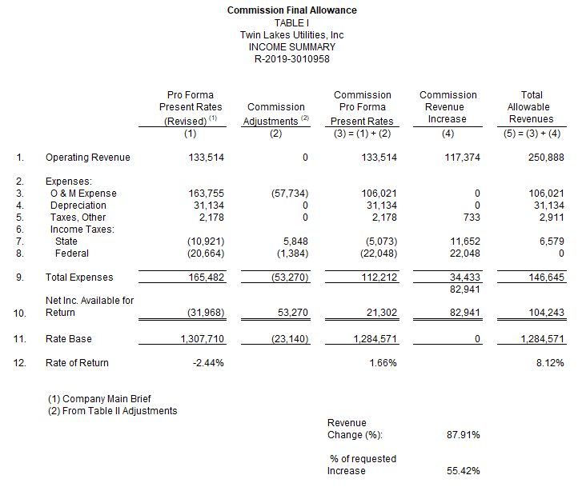

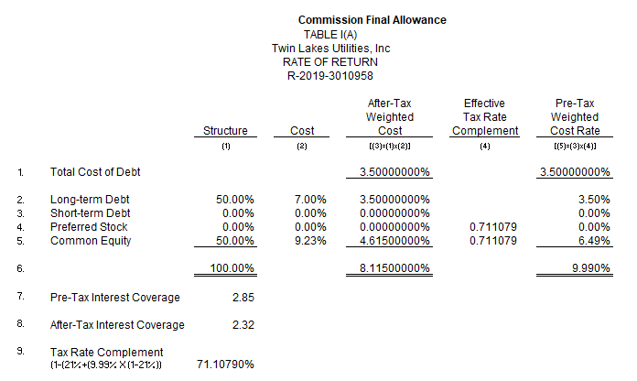
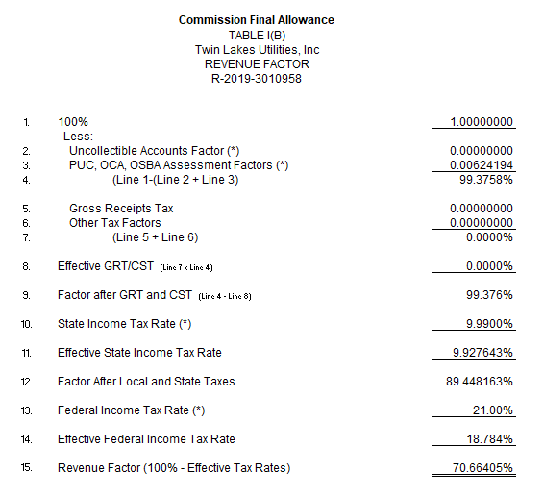
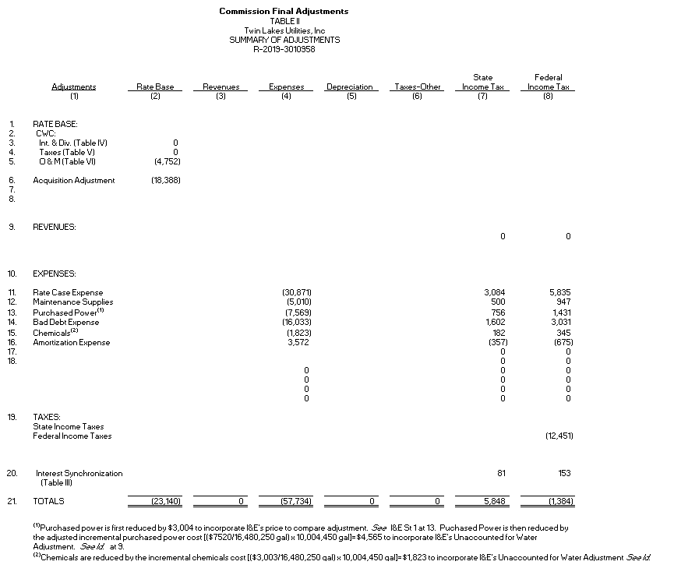

APPENDIX B

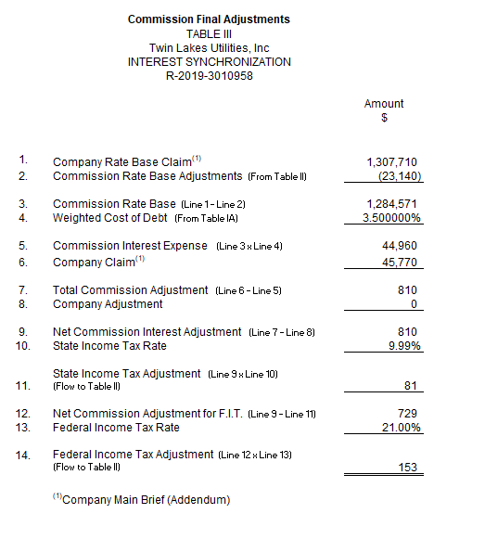
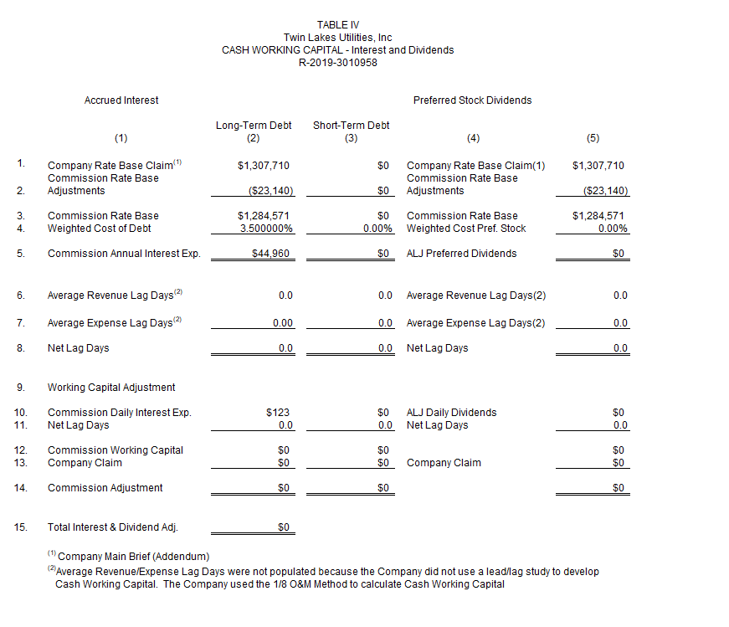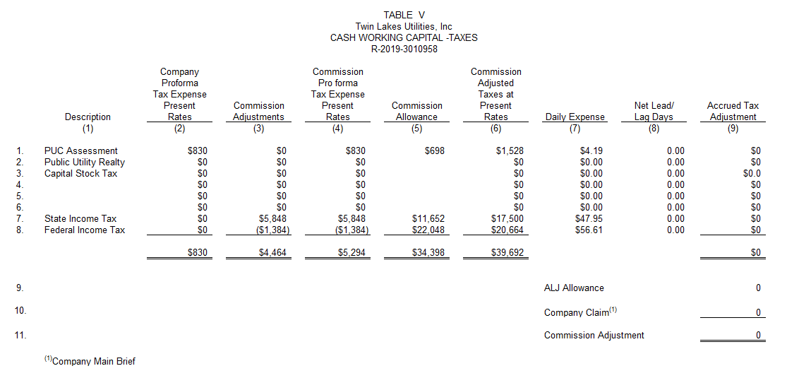

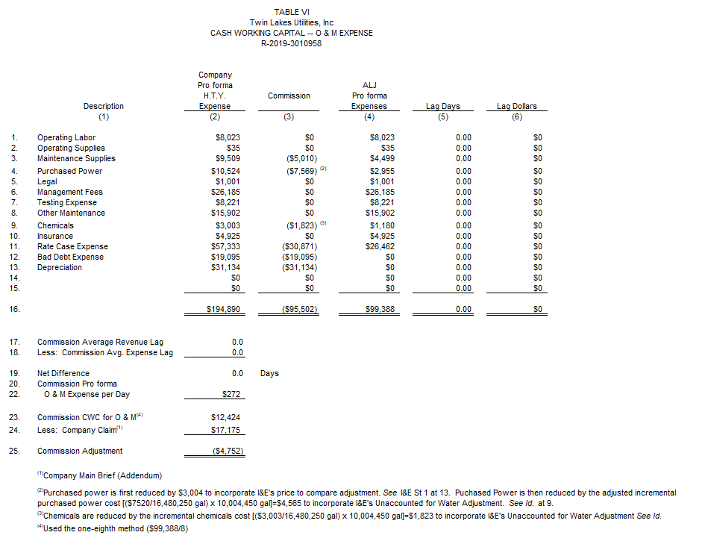

APPENDIX B

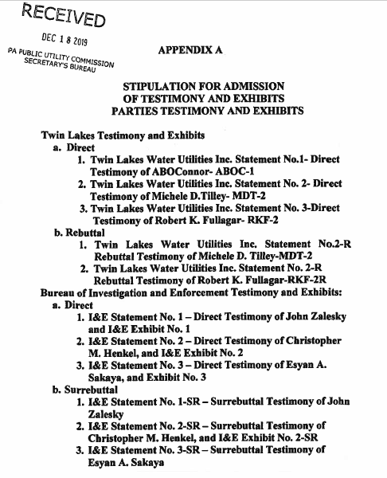

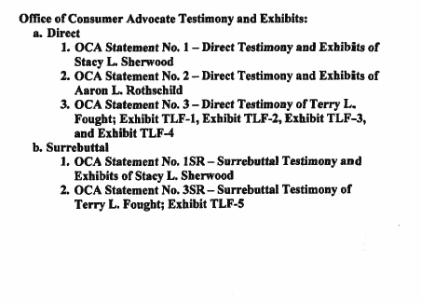

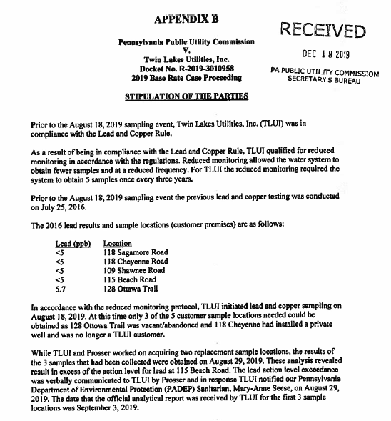

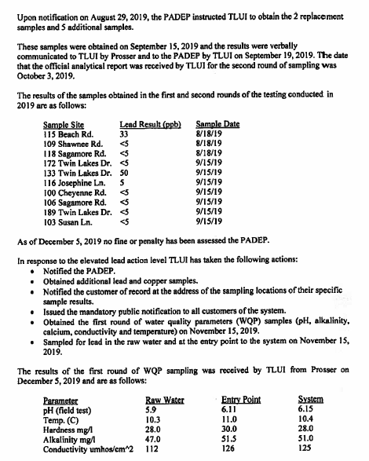

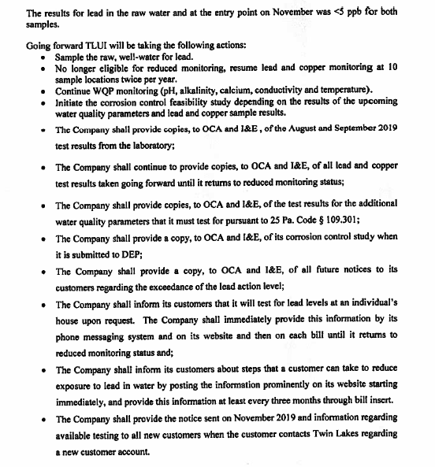

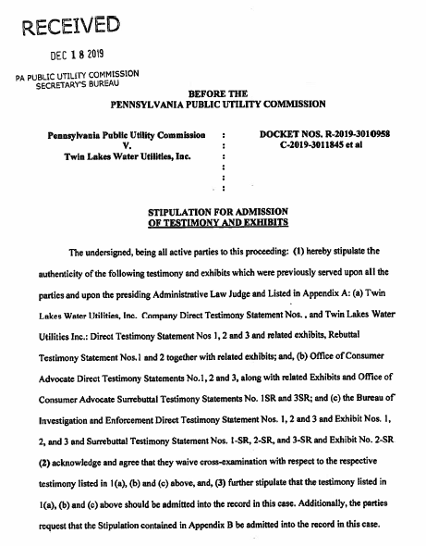
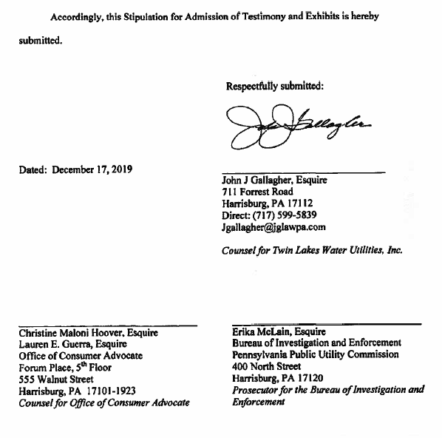

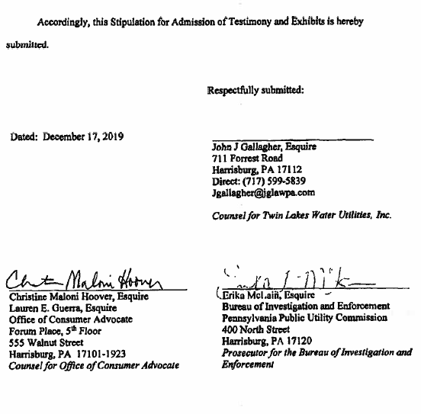

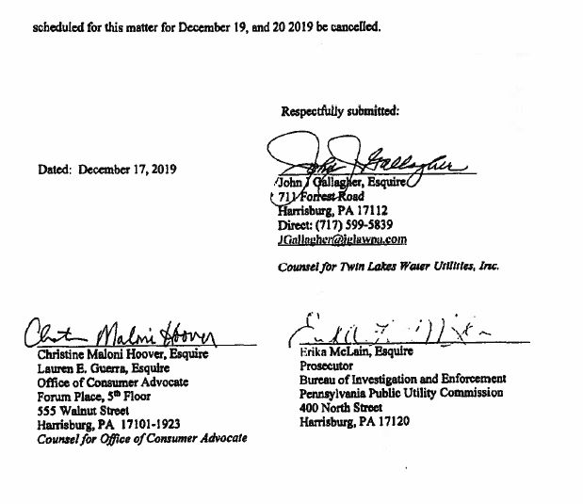

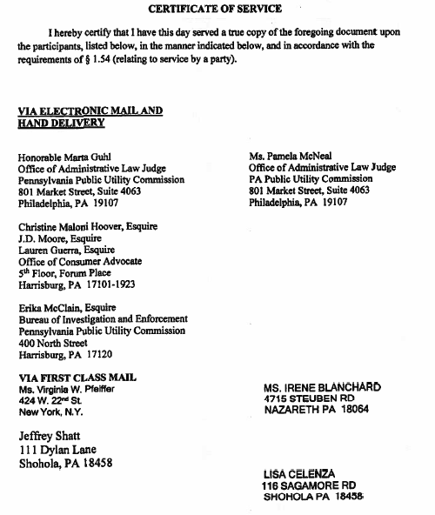

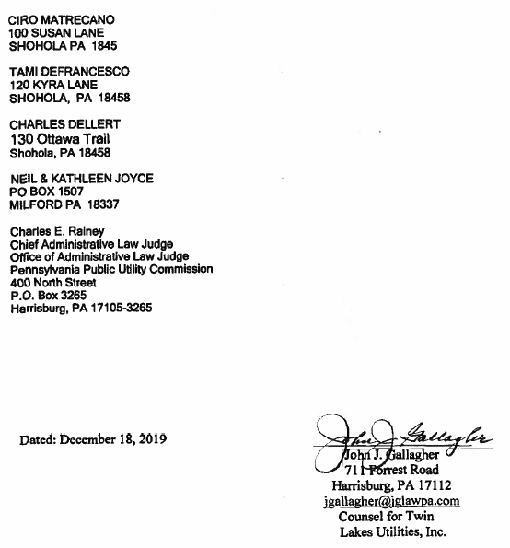

1 Pa. C.S. § 1922(1), PA Financial Responsibility Assigned Claims Plan v. English, 541 Pa. 424, 430-431, 64 A.2d 84, 87 (1995).
Although, we identified Revenues and Revenue Requirement as one of the ALJ’s uncontested recommendations, we shall address this issue later due to our modification of the ALJ’s recommendation regarding the amount for the allowance of the Company’s state income taxes.
In this proceeding, I&E did not challenge the validity of the Company’s original amount claimed as an Acquisition Adjustment. I&E only contested the proper calculation of the adjustment over time. R.D. at 17 (citing I&E M.B. at 7).
See, https://www.revenue.pa.gov/FormsandPublications/FormsforBusinesses/CorporationTax/Documents/2018/2018_rev-1200.pdf.
See, https://www.revenue.pa.gov/FormsandPublications/FormsforBusinesses/CorporationTax/Documents/2018/2018_rev-1200.pdf.
Although Rate of Return was not raised directly by the Exceptions and Replies regarding Quality of Service and Affordability of Rates, infra., the question of the appropriate calculation of the overall Rate of Return based on the assigned COE arises by implication where the Exceptions and Replies pertain to factors considered by the ALJ in rendering her recommendation on COE to yield an overall reasonable rate of return, included quality of service and affordability of rates. Therefore, to the extent the Exceptions and Replies, infra., implicate the appropriate calculation of COE, we shall address the issue in the context of our disposition of the Exception and Replies.
See, R.D. 55-68, 65-73 (ALJ’s summary of I&E’s and OCA’s expert testimony regarding a market-based analysis of COE).
I&E M.B. at 53 (citing United States Environmental Protection Agency. “Guidance: Coordinating CSO Long-term Planning with Water Quality Standards Reviews.” pp. 31-32 (July 2001), available at https://www3.epa.gov/npdes/pubs/wqs_guide_final.pdf.)

