March 27, 2020
Docket No. R-2020-3018835
Utility Code: 120700

Mr. Andrew S. Tubbs
Columbia Gas of Pennsylvania
800 N. 3rd Street, Suite 204
Harrisburg, PA 17102

RE: Request of Columbia Gas of Pennsylvania, Inc. for Waiver of 120 Day Filing Period Under 52 Pa. Code § 53.52(b)(2)

Dear Mr. Tubbs:

On March 24, 2020, Columbia Gas of Pennsylvania, Inc. (the Company) filed for a waiver of 52 Pa. Code § 53.52(b)(2) concerning the time period between the end of an historic test year and the date on which a proposed increase in base rates is filed. 52 Pa. Code § 53.52(b)(2) requires the supporting data be for a twelve-month period ending no more than 120 days prior to filing.

The Company requests a thirty (30) day extension granting authority to file data in support of a proposed increase in base rates based upon an historic test year ended November 30, 2019 on or before April 28, 2020. The Commission grants your request.

If you need further information or assistance, you may contact Marissa Boyle, Bureau of Technical Utility Services, at (717) 787-7237 or maboyle@pa.gov.

Sincerely,
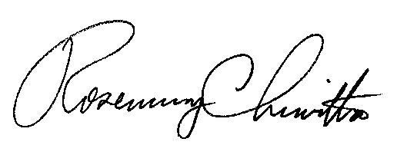

Rosemary Chiavetta
Secretary

