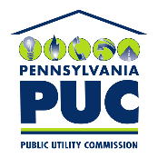 | COMMONWEALTH OF PENNSYLVANIA  PENNSYLVANIA PUBLIC UTILITY COMMISSION  P.O. BOX 3265, HARRISBURG, PA 17105-3265 | IN REPLY PLEASE REFER TO OUR FILE  M-2016-2554787

March 30, 2020

TO: All Parties of Record in Docket No. M-2016-2554787

RE: Petition of PPL Electric Utilities Corporation (PPL) to temporarily amend its current 2017-2022 Universal Service and Energy Conservation Plan (USECP or Plan)

On March 27, 2020, PPL filed a petition with the Pennsylvania Public Utility Commission (Commission), at this docket, to request a temporary change to the income eligibility requirements of its Operation HELP program from annual incomes at or below 200% of the federal poverty income guidelines (FPIG) to annual incomes at or below 250% of the FPIG. PPL proposes maintaining the revised income eligibility requirements for Operation Help through the end of 2020. PPL Petition at 1. PPL states that this request is in response to the COVID-19 emergency situation.

Operation HELP is PPL’s hardship fund and provides grants to residential customers who are low income with overdue balances and an inability to pay the full amount of their energy bills. Operation HELP is administered by 15 community-based organizations (CBOs) and operates year-round (funding-permitted) with ongoing corporate contributions and donations from its employees, retirees, and customers. Customers are currently eligible to apply for Operation HELP assistance if they have: (1) household incomes at or below 200% of the FPIG; (2) a current hardship; and (3) an inability to pay the full amount of energy bills. Hardships may include the death or serious illness of a primary wage earner and life-threatening situations. Operation HELP provides financial assistance for any type of energy bill (e.g., electric, gas, coal, and oil). A customer may not receive more than one Operation HELP grant per year. Operation HELP is fully funded through donations and corporate contributions; program costs are not recovered from ratepayers. See PPL’s 2017-2019 USECP, Docket No. M-2016-2554787, at 68-72 (filed on November 3, 2017).

PPL reports that the primary benefits of Operation HELP include: (1) direct financial assistance for overdue energy bills; (2) protection against shutoffs; and (3) referrals to other programs and services. PPL Petition at 1.

PPL explains it is making the request to temporarily expand the number of customers who may qualify for assistance under Operation HELP in response to the COVID-19 emergency situation. PPL reports that the Office of Consumer Advocate (OCA) and the Coalition for Affordable Utility Services and Energy Efficiency in Pennsylvania (CAUSE-PA) have been consulted and do not oppose this proposed change. PPL Petition at 1-2.

The Commission recognizes that households whose incomes exceed the eligibility limits for traditional energy assistance programs may be experiencing temporary financial hardships due to the COVID-19 crisis. Therefore, the Commission supports PPL’s proposal to temporarily increase its income limits for Operation HELP, which will not impact PPL’s universal service cost recovery mechanism, to help more customers address energy debt and maintain service through December 31, 2020.

Accordingly, the Commission hereby approves PPL’s Petition to increase the income eligibility threshold for Operation HELP from 200% of the FPIG to 250% of the FPIG through December 31, 2020. PPL is directed to reflect this temporary change on its website and communications with customers.

If you have any questions, please contact Joseph Magee in the Commission’s Bureau of Consumer Services at jmagee@pa.gov or 717-772-1204.

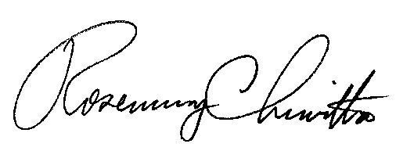
Sincerely,

Rosemary Chiavetta
Secretary
cc: Lori Mohr, BCS, laumohr@pa.gov
Joseph Magee, BCS, jmagee@pa.gov
Louise Fink Smith, finksmith@pa.gov
Parties of Record in M-2016-2554787

PPL’s current USECP, originally covering 2017 through 2019, was extended through 2022, pursuant to Commission order entered on October 3, 2019, at Docket M-2019-3012601. On January 6, 2020, PPL filed updated budget and enrollment projections for 2020, 2021, and 2022. Accordingly, the docket for PPL’s current USECP has been amended to reflect the additional years.
http://www.puc.pa.gov/pcdocs/1543006.pdf

