 | COMMONWEALTH OF PENNSYLVANIA  PENNSYLVANIA PUBLIC UTILITY COMMISSION  400 NORTH STREET, HARRISBURG, PA 17120  April 9, 2020 | IN REPLY PLEASE REFER TO OUR FILE

Docket No. P-2016-2526627
Utility Code: 110500

KIMBERLY A KLOCK
PPL ELECTRIC UTILITIES CORPORATION
TWO NORTH NINTH ST
ALLENTOWN PA 18101

Re: PPL Electric Utilities Corporation
Results of April 2020 Request for Proposals Process

Dear Ms. Klock.:

On April 8, 2020, PPL Electric Utilities Corporation (PPL or the Company) filed the results of its Request for Proposals (RFP) Process and Rules for the April 2020 Solicitation for provider of last resort service. The filing includes bid results for a Full Requirements RFP for Residential, Small Commercial & Industrial, and Large Commercial & Industrial customers who receive default service from PPL during the period June 1, 2020 through May 31, 2021.

This filing was submitted in accordance with the RFP Process and Rules filed by PPL on July 19, 2016 as part of a Joint Petition for Partial Settlement. The RFP Process and Rules were approved as modified by the Partial Settlement in the Commission’s Opinion and Order, entered October 27, 2016, at Docket No. P-2016-2526627.

PPL requests that the Commission approve the bid results of the April 2020 Solicitation on or before April 9, 2020.

Further investigation does not appear to be warranted at this time, since the results of the April 2020 Solicitation appear to have been conducted in accordance with the RFP Process and Rules as approved by the Commission.

Therefore, we direct PPL to disclose the results of this April 2020 Solicitation in accordance with the Commission’s Secretarial Letter in Re: Disclosure of Default Service Solicitation Results and Creation of a Default Service Rate Calculation Model, issued October 12, 2010 at Docket No. M-2009-2082042.

Please direct any questions to Debra Backer, Energy Supervisor, Bureau of Technical Utility Services, at (717) 783-9787.

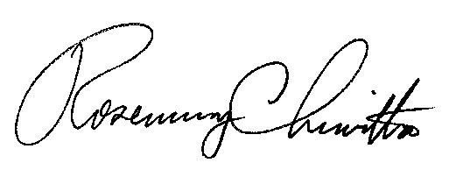
Sincerely,

Rosemary Chiavetta
Secretary
cc: All Parties of Record

