COMMONWEALTH OF PENNSYLVANIA
PENNSYLVANIA PUBLIC UTILITY COMMISSION
400 NORTH STREET, HARRISBURG, PA 17120

April 24, 2020
Docket No: A-2020-3019470
Utility Code: 1723099

NNE Resources LLC
707 Virginia St E, Suite 1200
Charleston, WV 25301

Re: Annual Pipeline Operator Registration

Dear NNE Resources LLC:

This letter acknowledges the receipt of your company’s Pipeline Operator Registration Form. The docket number assigned to your company is

A-2020-3019470. Please refer to this number in all future correspondence with the Pennsylvania Public Utility Commission.

Should you have any questions pertaining to your registration, please contact the Bureau of Technical Utility Services at 717-783-5242, or email your questions to ra-Act127@pa.gov.

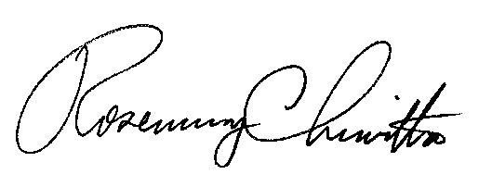
Sincerely,

Rosemary Chiavetta

Secretary

cc:

Amy Zuvich
Bureau of Administration, Financial & Assessments

