BEFORE THE
PENNSYLVANIA PUBLIC UTILITY COMMISSION

Noreen McCarthy :
:
v. : C-2019-3006923
:
Metropolitan Edison Company :

INTERIM ORDER
HOLDING OUTSTANDING MOTIONS IN ABEYANCE

By Notice dated March 31, 2020, this case was reassigned from Administrative Law Judge Jeffrey A. Watson to me for hearing. By Notice dated April 28, 2020, the Parties were informed that this case is scheduled for a telephonic hearing on July 14, 2020, at 10:00 a.m. Any motions in this case that have not been ruled upon and remain outstanding are held in abeyance. Outstanding motions will be addressed at the July 14, 2020 evidentiary hearing, during which the Parties must be prepared to present their testimony and evidence.

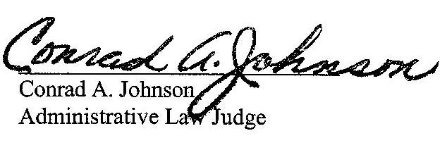
Date: May 4, 2020

C-2019-3006923 - NOREEN MCCARTHY v. METROPOLITAN EDISON COMPANY
NOREEN MCCARTHY
18 MILLSTONE LANE
POTTSTOWN PA 19465
610.469.2009
ACCEPTS E-SERVICE
LAUREN M LEPKOSKI ESQUIRE
TORI L GIESLER ESQUIRE
FIRSTENERGY
2800 Pottsville Pike
PO BOX 16001
READING PA 19612-6001
610.921.6203
610.921.6658
ACCEPTS E-SERVICE

