June 15, 2020
A-8922831
R-2020-3020356

TRISTATE HOUSEHOLD GOODS TARIFF CONFERENCE INC
ATTN CHARLIE MORRIS
P O BOX 6125
LANCASTER PA 17607-6125

RE: Brier Moving Company, LLC -- Tariff Filing

Mr. Morris:

On June 4, 2020, the 316th Page 2, 1St Revised Page 23-B. and 1st Revised Page 23-B-1, to Tristate Tariff Freight Pa. P.U.C. No. 54 were filed for the Commission’s approval. The filing was accepted for filing and docketed with the Public Utility Commission.

These revised pages to Tristate Tariff Freight Pa. P.U.C. No. 54 have been accepted and approved. The proposed changes shall be effective as per July 6, 2020 (except as noted in the officially filed tariff).

This case shall now be marked closed.

Very truly yours,

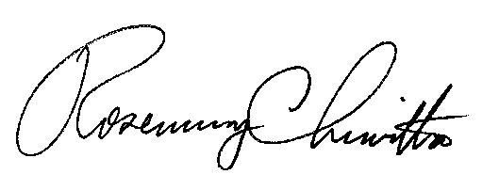

Rosemary Chiavetta
Secretary

