From: Sophy, Kathryn G <ksophy@pa.gov>
Sent: Monday, June 22, 2020 9:39 AM
To: Spunaugle, Shirley A <sspunaugle@pa.gov>; Chiavetta, Rosemary <rchiavetta@pa.gov>
Subject: RE: [External] PECO Life Service/Depreciation Study

Yes. Changing the regulation will take some time unfortunately.

From: Spunaugle, Shirley A <sspunaugle@pa.gov>
Sent: Monday, June 22, 2020 9:37 AM
To: Sophy, Kathryn G <ksophy@pa.gov>; Chiavetta, Rosemary <rchiavetta@pa.gov>
Subject: RE: [External] PECO Life Service/Depreciation Study

I pulled up the referenced docket Amy notates and it is for Peco Gas at M-2015-2476839. Bert notes that it was assigned to OSA in error and that TUS reviews these. I am not sure why after all this time the Code was never updated to reflect this or if there is something that prevents us from doing so? Here are the notes from that docket.

I will ask Amy to refile with the info you provided below. Do you both feel it is safe for me to update our instructions to assign to TUS?

Thank you for all your help!

Shirley

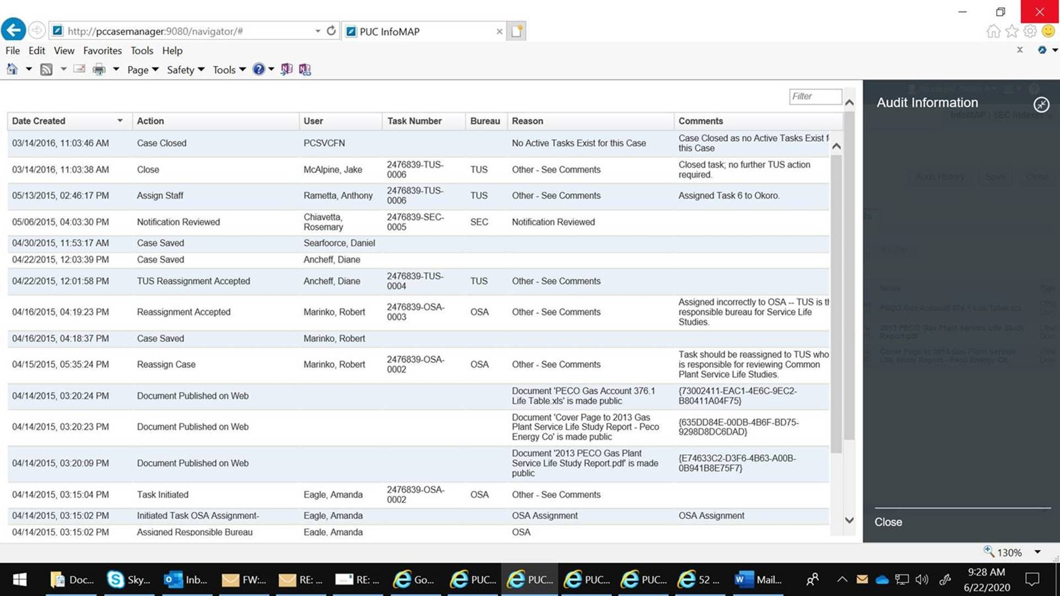

From: Sophy, Kathryn G <ksophy@pa.gov>
Sent: Monday, June 22, 2020 9:05 AM
To: Spunaugle, Shirley A <sspunaugle@pa.gov>; Chiavetta, Rosemary <rchiavetta@pa.gov>
Subject: RE: [External] PECO Life Service/Depreciation Study

I had no idea anything came through that wasn’t also sent to the Sec Bureau. I have searched my email and the OSA RA account. I can find nothing on this.

I have no reason to doubt it was sent, but I don’t have it. I get a lot of courtesy emails that may never cross our assignments. I may have assumed it was something like that and deleted it. If the deadline is regulatory (from 52 Pa. Code), we can either waive the deadline or receive a re-filing as nunc pro tunc (literally translated as “now for then” and means we’ll take the filing now but deem it as filed back when it was due).

They can refile (copy the Secretary) and note that the original filing was never docketed due to the office closing. As far as why this regulation requires filing with OSA and no one else – I am at a loss. I cannot imagine why anything would be filed only with OSA. Seems this is something TUS would look at if there were no adversaries. I’m going to have to scour the procedures manual for guidance. I honestly don’t know what OSA would be expected to do with such a filing.

From now on, I will take a closer look at emails from the industry and forward to Sec Bureau if you are not a recipient.

From: Spunaugle, Shirley A <sspunaugle@pa.gov>
Sent: Monday, June 22, 2020 8:43 AM
To: Sophy, Kathryn G <ksophy@pa.gov>; Chiavetta, Rosemary <rchiavetta@pa.gov>
Subject: FW: [External] PECO Life Service/Depreciation Study
Importance: High

Good morning Kathy,

Hope you had a great long weekend! Currently Rosemary is unavailable but will be back in the loop after lunch.

As noted below, Amy states she filed Peco’s Service Life Study with OSA via email in April due to COVID. Previously these have always been filed hard copy addressed to Cheryl, but Sec Bureau would docket high priority as a M and assign to OSA with a task to TUS.

I am not sure why the Code states to file directly with OSA. Is this something that should in fact be docketed as a M, and should we request the Code be revised to notate file with the Secretary? I have included our processing instructions below for reference.

Thank you for your help with this matter and hope your day is fabulous!

Shirley

Service Life Study: Date stamp, scan. THESE ARE HIGH PRIORITY!!! Filed per 52 Pa. Code § 73.5(a) Gets new M#. Assign OSA with tasks to OSA and TUS. (M)MISCELLANEOUS - OTHER

From: Neufeld, Amy W:(PECO) <Amy.Neufeld@exeloncorp.com>
Sent: Friday, June 19, 2020 2:16 PM
To: Spunaugle, Shirley A <sspunaugle@pa.gov>
Subject: [External] PECO Life Service/Depreciation Study
Importance: High

ATTENTION: This email message is from an external sender. Do not open links or attachments from unknown sources. To report suspicious email, forward the message as an attachment to CWOPA_SPAM@pa.gov.
Hello Shirley!
Hope this finds you well and a bit less busy as before (although it isn’t letting up here, so I’m sure it isn’t for you, too).
I had a basic, education question and you were the first person I thought to ask. The basic question is whether a filing we did via email to a Bureau other than the Secretary’s Bureau would get a docket number automatically assigned? Here’s some background:

In April, we filed our Life Study Report – also called the Depreciation Study (one each for electric and gas), which is due every five years and, per the regs (52 Pa. Code Sec. 73.5), gets filed directly with OSA (and sent to advocates as well). We did this filing via email to OSA (we didn’t e-file as it was to be filed directly with OSA). We are looking to reference this filing for another filing we are making, so wanted to include a docket number. After looking on the PUC’s website, we couldn’t find it. I did find one filed in 2015 (here is the cover letter: http://www.puc.pa.gov//pcdocs/1353478.pdf) BUT, back then, we filed an actual hard copy letter and report back then, so maybe that is why a docket number was generated?

Do you have any education you can share with me here? Or is there someone else I could ask, like going right to OSA? No rush, but I do appreciate any direction you could give me!

Hope all is well!
Amy

Amy W. Neufeld, Esq.
Regulatory Affairs Manager
PECO Energy Co.
500 North Third St., Suite 800
Harrisburg, PA 17101
Office: (717) 901-9846
Cell: (215) 218-8523

