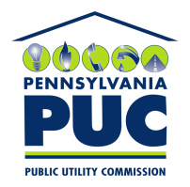 | COMMONWEALTH OF PENNSYLVANIA  PENNSYLVANIA PUBLIC UTILITY COMMISSION  400 NORTH STREET, KEYSTONE BUILDING, SECOND FLOOR  HARRISBURG, PENNSYLVANIA 17120 | IN REPLY PLEASE REFER TO OUR FILE

June 30, 2020

Via Certified Mail

Ted Basta
Nordic Energy Services LLC
One Tower Lane Suite 300
Oakbrook Terrace IL 60181

RE: Bond Continuation
Nordic Energy Services LLC
A-2011-2260255

Dear Mr. Basta:

Please find under cover of this letter the financial instrument filed with the Commission on behalf of Nordic Energy Services LLC because it is a photocopy, and not acceptable.

The Commission requires a supplier to file an original bond, letter of credit, continuation certificate, amendment, or other financial instrument as part of a supplier’s licensing requirements under Section 2809(c) of the Pennsylvania Public Utility Code.

The enclosed financial instrument does not have a "wet ink" original signature or raised seal for the surety company. Please file the original financial instrument with my office within 30 days of the date of this letter, preferably by overnight delivery to my office address listed above. If you are unable to meet this deadline due to the ongoing pandemic emergency of COVID-19, please email Secretary Rosemary Chiavetta at rchiavetta@pa.gov.

Sincerely,

Rosemary Chiavetta
Secretary of the Commission

RC: alw
Enclosures

