July 14, 2020
A-00099051
R-2020-3020767

TRISTATE HOUSEHOLD GOODS TARIFF CONFERENCE INC
ATTN CHARLIE MORRIS
P O BOX 6125
LANCASTER PA 17607-6125

RE: for William H. Kies, Jr., t/a Harry M. Kies Moving -- Tariff Filing

Mr. Morris:

On July 8, 2020, the 322nd Page 2, 194th Revised Page 2-A, 88th Revised Page 6, Original Page 63-2, and Original 63-2-A, to Tristate Tariff Freight Pa. P.U.C. No. 54 were filed for the Commission’s approval. The filing was accepted for filing and docketed with the Public Utility Commission.

These revised pages to Tristate Tariff Freight Pa. P.U.C. No. 54 have been accepted and approved. The proposed changes shall be effective as per August 10, 2020 (except as noted in the officially filed tariff).

This case shall now be marked closed.

Very truly yours,
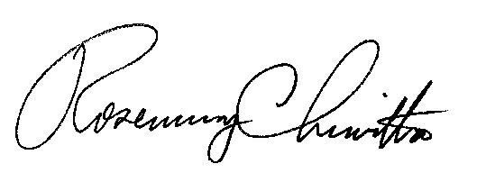

Rosemary Chiavetta
Secretary

