July 14, 2020

A-00097635
R-2020-3020768

CHARLIE MORRIS CONSULTING LLC
23 TURNBRIDGE DRIVE
LANCASTER PA 17603-9583

RE: James C. Logan, Inc. – Tariff Filing

Mr. Morris:

On July 2, 2019, Freight Pa. P.U.C. No. 22 was filed for the Commission’s approval. The filing was accepted for filing and docketed with the Public Utility Commission.

Freight Pa. P.U.C. No. 22 has been accepted and approved. The proposed changes shall be effective as per August 5, 2020. This case shall now be marked closed.

Very truly yours,
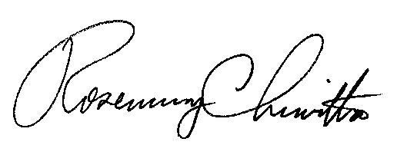

Rosemary Chiavetta
Secretary

