BEFORE THE
PENNSYLVANIA PUBLIC UTILITY COMMISSION

Noreen McCarthy :
:
v. : C-2019-3006923
:
Metropolitan Edison Company :

THIRD INTERIM ORDER
CLOSING THE RECORD

AND NOW, the hearing in this case having been held on July 14, 2020, and no further hearings in this matter are to be scheduled or held,

THEREFORE,

IT IS ORDERED:

- That the record at Docket No. C-2019-3006923 is closed.

2. That the Initial Decision in this case shall be prepared and issued.

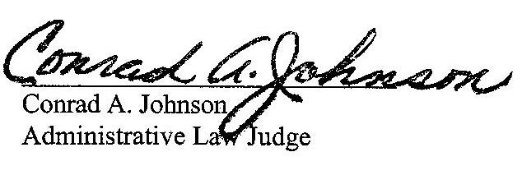
Dated: July 17, 2020

C-2019-3006923 - NOREEN MCCARTHY v. METROPOLITAN EDISON COMPANY
NOREEN MCCARTHY
18 MILLSTONE LANE
POTTSTOWN PA 19465
610.469.2009
ACCEPTS E-SERVICE
LAUREN M LEPKOSKI ESQUIRE
TORI L GIESLER ESQUIRE
FIRSTENERGY
2800 Pottsville Pike
PO BOX 16001
READING PA 19612-6001
610.921.6203
610.921.6658
ACCEPTS E-SERVICE

