 | COMMONWEALTH OF PENNSYLVANIA  PENNSYLVANIA PUBLIC UTILITY COMMISSION  400 NORTH STREET, HARRISBURG, PA 17120 | IN REPLY PLEASE REFER TO OUR FILE
July 21, 2020
Docket No. A-2020-3020776
Utility Code: 1223274
CERTIFIED

ANN MARIE TOSS CCO
SMARTENERGY HOLDINGS LLC
400 MADISON AVE STE 9A
NEW YORK NY 10017

RE: Natural Gas Supplier License Application

Dear Ms. Toss:

On July 13, 2020, the Public Utility Commission accepted SmartEnergy Holdings, LLC’s application for a Natural Gas Supplier license. The application was incomplete. In order for us to complete our analysis of your application, the Energy Industry Group requires answers to the attached question(s).

Please be advised that you are directed to forward the requested information to the Commission within 30 days of receipt of this letter. Failure to respond may result in the application being denied. As well, if SmartEnergy Holdings, LLC has decided to withdraw its application, please reply notifying the Commission of such a decision.

Please forward the information to the Secretary of the Commission at the address listed below. When submitting documents, all documents requiring notary stamps must have original signatures. Please note that some responses may be e-filed to your case, http://www.puc.pa.gov/efiling/default.aspx. A list of document types allowed to be e-filed can be found at http://www.puc.pa.gov/efiling/DocTypes.aspx.

Rosemary Chiavetta, Secretary
Pennsylvania Public Utility Commission
400 North Street
Harrisburg, PA 17120

Your answers should be verified per 52 Pa Code § 1.36. Accordingly, you must provide the following statement with your responses:

I, ________________, hereby state that the facts above set forth are true and correct to the best of my knowledge, information and belief, and that I expect to be able to prove the same at a hearing held in this matter. I understand that the statements herein are made subject to the penalties of 18 Pa. C.S. § 4904 (relating to unsworn falsification to authorities).

The blank should be filled in with the name of the appropriate company representative, and the signature of that representative should follow the statement.

In addition, to expedite completion of the application, please also e-mail the information to Jeff McCracken at jmccracken@pa.gov. Please direct any questions to Jeff McCracken, Bureau of Technical Utility Services, at jmccracken@pa.gov (preferred) or (717) 783-6163.

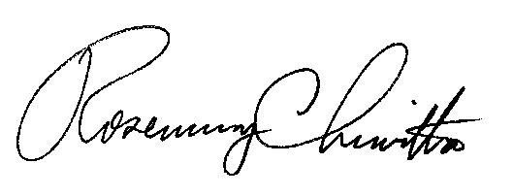
Sincerely,

Rosemary Chiavetta
Secretary

Enclosure

Docket No. A-2020-3020776
SmartEnergy Holdings, LLC
Data Requests

1. Reference Application, Section 1.b, Registered Agent – Applicant’s Registered Agent information does not match the information listed on the Commercial Registered Office Providers website. Please provide an updated application page with the appropriate corrections.

http://www.dos.pa.gov/BusinessCharities/Business/Resources/Pages/Commercial-Registered-Office-Providers.aspx#.Vp-Q4GQo6zV

2. Reference Application, Sections 5.c and 5.d, Customer/Regulatory/Prosecutory Actions – Please provide a detailed response with summaries of any cases, including dates, issues and resolutions.

