BEFORE THE
PENNSYLVANIA PUBLIC UTILITY COMMISSION

Darnell Jones :
:
v. : C-2019-3014574
:
Duquesne Light Company

INTERIM ORDER
ADMITTING LATE-FILED EXHIBIT AND CLOSING THE RECORD

AND NOW, the hearing in this case having been held on June 19, 2020, with the record to remain open until July 24, 2020, for the submission of late-filed exhibits and any objection thereto; and Complainant having submitted on July 8, 2020, one exhibit consisting of 17 pages, herein marked as Complainant’s Exhibit A; and on July 8, 2020, Respondent’s counsel, via email, having represented that Respondent did not have any objection to Complainant’s late-filed exhibit; and no further hearings in this matter are to be scheduled or held.

THEREFORE,

IT IS ORDERED:

- That Complainant’s late-filed Exhibit A, consisting of 17 pages, is admitted into the record.

- That the record at Docket No. C-2019-3014574 is closed.

3. That the Initial Decision in this case shall be prepared and issued.

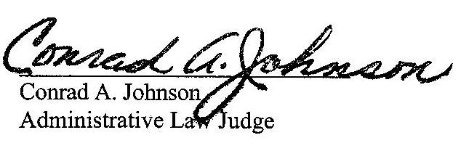
Dated: July 29, 2020
C-2019-3014574 - DARNELL JONES v. DUQUESNE LIGHT COMPANY
DARNELL D JONES
1210 HOLMES STREET
APARTMENT 1
MCKEES ROCKS PA 15136
412.587.3496
EMILY M FARAH COUNSEL
DUQUESNE LIGHT COMPANY
411 SEVENTH AVENUE
PITTSBURGH PA 15219
412.393.6431
ACCEPTS eService

