 | COMMONWEALTH OF PENNSYLVANIA  PENNSYLVANIA PUBLIC UTILITY COMMISSION  400 NORTH STREET, HARRISBURG, PA 17120 | IN REPLY PLEASE REFER TO OUR FILE
July 29, 2020
Docket No. A-2020-3020380
Utility Code: 1123219
CERTIFIED

DIANA BURCKHART GOVERNMENT AND REGULATORY AFFAIRS SPECIALIST
DIRECT ENERGY
867 BERKSHIRE BLVD STE 101
WYOMISSING PA 19610

RE: Electric Generation Supplier License Application

Dear Ms. Burckhart:

On June 15, 2020, the Public Utility Commission accepted Bounce Energy, Inc.’s application for an Electric Generation Supplier license. The application was incomplete. In order for us to complete our analysis of your application, the Energy Industry Group requires answers to the attached question(s).

Please be advised that you are directed to forward the requested information to the Commission within 30 days from the date of this letter. Failure to respond may result in the application being denied. As well, if Bounce Energy, Inc. has decided to withdraw its application, please reply notifying the Commission of such a decision.

Please forward the information to the Secretary of the Commission at the address listed below. When submitting documents, all documents requiring notary stamps must have original signatures. Please note that some responses may be e-filed to your case, http://www.puc.pa.gov/efiling/default.aspx. A list of document types allowed to be e-filed can be found at http://www.puc.pa.gov/efiling/DocTypes.aspx.

Rosemary Chiavetta, Secretary
Pennsylvania Public Utility Commission
400 North Street
Harrisburg, PA 17120

Your answers should be verified per 52 Pa Code § 1.36. Accordingly, you must provide the following statement with your responses:

I, ________________, hereby state that the facts above set forth are true and correct to the best of my knowledge, information and belief, and that I expect to be able to prove the same at a hearing held in this matter. I understand that the statements herein are made subject to the penalties of 18 Pa. C.S. § 4904 (relating to unsworn falsification to authorities).

The blank should be filled in with the name of the appropriate company representative, and the signature of that representative should follow the statement.

In addition, to expedite completion of the application, please also e-mail the information to Jeremy Haring at jharing@pa.gov. Please direct any questions to Jeremy Haring, Bureau of Technical Utility Services, at jharing@pa.gov (preferred) or (717) 783-6175.

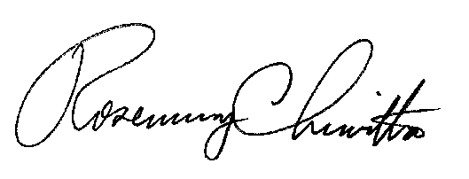
Sincerely,

Rosemary Chiavetta
Secretary

Enclosure

Docket No. A-2020-3020380
Bounce Energy, Inc.
Data Requests

- Reference Application, Section 3.a and 3.b, Affiliates and Predecessors – Applicant listed Direct Energy as an affiliate.

  - Please provide an organizational chart showing how Bounce Energy, Inc. fits in with Direct Energy.

  - News has been circulating regarding NRG Energy Inc acquiring Direct Energy. Please explain if this acquisition will affect the organizational chart or any details in this application.

- Reference Application, Section 4.b., Applicants Proposed Operations – Applicant indicated an intention to operate as a broker/marketer. Please specify if Bounce Energy, Inc. will only be providing broker/marketer services for one supplier or if its broker/marketer services will be provided to multiple EGS suppliers.

3. Reference Application, Section 4.b., Applicants Proposed Operations – Applicant did not check the box to verify that your organization will not be taking title to electricity nor will you be making payments for customers. Please affirm whether your organization will be taking title to electricity and/or making payments for customers.

