BEFORE THE
PENNSYLVANIA PUBLIC UTILITY COMMISSION

Todd Koger :
:
- : C-2019-3013238
:
Duquesne Light Company :

FIRST INTERIM ORDER
ADDRESSING COMPLAINANT’S MOTION

Todd Koger (Complainant) electronically mailed a motion captioned “New-Matter Motion to Reopen Record” to the undersigned and to counsel for Duquesne Light Company (Respondent). Complainant did not file the motion with the Commission’s Secretary. Complainant does not have an e-mail address for e-filing and e-service, or for communication regarding this proceeding. Attempts to contact Complainant by telephone regarding this intended filing have been unsuccessful.

Complainant is representing himself in this proceeding. In an effort to afford him the opportunity to correctly file his intended motion with the Commission’s Secretary and serve it on counsel for Duquesne Light Company, Complainant is directed to file the intended motion on or before August 19, 2020. If the motion is not filed and served by that date, an interim order will be issued closing the record. Respondent shall file a response to any motion filed by Complainant within 20 days of electronic service of Complainant’s motion on Respondent.

THEREFORE,

IT IS ORDERED:

- That Complainant shall file his motion with the Commission’s Secretary
in accordance with the following:
Due to the COVID-19 Pandemic, employees of the Secretary’s Bureau are working remotely and not accepting filings via U.S. Mail. Please follow the instructions attached hereto and made a part hereof to register for an e-filing account.

- That Complainant shall e-serve a copy of the motion on counsel for the
Respondent and the undersigned.

Date: August 5, 2020 /s/
Mark A. Hoyer Deputy Chief Administrative Law Judge

eFiling Subscription Services | 
What is an eFiling subscription and what are the benefits? | www.puc.pa.gov

eFile subscriptions allow users to automatically receive an email notification whenever a document is added, removed or changed on the PUC website that meets specific criteria. For example, a user may have saved a subscription that will notify them whenever a document is added, removed or changed for a specific document number or for documents of a specific type (such as a press release).
Do I need an eFiling account to sign up for subscriptions?
Yes, you establish an eFiling account, then log into your eFiling account and select “subscriptions” on left hand side of screen. (Screen shot below):
How do I add a new Subscription service?

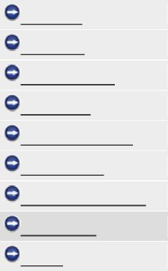
My Filings
New Filing
Modify Account POR Search eService Directory Subscriptions Technical Assistance eFiling FAQs Log Off
To create a subscription, fill out the properties shown on the screen (see below for screen shot of properties). You must provide either a Docket Number or select a document type, but you are not required to provide both. The utility type field is optional and may be selected to help narrow down the results of the subscription. You can view the results of the subscription by clicking the “view subscription results” link below. To save the subscription, click the “save subscription button”.
View Subscription Results

How will I get notified of updates to a case I subscribed to?
Save Subscription |  | Back to Subscription List

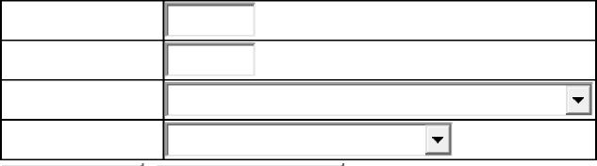
Utility Type:
Subscription Name: *
Docket Number:
Document Type:
Subscription notifications run twice a day. You will receive one email for each subscription you have created if there are documents that were added, removed or changed that meet the subscription criteria you defined.
Sign Up for Eservice
Step-by-Step

1) Click on PUC hyperlink provided in email
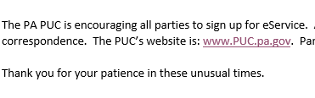

2) Click on “Filing & Resources” tab at the top


3) Click on “eFiling” under “Filing and/or Obtaining Information”
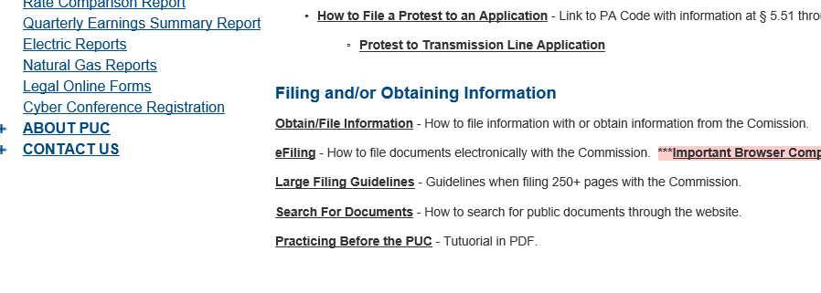

4) Click on “individual account” hyperlink
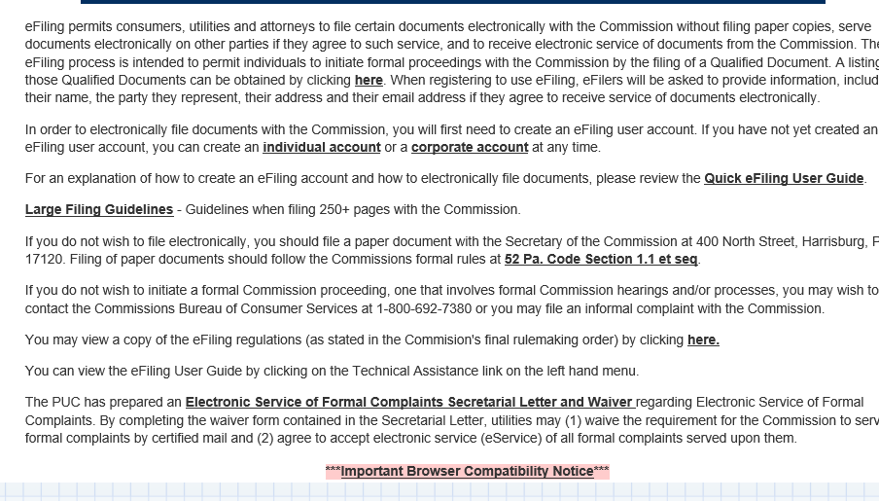
5) Fill out entire form
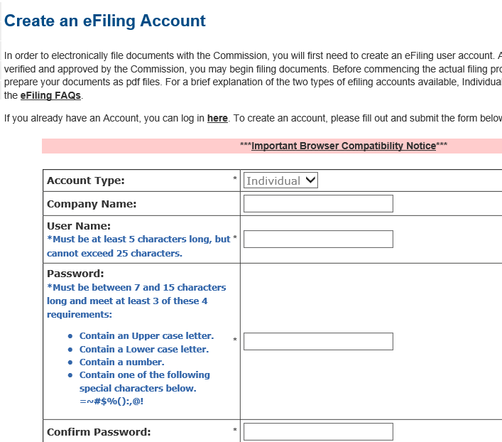

C-2019-3013238 - TODD KOGER V. DUQUESNE LIGHT COMPANY
TODD KOGER
515 KELLY AVENUE
PITTSBURGH PA 15221
412.758.4510
EMILY M FARAH COUNSEL
DUQUESNE LIGHT COMPANY
411 SEVENTH AVENUE
PITTSBURGH PA 15219
412.393.6431
ACCEPTS E-SERVICE

