 | COMMONWEALTH OF PENNSYLVANIA  PENNSYLVANIA PUBLIC UTILITY COMMISSION  400 NORTH ST, HARRISBURG, PA 17120 | IN REPLY PLEASE REFER TO OUR FILE

August 10, 2020
A- 8923356
A-2020-3021201

FAIRPRICE MOVERS INC
202 INDEPENDENCE ST
BLANDON PA 19510

RE: A-2020-3002109 –Application of Fairprice Movers, Inc., 202 Independence St., Blandon, Berks County, Pa 19510

To Whom It May Concern:

The purpose of this Letter is to advise you that your Application, Docket No. A-2020-3021201, has been DENIED by the Pennsylvania Public Utility Commission (Commission). The Commission has determined that a Certificate of Public Convenience WILL NOT BE GRANTED for the following reason(s):

- Failure to provide evidence of minimum of two-years’ experience with a licensed household goods carrier as required by 52 Pa. Code §3.381(c)(1)(iii)(A)(II)(-l-).

For this reason(s), your application is DENIED and DISMISSED. If you disagree with this decision, you may request that the Commission reconsider this matter under 52 Pa. Code §5.44. A petition for reconsideration must be filed with the Commission within twenty (20) days of the date of this Letter. If no timely request for reconsideration is made, this action will be deemed to be the final action of the Commission.

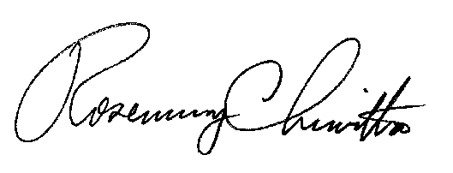
Very truly yours,

Rosemary Chiavetta
Secretary

