 | COMMONWEALTH OF PENNSYLVANIA  PENNSYLVANIA PUBLIC UTILITY COMMISSION  400 NORTH STREET, HARRISBURG, PA 17120 | IN REPLY PLEASE REFER TO OUR FILE
August 11, 2020
Docket No. A-2020-3020316
Utility Code: 1123208
CERTIFIED

CRAIG WILSON PRESIDENT & CEO
BREAKERBOX LLC
P.O. BOX 810
NEWBURYPORT, MA 01950

RE: Electric Generation Supplier License Application

Dear Mr. Wilson:

On June 9, 2020, the Public Utility Commission accepted Breakerbox, LLC’s application for an Electric Generation Supplier license. The application was incomplete. In order for us to complete our analysis of your application, the Energy Industry Group requires answers to the attached question(s).

Please be advised that you are directed to forward the requested information to the Commission within 30 days from the date of this letter. Failure to respond may result in the application being denied. As well, if Breakerbox, LLC has decided to withdraw its application, please reply notifying the Commission of such a decision.

Please forward the information to the Secretary of the Commission at the address listed below. When submitting documents, all documents requiring notary stamps must have original signatures. Please note that some responses may be e-filed to your case, http://www.puc.pa.gov/efiling/default.aspx. A list of document types allowed to be e-filed can be found at http://www.puc.pa.gov/efiling/DocTypes.aspx.

Rosemary Chiavetta, Secretary
Pennsylvania Public Utility Commission
400 North Street
Harrisburg, PA 17120

Your answers should be verified per 52 Pa Code § 1.36. Accordingly, you must provide the following statement with your responses:

I, ________________, hereby state that the facts above set forth are true and correct to the best of my knowledge, information and belief, and that I expect to be able to prove the same at a hearing held in this matter. I understand that the statements herein are made subject to the penalties of 18 Pa. C.S. § 4904 (relating to unsworn falsification to authorities).

The blank should be filled in with the name of the appropriate company representative, and the signature of that representative should follow the statement.

In addition, to expedite completion of the application, please also e-mail the information to Lee Yalcin at lyalcin@pa.gov. Please direct any questions to Lee Yalcin, Bureau of Technical Utility Services, at lyalcin@pa.gov (preferred) or (717) 787-6723.

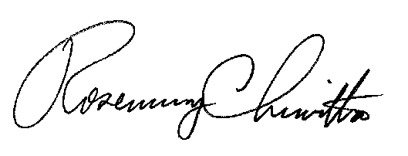
Sincerely,

Rosemary Chiavetta
Secretary

cc: Amy Klaviter

Enclosure

Docket No. A-2020-3020316
Breakerbox, LLC
Data Requests

- Reference Application, Section 7.b, Financial Fitness – Applicant did not provide sufficient documentation to demonstrate financial fitness. Please provide the following items:

- Proof of a corporate agreement, drawdown or credit agreement between Breakerbox and its parent company Exelon Generation Company which gives Breakerbox access to funds, spelling out the amounts, terms and rates of monies available to Breakerbox.

- A minimum of three consecutive months of recent Bank statements for Breakerbox indicating transactions and available funds.

