 | COMMONWEALTH OF PENNSYLVANIA  PENNSYLVANIA PUBLIC UTILITY COMMISSION  400 NORTH STREET, HARRISBURG, PA 17120 | IN REPLY PLEASE REFER TO OUR FILE

August 12, 2020
Docket Nos. A-2010-2190276
A-2010-2199236

CERTIFIED

SARAH C STONER
ECKERT SEAMANS CHERIN & MELLOTT LLC
213 MARKET ST 8TH FL
HARRISBURG PA 17101

RE: Transfer Customers from Ambit Northeast, LLC d/b/a Ambit Energy to Dynegy Energy Services (East), LLC

Dear Ms. Stoner:

On July 31, 2020, Ambit Northeast, LLC d/b/a Ambit Energy’s (Ambit Energy) Notice for Assignment of customers related to its Electric Generation Supplier license, Utility Code 1112504, to Dynegy Energy Services (East), LLC (Dynegy Energy), Utility Code 1112699, was filed with the Public Utility Commission. The filing was incomplete. In order for us to complete our analysis of your filing, and in compliance with 52 Pa. Code § 54.34 and/or 52 Pa. Code § 62.105, the Energy Industry Group requires answers to the attached question(s).

Please forward the information to the Secretary of the Commission at the address listed below within 20 days from the date of this letter. When submitting documents, all documents requiring notary stamps must have original signatures. Please note that some responses may be e-filed to your case, http://www.puc.pa.gov/efiling/default.aspx. A list of document types allowed to be e-filed can be found at http://www.puc.pa.gov/efiling/DocTypes.aspx.

Rosemary Chiavetta, Secretary
Pennsylvania Public Utility Commission
400 North Street
Harrisburg, PA 17120

Your answers should be verified per 52 Pa Code § 1.36. Accordingly, you must provide the following statement with your responses:

I, ________________, hereby state that the facts above set forth are true and correct to the best of my knowledge, information and belief, and that I expect to be able to prove the same at a hearing held in this matter. I understand that the statements herein are made subject to the penalties of 18 Pa. C.S. § 4904 (relating to unsworn falsification to authorities).

The blank should be filled in with the name of the appropriate company representative, and the signature of that representative should follow the statement.

In addition, to expedite completion of the application, please also e-mail the information to Jeff McCracken at jmccracken@pa.gov. Please direct any questions to Jeff McCracken, Bureau of Technical Utility Services, at jmccracken@pa.gov (preferred) or (717) 783-6163.

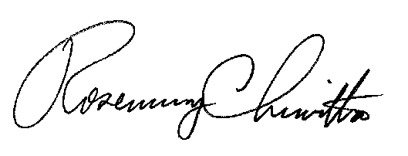
Sincerely,

Rosemary Chiavetta
Secretary

Enclosure

Docket Nos. A-2010-2190276 & A-2010-2199236
Ambit Northeast, LLC d/b/a Ambit Energy & Dynegy Energy Services (East), LLC
Data Requests

- Regarding Customers – Please provide an attestation from Ambit Energy verifying that these customer contracts are assignable.

- Regarding Gross Revenues –Dynegy Energy has not filed all required Electric Choice Quarterly Reports with the PUC. Please provide the missing report for the second quarter of 2020 in response to this data request. Please file this report only at Docket No. A-2010-2199236.

