 | COMMONWEALTH OF PENNSYLVANIA  PENNSYLVANIA PUBLIC UTILITY COMMISSION  400 NORTH STREET, HARRISBURG, PA 17120 | IN REPLY PLEASE REFER TO OUR FILE

August 17, 2020

CERTIFIED

RAY CUNNINGHAM GENERAL COUNSEL
ENGIE POWER & GAS LLC
1360 POST OAK BLVD STE 400
HOUSTON TX 77056

Docket No. A-2011-2264916
Utility Code: 1113925

RE: Electric Generation Supplier License Application Amendment for a Name Change

Dear Mr. Cunningham:

On May 14, 2020, PLYMOUTH ROCK ENERGY, LLC filed an application amendment for a name change to its Electric Generation Supplier license with the Public Utility Commission. The application amendment was incomplete. In order for us to complete our analysis of your application amendment, the Energy Industry Group requires answers to the attached question(s).

Please be advised that you are directed to forward the requested information to the Commission within 30 days of receipt of this letter. Failure to respond may result in the application amendment being denied. As well, if PLYMOUTH ROCK ENERGY, LLC has decided to withdraw its application amendment, please reply notifying the Commission of such a decision.

Please forward the information to the Secretary of the Commission at the address listed below. When submitting documents, all documents requiring notary stamps must have original signatures. Please note that some responses may be e-filed to your case, http://www.puc.pa.gov/efiling/default.aspx. A list of document types allowed to be e-filed can be found at http://www.puc.pa.gov/efiling/DocTypes.aspx.

Rosemary Chiavetta, Secretary
Pennsylvania Public Utility Commission
400 North Street
Harrisburg, PA 17120

Your answers should be verified per 52 Pa Code § 1.36. Accordingly, you must provide the following statement with your responses:

I, ________________, hereby state that the facts above set forth are true and correct to the best of my knowledge, information and belief, and that I expect to be able to prove the same at a hearing held in this matter. I understand that the statements herein are made subject to the penalties of 18 Pa. C.S. § 4904 (relating to unsworn falsification to authorities).

The blank should be filled in with the name of the appropriate company representative, and the signature of that representative should follow the statement.

In addition, to expedite completion of the application, please also e-mail the information to Jeff McCracken at jmccracken@pa.gov. Please direct any questions to Jeff McCracken, Bureau of Technical Utility Services, at jmccracken@pa.gov (preferred) or (717) 783-6163.

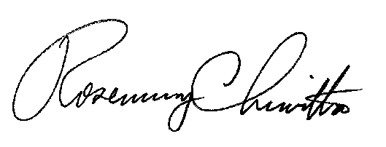
Sincerely,

Rosemary Chiavetta
Secretary

Enclosure

Docket No. A-2011-2264916
PLYMOUTH ROCK ENERGY, LLC
Data Requests

1. Reference Application, Section 1, Identification and Contact Information – Applicant states that its website will change to www.engiepowerandgas.com. However, this website is still inactive 2 months after the filing. Please explain when the applicant’s website information is changing, and if this change will affect any email addresses. Please provide updated contact information, if applicable.

2. Reference Application, Section 2, Business Entity Filings and Registration – Please provide applicant’s name change documentation from its home state.

3. Reference Application, Section 7.a, Bonding – Applicant failed to provide an updated financial security listing the company’s new name, which must match the Pennsylvania Department of State website listing EXACTLY. Please provide the missing documentation.

