August 18, 2020
A-00120024
R-2020- 3021319

TRISTATE HOUSEHOLD GOODS TARIFF CONFERENCE INC
ATTN CHARLIE MORRIS
P O BOX 6125
LANCASTER PA 17607-6125

RE: Ramsey's Moving Systems, LLC -- Tariff Filing

Mr. Morris:

On July 31, 2020, the 324th Revised Page 2, 116th Revised Page 2-B, and an 8th Revised Page 74-A, to Tristate Tariff Freight Pa. P.U.C. No. 54 were filed for the Commission’s approval. The filing was accepted for filing and docketed with the Public Utility Commission.

These revised pages to Tristate Tariff Freight Pa. P.U.C. No. 54 have been accepted and approved. The proposed changes shall be effective as per August 5, 2020 (except as noted in the officially filed tariff).

This case shall now be marked closed.

Very truly yours,
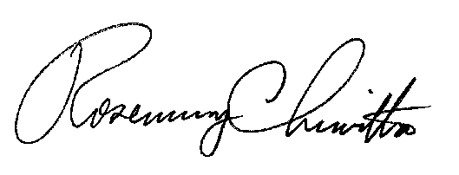

Rosemary Chiavetta
Secretary

