 | COMMONWEALTH OF PENNSYLVANIA  PENNSYLVANIA PUBLIC UTILITY COMMISSION  400 NORTH STREET, HARRISBURG, PA 17120 |  | IN REPLY PLEASE REFER TO OUR FILE
 | August 19, 2020

Docket No. A-2015-2470969
Utility Code: 1717403
CERTIFIED
C DEWAYNE SIMS
ALLIANCE PETROLEUM CORP
308 UPPER DOTY BRANCH RD
HAPPY KY 41746

RE: Act 127 Pennsylvania Pipeline Operator Annual Registration Form

Dear Mr. Sims:

On March 26, 2020, Alliance Petroleum Corporation’s registration for renewal of the Act 127 Pennsylvania Pipeline Operator Annual Registration in the Commonwealth of Pennsylvania was accepted for filing with the Public Utility Commission. The registration form was incomplete. In order for us to complete our analysis of your registration renewal, the Energy Industry Group requires answers to the attached question(s).

Please be advised that you are directed to forward the requested information to the Commission within 30 days of receipt of this letter. Pipeline operators who fail to respond may be referred to the Commission’s Bureau of Investigation and Enforcement and may be subject to civil penalties of up to $10,000 a day that the violation persists. If Alliance Petroleum Corporation no longer owns or operates equipment or facilities within the Commonwealth for the transportation of gas
it should notify the Commission along with necessary proof. For guidance with Act 127 compliance, please refer to the Commission’s website link at: http://www.puc.pa.gov/utility_industry/natural_gas/pipeline_safety.aspx.

Please forward the information to the Secretary of the Commission at the address listed below. When submitting documents, all documents requiring notary stamps must have original signatures. Please note that some responses may be e-filed to your case, http://www.puc.pa.gov/efiling/default.aspx. A list of document types allowed to be e-filed can be found at http://www.puc.pa.gov/efiling/DocTypes.aspx.

Rosemary Chiavetta, Secretary
Pennsylvania Public Utility Commission
400 North Street
Harrisburg, PA 17120

Your answers should be verified per 52 Pa Code § 1.36. Accordingly, you must provide the following statement with your responses:

I, ________________, hereby state that the facts above set forth are true and correct to the best of my knowledge, information and belief, and that I expect to be able to prove the same at a hearing held in this matter. I understand that the statements herein are made subject to the penalties of 18 Pa. C.S. § 4904 (relating to unsworn falsification to authorities).

The blank should be filled in with the name of the appropriate company representative, and the signature of that representative should follow the statement.

In addition, to expedite completion of the registration renewal, please also e-mail the information to Lee Yalcin at lyalcin@pa.gov. Please direct any questions to Lee Yalcin, Bureau of Technical Utility Services, at lyalcin@pa.gov (preferred) or (717) 787-6723.

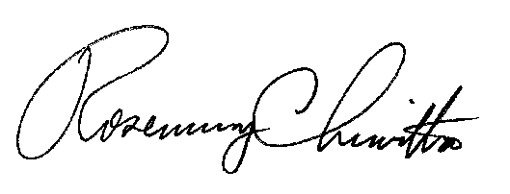
Sincerely,

Rosemary Chiavetta
Secretary

Enclosure

Alliance Petroleum Corporation
Docket No. A-2015-2470969
Data Request

- Reference attachment B, Alliance Petroleum Corporation reported additional assets on its current (2020) registration form that were not reported on its prior registration form in 2019. Alliance Petroleum Corporation however did not report .2miles of Class II T&D lines for Fayette County that were reported for 2019. Please resubmit the registration form, indicating if these assets in Fayette Co. were sold, if so to whom, or if they were reclassified or decommissioned, this way staff will be able to track and account for any pipeline assets in accordance with Act 127.

