Before the
PENNSYLVANIA PUBLIC UTILITY COMMISSION

Noreen McCarthy :
:
v. : C-2019-3006923
:
Metropolitan Edison Company :

INTERIM ORDER
SETTING DEADLINES FOR THE FILING OF
PROPOSED CORRECTIONS TO TRANSCRIPT AND OBJECTIONS

Background

Noreen McCarthy (Complainant) filed a Formal Complaint with the Pennsylvania Public Utility Commission (Commission) against Metropolitan Edison Company (Respondent) on January 7, 2019. On January 28, 2019, Respondent filed an Answer and New Matter to the Complaint. On March 11, 2019, Complainant filed an Amended Complaint against Respondent. On April 1, 2019, Respondent filed an Answer and New Matter to the Amended Complaint.

On July 14, 2020, the evidentiary hearing was held in this case. The record was closed by an Interim Order entered on July 17, 2020.

On August 11, 2020, Complainant filed a letter with the Commission’s Secretary’s Bureau stating she received the transcript of the evidentiary hearing on August 10, 2020. Complainant asserted there was a significant omission in the transcript, and she maintained she had identified several errors. Consequently, Complainant requested time to submit a list of her proposed transcript errors and corrections. Complainant estimated she would need two weeks to submit her list of proposed transcript errors and corrections.

The transcript of the July 14, 2020 evidentiary hearing was filed with the
Commission on August 13, 2020.
Discussion

The Commission’s rules provide that a correction in the official transcript may be made only to make it accurately reflect the evidence presented at the hearing and to speak the truth. A party who was present when the transcription was made may submit a written request to submit proposed corrections to the transcript. The Commission’s rules, in relevant part, provide that proposed corrections to the official transcript shall be filed within 10 days after the transcript has been filed with the Commission, and objections or comments to the proposed corrections shall be filed within 10 days of service of the proposed corrections. The presiding officer will rule upon a proposed correction to a transcript within 20 days of its receipt.

After due consideration, Complainant’s request to submit a list of proposed transcript errors and corrections will be granted in the ordering paragraphs below together with deadlines for the filing of Complainant’s proposed transcript errors and corrections and Respondent’s objections thereto, if any.

THEREFORE,

IT IS ORDERED THAT:

- Complainant Noreen McCarthy shall e-File her proposed transcript errors and corrections, sequentially listed by transcript page and line number, with the Commission’s Secretary’s Bureau at Docket No. C-2019-3006923, by Monday, August 24, 2020.

- Complainant Noreen McCarthy shall serve a copy of her proposed
transcript errors and corrections upon Respondent Metropolitan Edison Company by Monday, August 24, 2020.

- Respondent Metropolitan Edison Company shall e-File its objections to Complainant Noreen McCarthy’s proposed transcript errors and corrections, sequentially listed by transcript page and line number, with the Commission’s Secretary’s Bureau at Docket No.
C-2019-3006923, by Thursday, September 3, 2020.

- Respondent Metropolitan Edison Company shall serve a copy of its objections to Complainant Noreen McCarthy’s proposed transcript errors and corrections upon Complainant Noreen McCarthy by Thursday, September 3, 2020.

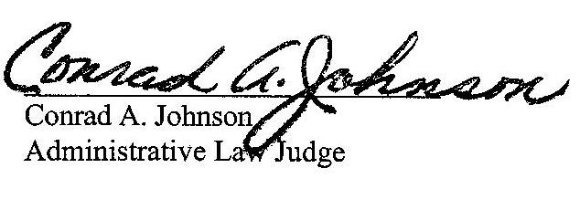
Date: August 19, 2020

C-2019-3006923 - NOREEN MCCARTHY v. METROPOLITAN EDISON COMPANY
NOREEN MCCARTHY
18 MILLSTONE LANE
POTTSTOWN PA 19465
610.469.2009
ACCEPTS E-SERVICE
LAUREN M LEPKOSKI ESQUIRE
TORI L GIESLER ESQUIRE
FIRSTENERGY
2800 Pottsville Pike
PO BOX 16001
READING PA 19612-6001
610.921.6203
610.921.6658
ACCEPTS E-SERVICE

52 Pa.Code § 5.253(a).
52 Pa.Code § 5.253(b)(2).
52 Pa.Code § 5.253(c)(1).
52 Pa.Code § 5.253(d).
52 Pa.Code § 5.253(f).

