 | COMMONWEALTH OF PENNSYLVANIA  PENNSYLVANIA PUBLIC UTILITY COMMISSION  400 NORTH STREET, HARRISBURG, PA 17120 | IN REPLY PLEASE REFER TO OUR FILE
August 20, 2020
Docket No. A-2012-2294767
Utility Code: 1714461

DANIEL STAHL
DOMINION ENERGY TRANSMISSION INC
925 WHITE OAKS BLVD
BRIDGEPORT WV 26330

RE: Cancellation of Act 127 Registration

Dear Mr. Stahl:

This letter serves to acknowledge your notification to the Commission that Dominion Energy Transmission, Inc. (DETI) wishes to cancel its Act 127 registration. Since initially registering with the Commission in 2012, DETI had all of its pipeline assets reclassified as “Interstate” pipelines under the jurisdiction of the Federal Energy Regulatory Commission or as “Production” pipelines, not subject to Act 127 reporting requirements. DETI reported zero miles in its last submitted report for year ending 2018. DETI has no assets associated with Docket No. A-2012-2294467 as defined in the Gas and Hazardous Liquids Pipeline Act or Act 127 of 2011, therefore, the Commission will remove DETI from its Registry.

The Commission reminds if DETI were to acquire any jurisdictional assets in the future, it must file an Initial Registration Form with the Commission in order to comply with the mandates of Act 127.

Please direct any questions to Lee Yalcin, Financial Analyst, Technical Utility Services at email yalcin@pa.gov (preferred) or (717) 787-6723.

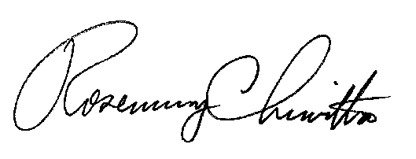
Sincerely,

Rosemary Chiavetta
Secretary

Cc: Bureau of Administration, Financial & Assessments, PUC

