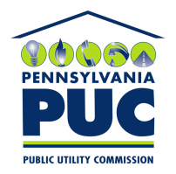 | COMMONWEALTH OF PENNSYLVANIA  PENNSYLVANIA PUBLIC UTILITY COMMISSION  400 NORTH STREET, KEYSTONE BUILDING, SECOND FLOOR  HARRISBURG, PENNSYLVANIA 17120 | IN REPLY PLEASE REFER TO OUR FILE

Sent: August 25, 2020

Via Certified Mail

Mark Mininberg
Hospital Energy LLC
7 Portwalk Place # 1523
Portsmouth NH 03801

RE: Bond and Continuation Certificate
Hospital Energy LLC
A-2018-3006502

Dear Mr. Mininberg:

Please find under cover of this letter the updated financial instrument filed with the Commission on behalf of Hospital Energy LLC because it is a copy and not acceptable.

The Commission requires a supplier to file an original bond, letter of credit, continuation certificate, amendment, or other financial instrument as part of a supplier’s licensing requirements under Section 2809(c) of the Pennsylvania Public Utility Code.

The enclosed financial instrument does not have a "wet ink" original signature or raised seal for the surety company, and no signature at all for the principal. As this financial instrument is an exact duplicate of the one already on file with the Commission, no further action is required at this time.

Sincerely,

Rosemary Chiavetta
Secretary of the Commission

RC: alw
Enclosures

