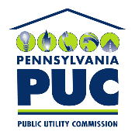 | COMMONWEALTH OF PENNSYLVANIA  PENNSYLVANIA PUBLIC UTILITY COMMISSION  400 North Street, Harrisburg, Pennsylvania 17120 | IN REPLY PLEASE REFER TO OUR FILE
L-2017-2628991

August 25, 2020

To: All Electric Generation Suppliers, Bureau of Investigation and Enforcement, Office of Consumer Advocate and Office of Small Business Advocate.

Re: Revised Chapter 54 EGS Customer Information Regulations

Docket No. L-2017-2628991

The Secretarial Letter dated August 24, 2020, in the above captioned case, contains an error on the first page with regard to the date of publication in the Pennsylvania Bulletin.

The date that the revised Chapter 54 regulations were published in the Pennsylvania Bulletin was incorrectly identified as August 31, 2020 but should be August 1, 2020. This information is contained in the first paragraph of the letter.

The Secretarial Letter on the PA PUC website will be corrected as indicated above. In addition, please find attached the corrected Secretarial Letter.

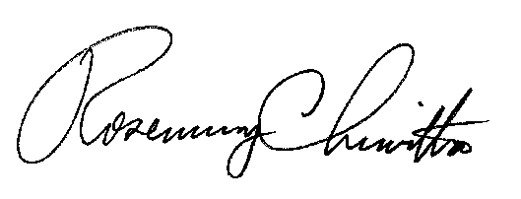
Sincerely,

Rosemary Chiavetta
Secretary

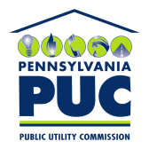 | COMMONWEALTH OF PENNSYLVANIA  PENNSYLVANIA PUBLIC UTILITY COMMISSION  P.O. BOX 3265, HARRISBURG, PA 17105-3265 | IN REPLY PLEASE REFER TO OUR FILE  L-2017-2628991

August 24, 2020

To: All Electric Generation Suppliers, Bureau of Investigation and Enforcement, Office of Consumer Advocate and Office of Small Business Advocate.

Re: Revised Chapter 54 EGS Customer Information Regulations

Docket No. L-2017-2628991

The Pennsylvania Public Utility Commission (Commission) issues this Secretarial Letter to announce the effective date of the revised Commission regulations relating to electric generation supplier (EGS) customer information. The revised regulations at 52 Pa. Code Chapter 54 (relating to electric generation customer choice customer information) applicable to EGSs were published in the Pennsylvania Bulletin on August 1, 2020 - with the revised regulations becoming effective 60 days after publication on September 30, 2020. The revised regulations provide changes to standards and pricing practices for retail electric services; the disclosure statement for residential and small business customers; marketing/sales activities; and the provision of notices of contract expiration or changes in terms. The revised regulations also include a prohibition against EGSs charging early termination fees if a residential or small business customer terminates a contract within the last 30 days of the contract expiration date.

EGSs that serve residential and small business customers are advised to familiarize themselves with the new regulations prior to the September 30 effective date. The regulations as published in the Pennsylvania Bulletin are available at this weblink:

https://www.pacodeandbulletin.gov/Display/pabull?file=/secure/pabulletin/data/vol50/50-31/1029.html
All documents related to this proceeding, including the February 2020 Final Rulemaking Order that includes a marked-up version of the regulations can be found on the Commission’s website (http://www.puc.pa.gov/) by searching the Docket L-2017-2628991 and also available at this weblink:

http://www.puc.pa.gov/about_puc/consolidated_case_view.aspx?Docket=L-2017-2628991

Any EGS or any other party or individual with questions about the revised regulations are invited to submit the question(s) in writing to the Office of Competitive Market Oversight (OCMO) at RA-OCMO@pa.gov. OCMO may use the questions submitted to develop a FAQ document for posting on our website, and possibly a follow-up conference call/electronic venue for addressing common questions and concerns.

If you have any questions about the information presented in this Secretarial Letter, please contact the Director of the Office of Competitive Market Oversight Daniel Mumford at dmumford@pa.gov or (717) 525-2084.

Very truly yours,

Rosemary Chiavetta
Secretary

cc: Seth Mendelsohn, Executive Director
Renardo Hicks, Chief Counsel
Richard Kanaskie, Director, Bureau of Investigation and Enforcement
Alexis M. Bechtel, Director, Bureau of Consumer Services
Tom Charles, Director, Office of Communications
Daniel Mumford, Director of Office of Competitive Market Oversight
Kriss Brown, Deputy Director of Office of Competitive Market Oversight

Small Business Customer is defined at 52 Pa Code § 54.2: Small business customer—The term refers to a person, sole proprietorship, partnership, corporation, association or other business entity that receives electric service under a small commercial, small industrial or small business rate classification, and whose maximum registered peak load was less than 25 kW within the last 12 months.

