 | COMMONWEALTH OF PENNSYLVANIA  PENNSYLVANIA PUBLIC UTILITY COMMISSION  400 NORTH STREET, HARRISBURG, PA 17120 | IN REPLY PLEASE REFER TO OUR FILE
August 31, 2020

Docket No. A-2012-2293754
Utility Code: 1714389
PHILIP COLEMAN
M3 APPALACHIA GATHERING LLC
ONE ENERGY PLAZA WCB 2130
DETROIT MI 48226

RE: Act 127 Registration Pipeline Name Change

Dear Mr. Coleman:

This letter serves to acknowledge your notification to the Commission of the name change from M3 Appalachia Gathering, LLC to DTE Appalachia Gathering, LLC. The Commission will remove M3 Appalachia Gathering, LLC from its Registry. DTE Appalachia Gathering, LLC at Docket No. A-2018-3001229 is currently listed on the Commission’s registry of Act 127 owner/operators.

The Commission reminds if M3 Appalachia Gathering, LLC were to acquire any jurisdictional assets under any other name in the future, it must file an Initial Registration Form with the Commission in order to comply with the mandates of Act 127.

Please direct any questions to Lee Yalcin, Financial Analyst, Technical Utility Services at email lyalcin@pa.gov (preferred) or (717) 787-6723.

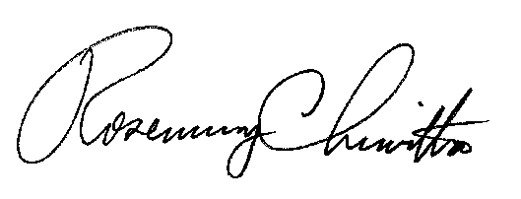
Sincerely,

Rosemary Chiavetta
Secretary

Cc: Shirley Spunaugle, Secretary’s bureau
Amy Zuvich, Bureau of Administration, Financial and Assessments

