August 31, 2020
A-00108228
R-2020-3021413

CHARLIE MORRIS CONSULTING LLC
23 TURNBRIDGE DRIVE
LANCASTER PA 17603-9583

RE: F. Ambrose Moving, Inc. – Tariff Filing

Mr. Morris:

On July 25, 2020, Freight Pa. P.U.C. No. 5 was filed for the Commission’s approval. The filing was accepted for filing and docketed with the Public Utility Commission.

Freight Pa. P.U.C. No. 5 has been accepted and approved. The proposed changes shall be effective as per August 28, 2020. This case shall now be marked closed.

Very truly yours,
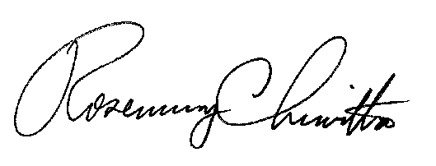

Rosemary Chiavetta
Secretary

