August 31, 2020
A-8920233
R-2020-3021511

CHARLIE MORRIS CONSULTING LLC
23 TURNBRIDGE DRIVE
LANCASTER PA 17603-9583

RE: Keystone Moving & Junk Removal, LLC – Tariff Filing

Mr. Morris:

On August 20, 2020, Freight Pa. P.U.C. No. 6 was filed for the Commission’s approval. The filing was accepted for filing and docketed with the Public Utility Commission.

Freight Pa. P.U.C. No. 6 has been accepted and approved. The proposed changes shall be effective as per September 24, 2020. This case shall now be marked closed.

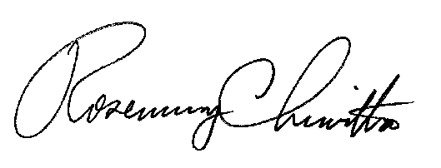
Very truly yours,

Rosemary Chiavetta
Secretary

