August 31, 2020
A-00119720
R-2020-3021525

TRISTATE HOUSEHOLD GOODS TARIFF CONFERENCE INC
ATTN CHARLIE MORRIS
P O BOX 6125
LANCASTER PA 17607-6125

RE: Movin’ Murdy, Inc. -- Tariff Filing

Mr. Morris:

On August 22, 2020, the 326th Revised Page 2, 118th Revised Page 2-B, 8th Revised Page 70-J, 4th Revised Page 70-K, 1st Revised Page 70-K-1, and 6th Revised Page 70-L, to Tristate Tariff Freight Pa. P.U.C. No. 54 were filed for the Commission’s approval. The filing was accepted for filing and docketed with the Public Utility Commission.

These revised pages to Tristate Tariff Freight Pa. P.U.C. No. 54 have been accepted and approved. The proposed changes shall be effective as per July 25, 2020 (except as noted in the officially filed tariff).

This case shall now be marked closed.

Very truly yours,
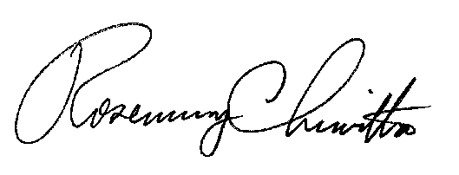

Rosemary Chiavetta
Secretary

