 | COMMONWEALTH OF PENNSYLVANIA  PENNSYLVANIA PUBLIC UTILITY COMMISSION  400 NORTH STREET, HARRISBURG, PA 17120
September 2, 2020
Docket No. A-2013-2384046
Utility Code: 1216022

RAY CUNNINGHAM GENERAL COUNSEL
ENGIE POWER & GAS LLC
1360 POST OAK BLVD STE 400
HOUSTON TX 77056

Re: Natural Gas Supplier License of ENGIE Power & Gas LLC

Dear Mr. Cunningham:

On May 14, 2020, PLYMOUTH ROCK ENERGY, LLC (PLYMOUTH ROCK ENERGY) filed a request with the Commission to change the name on its license to provide natural gas services, as a supplier, to ENGIE Power & Gas LLC (ENGIE Power & Gas).
ENGIE Power & Gas has provided the proper Pennsylvania Department of State documentation and has provided proof of service to the interested parties as required by the Commission.
Therefore, the Commission approves, by this Secretarial Letter, the change of PLYMOUTH ROCK ENERGY, LLC’s name on its license for the provision of natural gas services as a supplier.
The Secretary’s Bureau will issue a new license to ENGIE Power & Gas LLC the right to begin to offer, render, furnish, or supply natural gas services as a supplier to residential, small commercial (under 6,000 MCF annually), large commercial (6,000 MCF or more annually), industrial, and governmental customers in the natural gas distribution company service territories of Columbia Gas of Pennsylvania, Inc., National Fuel Gas Distribution Corporation, PECO Energy Company, Peoples Gas Company, LLC, Peoples Natural Gas Company, LLC, Philadelphia Gas Works, and UGI Utilities, Inc., within the Commonwealth of Pennsylvania.

If you have any questions in this matter, please contact Jeff McCracken of the Bureau of Technical Utility Services at jmccracken@pa.gov or 717-783-6163.

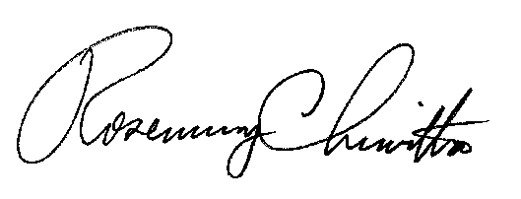
Sincerely,

Rosemary Chiavetta
Secretary

Cc: Amy Zuvich, Bureau of Administration, Financial and Assessments

LICENSE ENCLOSED

