 | COMMONWEALTH OF PENNSYLVANIA  PENNSYLVANIA PUBLIC UTILITY COMMISSION  400 NORTH STREET, HARRISBURG, PA 17120 | IN REPLY PLEASE REFER TO OUR FILE
September 3, 2020

RICHARD PLUTZER, CFO
RESOURCE ENERGY SOLUTIONS LLC
4 HIGH RIDGE PARK, SUITE 202
STAMFORD, CT 06905

Dear Sir:

On September 2, 2020, the Commission received the Application of Resource Energy Solutions LLC for approval to supply natural gas services to the public in the Commonwealth of PA. Upon initial review, the Application has been determined to be missing information for the following reasons:

- The date on the Certificate of Service cannot be a date in the future. In other words, the date on the Certificate of Service cannot be September 3, 2020 if it was e-filed on September 2, 2020.

Pursuant to 52 Pa. Code §1.4, you are being advised of this missing information and are required to file corrections. Failure to correct the foregoing missing information within 20 days of the date of this letter will result in the Application being returned unfiled.
Please return your items to the above listed address and address to the attention of the Office of the Secretary.
If you have any question in regards to this letter, please contact our bureau at (717) 772-7777. Thank you
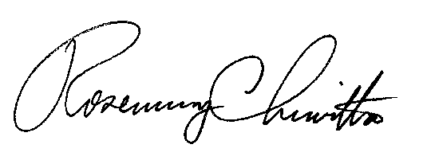
Sincerely,

Rosemary Chiavetta
Secretary

RC:AEL

