September 11, 2020
A-8911652
R-2020- 3021677

TRISTATE HOUSEHOLD GOODS TARIFF CONFERENCE INC
ATTN CHARLIE MORRIS
P O BOX 6125
LANCASTER PA 17607-6125

RE: for Kennedy Transfer, Inc. -- Tariff Filing

Mr. Morris:

On September 2, 2020, the 328th Revised Page 2, 197th Revised Page 2-A, and 4th Revised Page 56, to Tristate Tariff Freight Pa. P.U.C. No. 54 were filed for the Commission’s approval. The filing was accepted for filing and docketed with the Public Utility Commission.

These revised pages to Tristate Tariff Freight Pa. P.U.C. No. 54 have been accepted and approved. The proposed changes shall be effective as per October 2, 2020 (except as noted in the officially filed tariff).

This case shall now be marked closed.

Very truly yours,
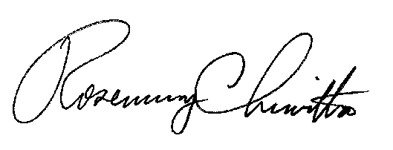

Rosemary Chiavetta
Secretary

