BEFORE THE
PENNSYLVANIA PUBLIC UTILITY COMMISSION

David Coyle :
:
v. : C-2019-3014261
:
West Penn Power Company :

INTERIM ORDER
CLOSING THE RECORD

AND NOW, the transcript of the September 8, 2020 hearing in this case having been docketed by the Commission’s Secretary’s Bureau in Harrisburg on September 18, 2020, and no further hearings in this matter are to be scheduled or held.

THEREFORE,

IT IS ORDERED:

- That the record at Docket No. C-2019-3014261 is closed.

2. That the Initial Decision in this case shall be prepared and issued.

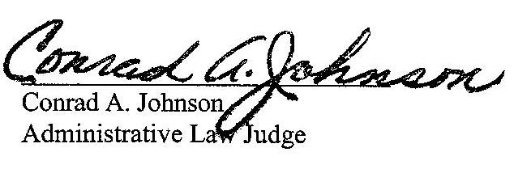
Dated: September 18, 2020

C-2019-3014261 - DAVID COYLE v. WEST PENN POWER COMPANY
DAVID COYLE
184 OAK MANOR DR
NATRONA HEIGHTS PA 15065
724.681.3191
Accepts eService
TORI L GIESLER ESQUIRE
LAUREN MARISSA LEPKOSKI ESQUIRE
FIRSTENERGY SERVICES CO
2800 POTTSVILLE PIKE
PO BOX 16001
READING PA 19612
610.921.6203
610.921.6658
Accepts eService

