 | COMMONWEALTH OF PENNSYLVANIA  PENNSYLVANIA PUBLIC UTILITY COMMISSION  P.O. BOX 3265, HARRISBURG, PA 17105-3265 | IN REPLY PLEASE REFER TO OUR FILE

C-2020-3020551
Date of Service: September 28, 2020

Warren Taxi Service, LLC
T/A WARREN TAXI SERVICE
111 WALNUT STREEET
Warren, PA 16365-1940

PENNSYLVANIA PUBLIC UTILITY COMMISSION
BUREAU OF INVESTIGATON & ENFORCEMENT
v.
WARREN TAXI SERVICE, LLC T/A WARREN TAXI SERVICE

Dear Sir/Madam:

Please be advised that the attached complaint has been filed against you by the Bureau of Investigation & Enforcement.

Detailed instructions on how to proceed are contained in the NOTICE section, and you are advised to read everything carefully or consult with your attorney.

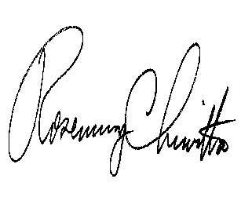
Very truly yours,

Rosemary Chiavetta
Secretary

Attachments

NW

