 | COMMONWEALTH OF PENNSYLVANIA  PENNSYLVANIA PUBLIC UTILITY COMMISSION  P.O. BOX 3265, HARRISBURG, PA 17105-3265 | IN REPLY PLEASE REFER TO OUR FILE

C-2020-3020692
Date of Service: September 30, 2020

IVAN SAMOILO
T/A SOMEGUYANDHISCAR LLC
4756 SPRINGVIEW DRIVE APT 204
ERIE PA 16509

PENNSYLVANIA PUBLIC UTILITY COMMISSION
BUREAU OF INVESTIGATON & ENFORCEMENT
v.
IVAN SAMOILO T/A SOMEGUYANDHISCAR LLC

Dear Sir/Madam:

Please be advised that the attached complaint has been filed against you by the Bureau of Investigation & Enforcement.

Detailed instructions on how to proceed are contained in the NOTICE section, and you are advised to read everything carefully or consult with your attorney.

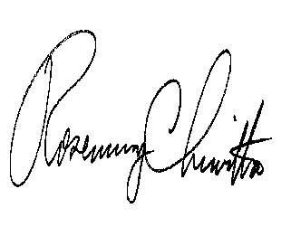
Very truly yours,

Rosemary Chiavetta
Secretary

Attachments

NW

