 | COMMONWEALTH OF PENNSYLVANIA  PENNSYLVANIA PUBLIC UTILITY COMMISSION  P.O. BOX 3265, HARRISBURG, PA 17105-3265 | IN REPLY PLEASE REFER TO OUR FILE

C-2020-3021888

Date of Service: October 20, 2020

HECKMANN WATER RESOURCES (CVR) INC
1607 NE LOOP
CARTHAGE, TX 75633

PENNSYLVANIA PUBLIC UTILITY COMMISSION
BUREAU OF INVESTIGATON & ENFORCEMENT
v.
HECKMANN WATER RESOURCES (CVR) INC

Dear Sir/Madam:

Please be advised that the attached complaint has been filed against you by the Bureau of Investigation & Enforcement.

Detailed instructions on how to proceed are contained in the NOTICE section, and you are advised to read everything carefully or consult with your attorney.

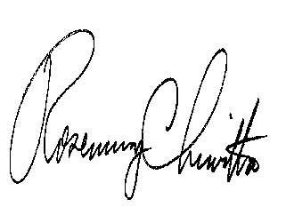
Very truly yours,

Rosemary Chiavetta
Secretary

Attachments

NW

