 | COMMONWEALTH OF PENNSYLVANIA  PENNSYLVANIA PUBLIC UTILITY COMMISSION  P.O. BOX 3265, HARRISBURG, PA 17105-3265 | IN REPLY PLEASE REFER TO OUR FILE

C-2020-3021894

Date of Service: October 20, 2020

FOGELMAN TRUCKING INC
580 FOGELMAN ROAD
WATSONTOWN, PA 17777

PENNSYLVANIA PUBLIC UTILITY COMMISSION
BUREAU OF INVESTIGATON & ENFORCEMENT
v.
FOGELMAN TRUCKING INC

Dear Sir/Madam:

Please be advised that the attached complaint has been filed against you by the Bureau of Investigation & Enforcement.

Detailed instructions on how to proceed are contained in the NOTICE section, and you are advised to read everything carefully or consult with your attorney.

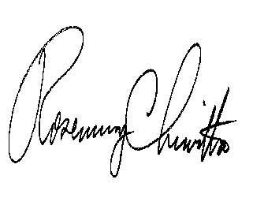
Very truly yours,

Rosemary Chiavetta
Secretary

Attachments

NW

