 | COMMONWEALTH OF PENNSYLVANIA  PENNSYLVANIA PUBLIC UTILITY COMMISSION  P.O. BOX 3265, HARRISBURG, PA 17105-3265 | IN REPLY PLEASE REFER TO OUR FILE

C-2020-3022096

Date of Service: October 20, 2020

PASHA LUXURY SERVICES, INC.
T/A CORPORATE SEDAN SERVICE,THE
67 BUCK ROAD SUITE 107
HUNTINGDON VALLEY, PA 19006

PENNSYLVANIA PUBLIC UTILITY COMMISSION
BUREAU OF INVESTIGATON & ENFORCEMENT
v.
PASHA LUXURY SERVICES, INC. T/A CORPORATE SEDAN SERVICE,THE

Dear Sir/Madam:

Please be advised that the attached complaint has been filed against you by the Bureau of Investigation & Enforcement.

Detailed instructions on how to proceed are contained in the NOTICE section, and you are advised to read everything carefully or consult with your attorney.

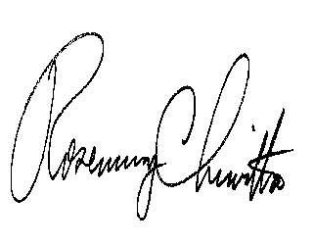
Very truly yours,

Rosemary Chiavetta
Secretary

Attachments

NW

