 | COMMONWEALTH OF PENNSYLVANIA  PENNSYLVANIA PUBLIC UTILITY COMMISSION  P.O. BOX 3265, HARRISBURG, PA 17105-3265 | IN REPLY PLEASE REFER TO OUR FILE

C-2020-3022224

Date of Service: October 27, 2020

MYERS BROTHERS TRUCKING LLC
6106 RENOVO ROAD
MILL HALL, PA 17751

PENNSYLVANIA PUBLIC UTILITY COMMISSION
BUREAU OF INVESTIGATON & ENFORCEMENT
v.
MYERS BROTHERS TRUCKING LLC

Dear Sir/Madam:

Please be advised that the attached complaint has been filed against you by the Bureau of Investigation & Enforcement.

Detailed instructions on how to proceed are contained in the NOTICE section, and you are advised to read everything carefully or consult with your attorney.

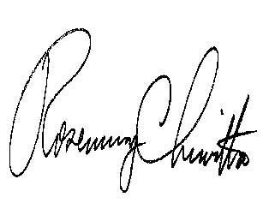
Very truly yours,

Rosemary Chiavetta
Secretary

Attachments

NW

