PENNSYLVANIA
PUBLIC UTILITY COMMISSION
Harrisburg, PA 17120

Public Meeting held October 29, 2020

Commissioners Present:

Gladys Brown Dutrieuille, Chairman
David W. Sweet, Vice Chairman
John F. Coleman, Jr.
Ralph V. Yanora

Pennsylvania Public Utility Commission,  Bureau of Investigation and Enforcement  v.  The United Telephone Company of Pennsylvania LLC d/b/a CenturyLink |  | M-2020-3012956

Opinion and Order

BY THE COMMISSION:

Before the Pennsylvania Public Utility Commission (Commission) for consideration and disposition is a proposed Joint Petition for Approval of Settlement (Settlement Agreement or Settlement) filed on July 7, 2020, by the Commission’s Bureau of Investigation and Enforcement (I&E) and The United Telephone Company of Pennsylvania LLC d/b/a CenturyLink (CenturyLink or Company) (collectively, the Parties), with respect to an informal investigation conducted by I&E. Both Parties submitted Statements in Support of the Settlement. The Parties submit that the proposed Settlement is in the public interest and is consistent with the Commission’s Policy Statement at 52 Pa. Code § 69.1201, Factors and standards for evaluating litigated and settled proceedings involving violations of the Public Utility Code and Commission regulations—statement of policy. Settlement at 14. We will issue the Settlement for comment.

History of the Proceeding

This matter concerns an alleged failure by CenturyLink to timely install telephone and broadband services. The Commission’s Bureau of Consumer Services (BCS) received complaints regarding CenturyLink’s alleged failure to timely install services in accordance with the Public Utility Code (Code) and the Commission’s Regulations, and the alleged failure to meet Chapter 30 requirements. Over the weekend of April 28, 2018, CenturyLink transitioned to a new dispatch system in Pennsylvania. CenturyLink experienced unforeseeable and unanticipated dispatch delays for telephone and broadband services. BCS received several informal complaints related to installation delays, and some ancillary alleged Chapter 30 violations. Settlement at 5.

BCS referred the matter to I&E on September 16, 2019. By letter dated September 24, 2019, I&E notified CenturyLink that it had initiated an informal investigation of the Company consistent with Sections 331(a) and 506 of the Code, 66 Pa. C.S. §§ 331(a), 506, and Section 3.113 of the Commission’s Regulations, 52 Pa. Code § 3.113. I&E further advised CenturyLink that its investigation would focus on CenturyLink’s alleged failure to provide telephone and broadband services in violation of Chapter 30 and the Code and the Commission’s Regulations governing installation of services.

By letter dated September 24, 2019, I&E submitted informal data requests to CenturyLink. CenturyLink responded to I&E’s data requests on November 14, 2019. CenturyLink met with I&E on January 16, 2020, and provided additional information as requested by I&E. A settlement conference call was convened on April 7, 2020, with additional settlement discussions occurring in May 2020. Thereafter, the Parties entered into negotiations and agreed to resolve the matter in accordance with the Commission’s policy to promote settlements at 52 Pa. Code § 5.231. The results of I&E’s investigation, which included review of the customer complaints, CenturyLink’s responses to data requests, and the additional information provided by CenturyLink, formed the basis for the Settlement Agreement. The Parties filed the instant Settlement on July 7, 2020.

Background

Installation of Services Allegations

The untimely service installation allegations stem from a total of sixteen customer complaints. Of the total complaints, ten customer complaints involved installation of telephone service, broadband service, or both, thus creating multiple counts per customer. The remaining six customer complaints involved allegations regarding Chapter 30 of the Code. The customer complaints are summarized in Table 1 below. Settlement at 6.

Table 1 - Summary of Customer Complaints – Telephone and Broadband Service

Customer | Date Customer Requested Service | CenturyLink Installed Service | Alleged Delay in Working Days  Telephone Service | Alleged Delay in Working Days  Broadband Service
A | July 2, 2018 | July 18, 2018 | 7 | 2
B | August 24, 2018 | October 5, 2018 | 24 | 19
C | August 22, 2018 | October 31, 2018 | 44 | 39
D | May 12, 2019 | June 20, 2019 | 23 | 18
E | May 14, 2019 | June 24, 2019 | 23 | 18
F | January 2, 2018 | January 16, 2018 | 5 | N/A
G | January 2, 2018 | January 16, 2018 | 5 | N/A
H | May 22, 2018 | June 21, 2018 | 16 | N/A
I | December 31, 2018 | January 11, 2019 | 3 | N/A
J | June 11, 2018 | July 9, 2018 | N/A | 9
Total waiting period past the 5-day time frame prescribed in 52 Pa. Code § 63.58(a) |  |  | 150
Total waiting period past the 10-day time frame prescribed in 66 Pa. C.S. § 3014(b) |  |  |  | 105

Under Section 63.58 of the Commission’s Regulations applicable to telephone service, a public utility shall complete installation of primary service orders withing five working days of receipt of an application unless a later date is requested by the applicant or construction is required. Nine customer complaints related to CenturyLink’s alleged failure to install telephone services within five days. The customers claimed a total waiting period of 150 days past the 5-day time frame prescribed in Section 63.58(a). Settlement at 6-7 (citing 52 Pa. Code § 63.58(a)).

Under Section 3014 of the Code, a local exchange telecommunications company “may amend its network modernization plan to extend the period of time within which broadband service must be made available to a customer to up to ten business days after the customer’s request for broadband service.” 66 Pa. C.S. § 3014(b)(5). In response to I&E’s informal data requests, CenturyLink provided six customer complaints that related to CenturyLink’s alleged failure to install broadband services within ten days. The customers claimed a total waiting period of 105 days past the 10-day timeframe prescribed in Section 3014(b). Settlement at 8-9.

Section 1501 Allegations

As detailed in Table 1 above, ten customers alleged that CenturyLink failed to furnish reasonable service as required by Section 1501 of the Code. Settlement at 10.

Chapter 30 Allegations

Section 3014(b) of the Code provides that a rural telecommunications carrier that elects to amend its network modernization plan shall remain subject to its network modernization plan through December 31, 2013 and shall commit to accelerate broadband availability to 100% of its total retail access lines in its distribution network by December 31, 2013. 66 Pa. C.S. § 3014(b)(2)(ii)(A). Settlement at 10.

In response to I&E’s informal data requests, CenturyLink identified four customers who alleged that CenturyLink did not provide broadband services upon request and two customers who alleged that CenturyLink did not provide the minimum speed of 1.544 Mbps in the downstream direction. Settlement at 11.

As a result of its informal investigation, I&E concluded that there was sufficient data to substantiate allegations of violations of our Regulations. Specifically, I&E was prepared to allege in a formal complaint that the issues associated with the implementation of the new dispatch systems resulted in:

- the untimely installation of telephone service within five working days. If proven, this would have violated 52 Pa. Code § 63.58 and 66 Pa. C.S. § 1501. (Multiple counts).

- the untimely installation of broadband service within ten working days. If proven, I&E alleges that such conduct would have violated and 66 Pa. C.S. § 3014 and 66 Pa. C.S. § 1501. (Multiple counts).

Additionally, I&E would have alleged that CenturyLink failed to provide broadband services upon request or failed to provide the minimum broadband speed of 1.544 Mbps. If proven, I&E alleges that such conduct would have violated Chapter 30, 66 Pa. C.S. § 3011, et seq. Settlement at 11-12.

The proposed Settlement, which is attached to this Opinion and Order, has been filed by the Parties in order to resolve allegations of the failure to timely install services and the alleged failure to meet Chapter 30 requirements. The Parties urge the Commission to approve the Settlement as being in the public interest. Settlement at 14.

Terms of the Settlement

Pursuant to the proposed Settlement, CenturyLink will pay a civil penalty of $32,050, which includes: (1) $28,050 - a civil penalty of $110.00 per day, for each day, for a total of 255 days that CenturyLink allegedly failed to timely install telephone and broadband services; (2) $2,000 – a civil penalty of $200.00 per customer complaint for the alleged Section 1501 violations; and (3) $2,000 – a civil penalty for the alleged Chapter 30 violations. The civil penalty shall not be tax deductible or passed through as an additional charge to CenturyLink’s customers in Pennsylvania. Settlement at 13.

The proposed Settlement is conditioned on the Commission’s approval without modification of any of its terms or conditions. If the Commission does not approve the proposed Settlement or makes any change or modification to the proposed Settlement, either Party may elect to withdraw from the Settlement. Settlement at 13-14.

Discussion

Pursuant to our Regulations at 52 Pa. Code § 5.231, it is the Commission’s policy to promote settlements. The Commission must, however, review proposed settlements to determine whether the terms are in the public interest. Pa. PUC v. Philadelphia Gas Works, Docket No. M-00031768 (Order entered January 7, 2004).

Conclusion

Before issuing a decision on the merits of the proposed Settlement, and consistent with the requirement of 52 Pa. Code § 3.113(b)(3), we are providing an opportunity for interested parties to file comments regarding the proposed Settlement; THEREFORE,

IT IS ORDERED:

1. That this Opinion and Order, together with the attached Settlement Agreement and Statements in Support, shall be issued for comments by any interested party.

2. That a copy of this Opinion and Order, together with the attached Settlement Agreement and the Statements in Support thereof, shall be served on the Office of Consumer Advocate and the Office of Small Business Advocate.

3. That within twenty (20) days from the date of entry of this Opinion and Order, interested parties may file comments concerning the proposed Settlement Agreement. Comments to the proposed Settlement Agreement shall be filed through efiling. Please know that at this time ALL parties wanting to file with the Commission and participate in proceedings before the Commission, must open an efiling account free of charge through our website and accept eservice. This is in accordance with the Commission’s Emergency Order at M-2020-3019262. An efiling account may be opened at our website, https://www.puc.pa.gov/efiling/default.aspx.

4. That, subsequent to the Commission’s review of comments filed in this proceeding, an Opinion and Order will be issued.

BY THE COMMISSION,

Rosemary Chiavetta
Secretary

(SEAL)
ORDER ADOPTED: October 29, 2020
ORDER ENTERED: October 29, 2020

ATTACHMENT

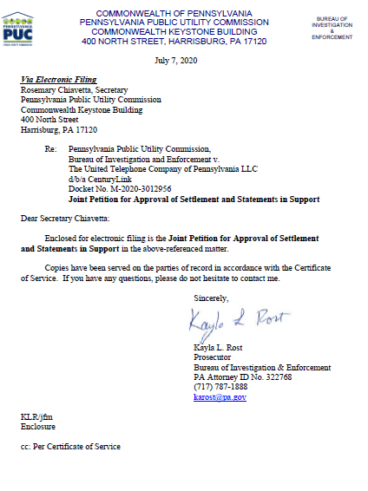
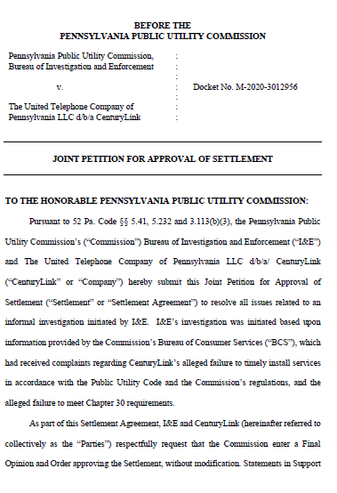
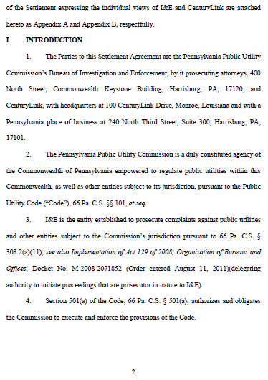

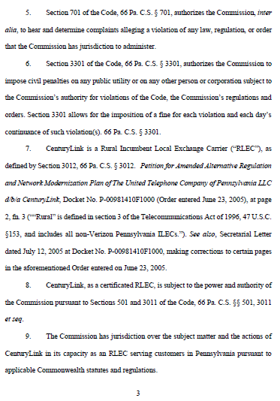
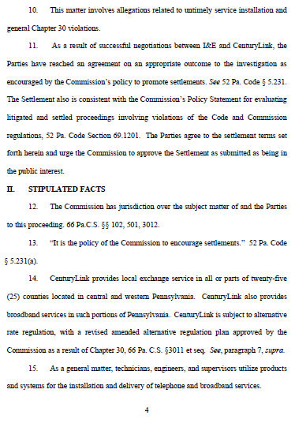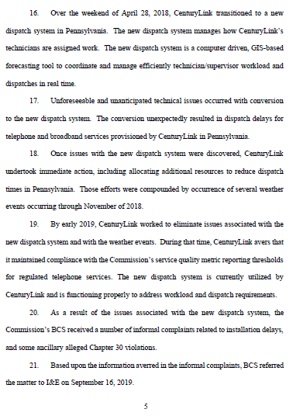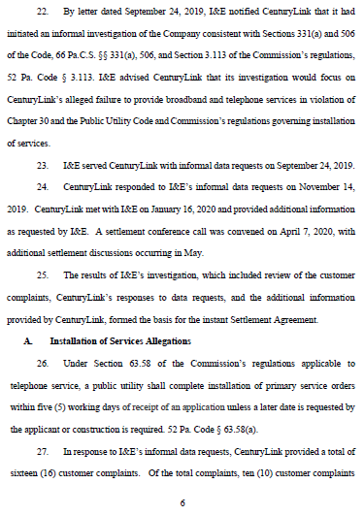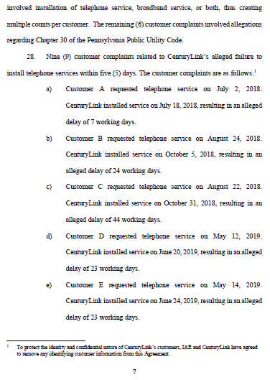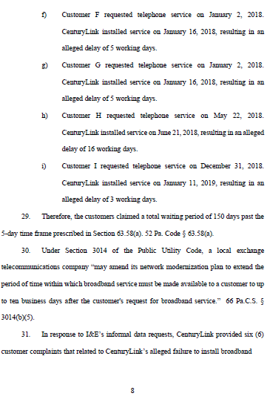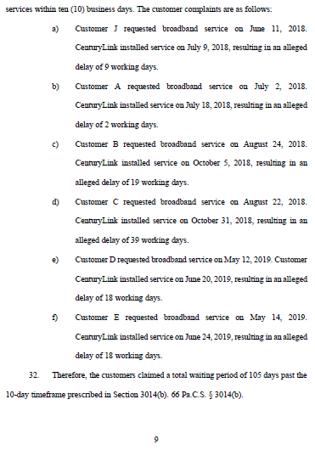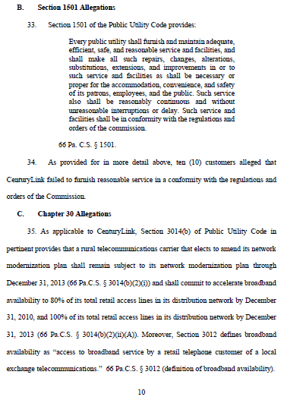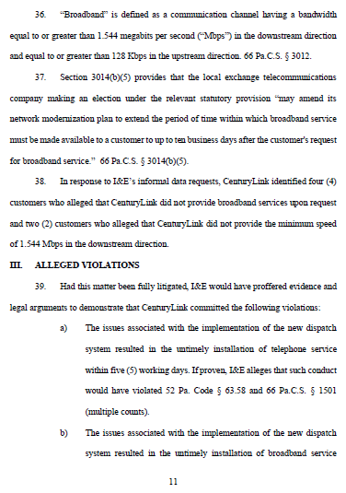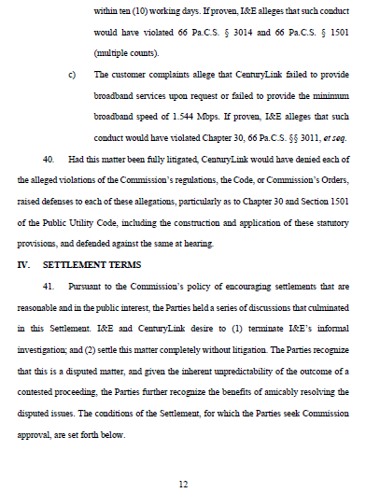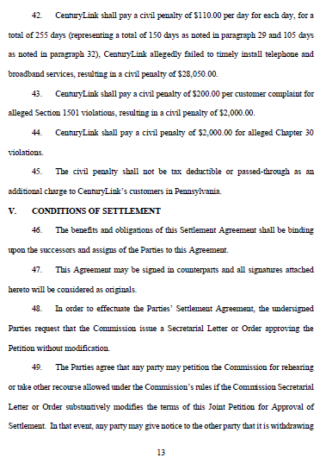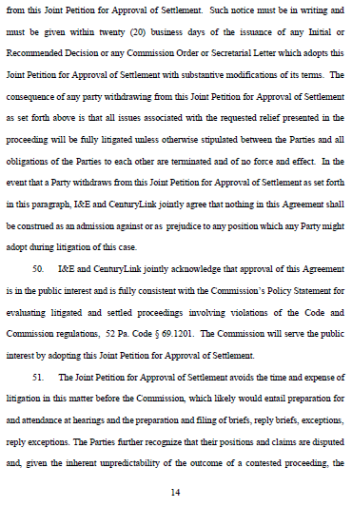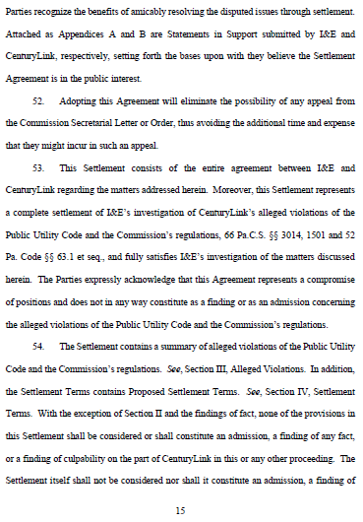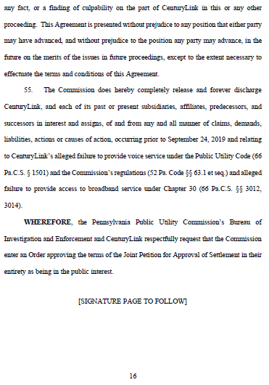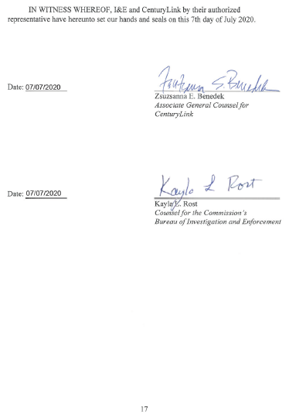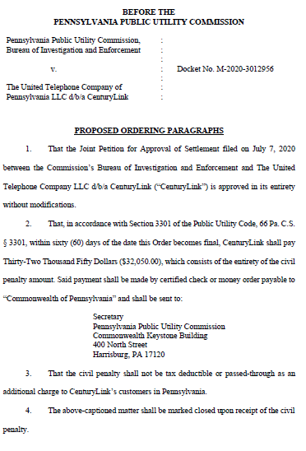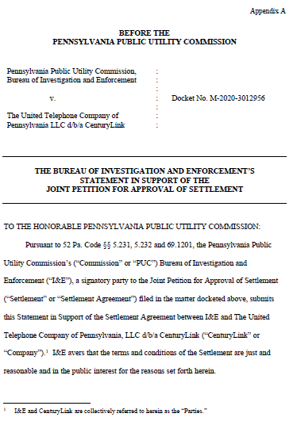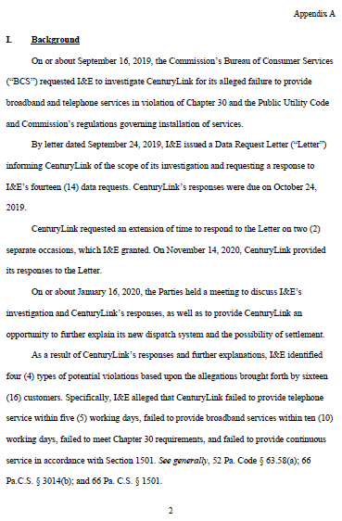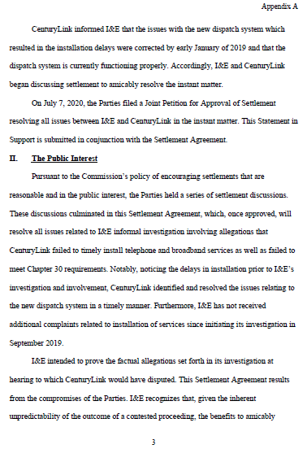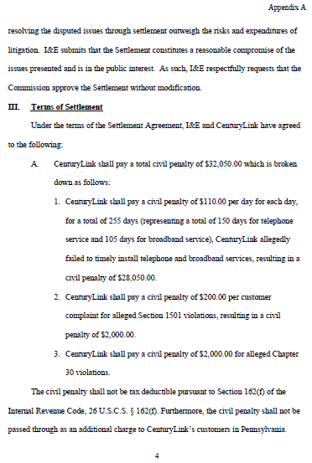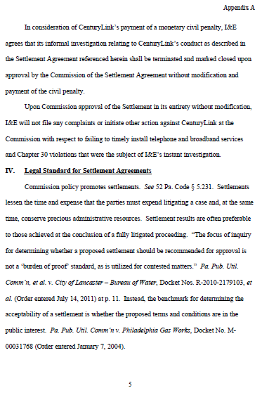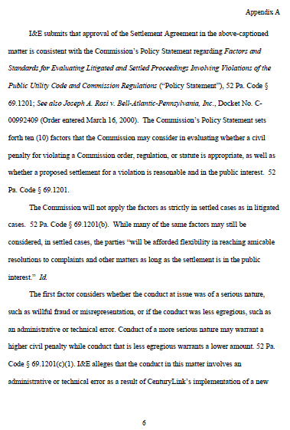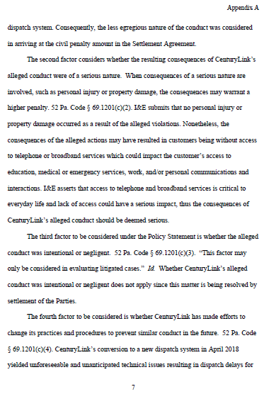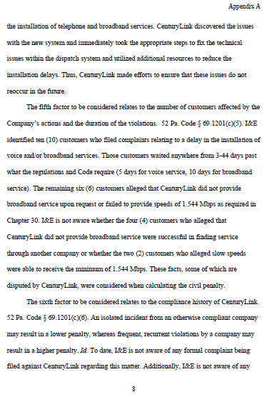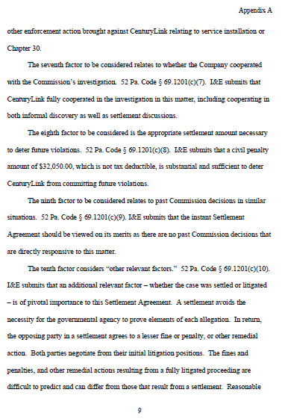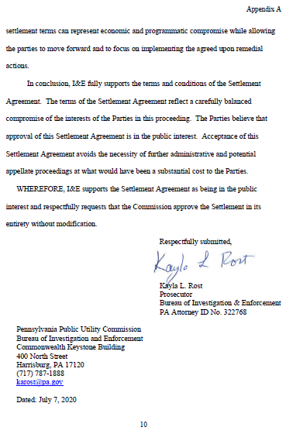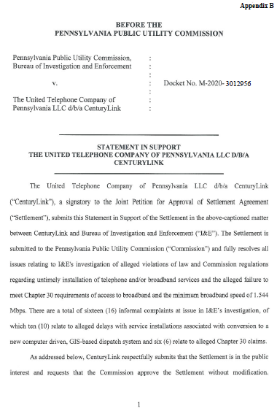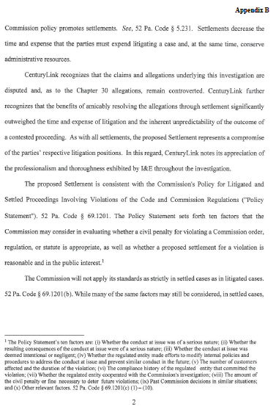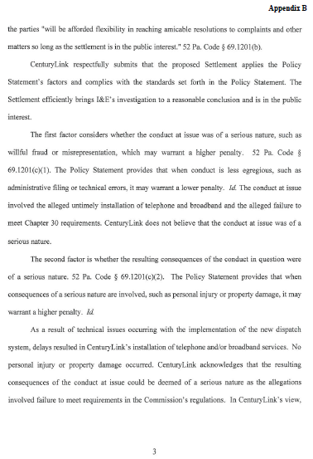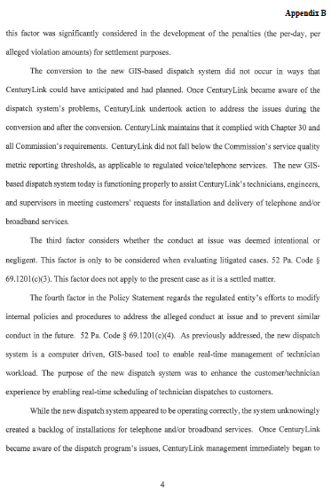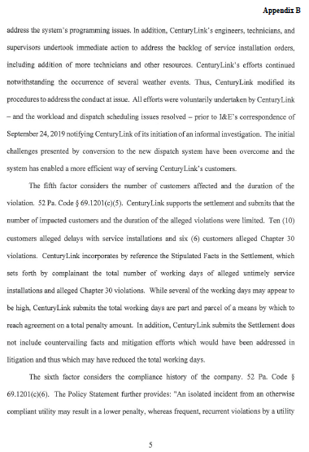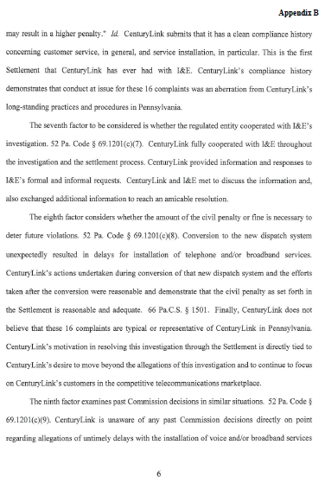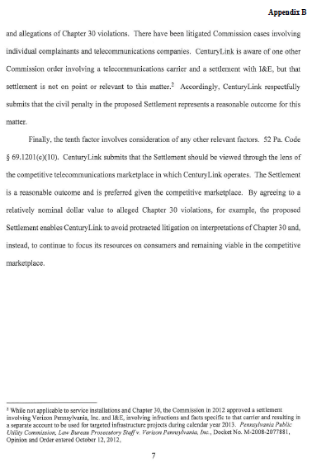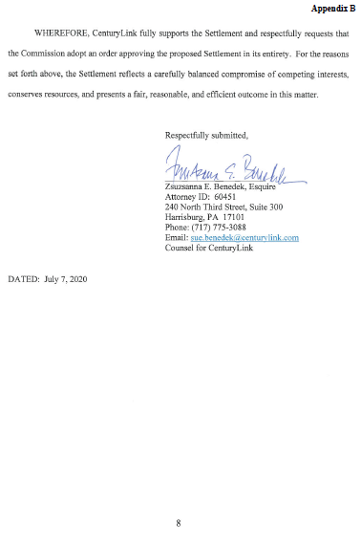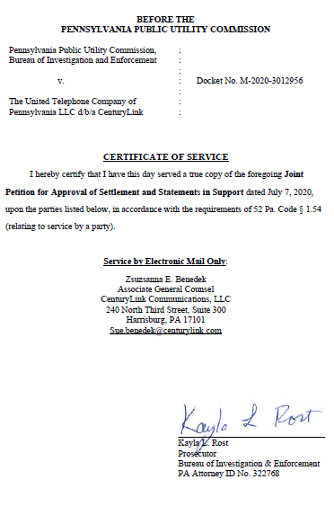

“Broadband” is defined as a communication channel having a bandwidth equal to or greater than 1.544 megabits per second (Mbps) in the downstream direction and equal to or greater than 128 kilobits per second (Kbps) in the upstream direction. 66 Pa. C.S. § 3012. Settlement at 11.

